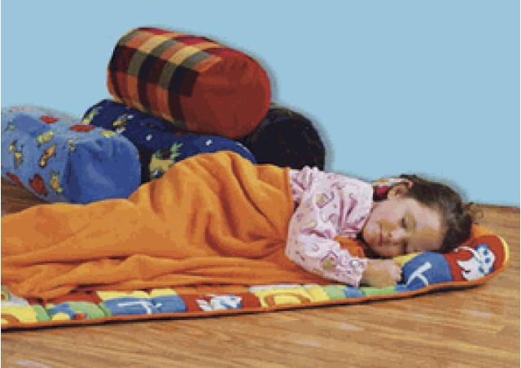
[1] Regular habits
@ Do you usually go to sleep early?
@ When do you often go to sleep?
@ Do you have any brothers or sisters?
@ When does he/she usually go to sleep?
@ When does he/she always get up?
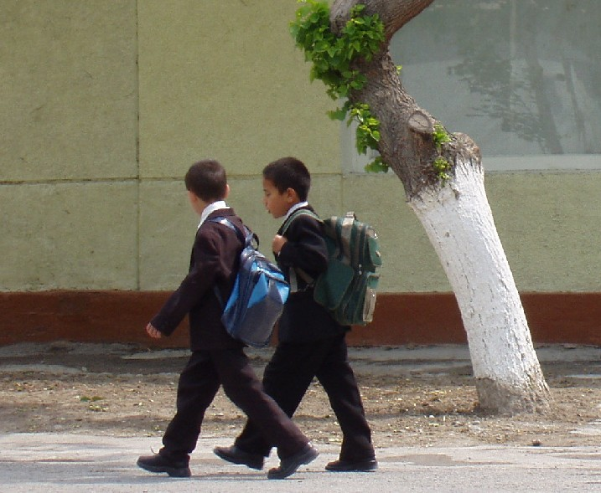
@ What do you usually do after getting up?
@ Do you always prepare your bag?
@ Does your mother prepare breakfast?
@ What do you usually do after breakfast?
@ How often do you go to school?

I ask some students to say the answers and write some complete sentences on the board using ‘I – He – She – We – You – They’ to extract the rule.
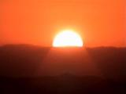
[2] Facts
@ What do you see in the picture?
@ Does the sun rise in the west?
@ Where does the sun always rise?
@ When does it usually rise / set?
@ Where does the sun always set?

I ask some students to say the answers and write some complete sentences on the board using ‘The sun – the moon – water - boil’ to extract the rule.
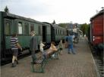
[3] Timetables
@ What can you see in this picture?
@ Do you like travelling by train?
@ Does it arrive in time?
@ When does the train leave the station?
@ When does it arrive at the station?

I ask some students to say the answers and write some complete sentences on the board using ‘The train – the bus – the plane’ to extract the rule

