يالة اتفضلو معايا
1-Join the sentences using “either “ or “ neither “ :-
1 – He is not clever at his lessons. He is not a good player of games.
2 – I did not go to the meeting. I did not send a message.
3 – I can do the homework today. I can do it tomorrow.
4 – Yara was not at the party. Her brother was not at the party.
5 – He is very foolish. OR he is very rich.
6 – The journey wasn’t comfortable. It wasn’t interesting.
7 – George couldn’t read Arabic. He couldn’t write it.
8 – Tom was not at the party. Mary was not at the party.
9-Eman hasn’t bought any skirts or dresses.
10-He is deaf and blind.
2-Finish the sentences:-
1 – Seham can ………….. drive a car nor ride a bicycle.
2 – Neither Emad………. his sister went to school yesterday .
3 – Yara speaks …. …….French nor Italian.
4 – We can have ………..fish or meat. It doesn’t matter.
5 – Can you telephone me …………. on Saturday or on Monday?
3-Rewrite the following sentences using the words in brackets:-
1 –We can meet tomorrow. We can meet next week. (Either …… or ….
………………………………………………………………………..
2 –Seham doesn’t like basketball. She doesn’t like handball. (neither …nor )
………………………………………………………………………..
3 -Wafaa wasn’t at home. Her husband wasn’t at home. ( neither … nor ... )
………………………………………………………………………..
4 –Do you learn French? Do you learn Spanish? (either …… or …. )
………………………………………………………………………..
5 –You can put the oranges in the fridge or in the cupboard ( either …or )
………………………………………………………………………..
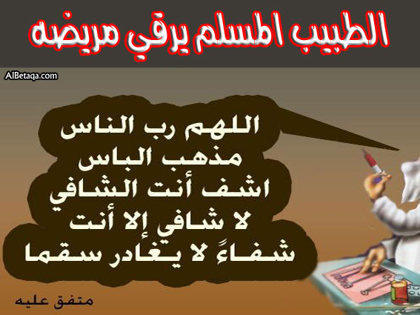
6-Ahmed didn’t have a mobile or a car. ( neither….or)
………………………………………………………………..
7-We didn’t see him often (hardly).
………………………………………………………………………..
8-– I feel sure he is ill. (must )
………………………………………………………………………..
9- Their father entered during their watching TV. (While)
………………………………………………………………………..
10-I did not go to the meeting and did not apologize. (neither)
………………………………………………………………………..
11-It is possible he went to the countryside. (might)
………………………………………………………………………..
12-Ahmed neither watches TV or slept (Neither)
………………………………………………………………………..
4-Finish the following dialogue.
Ahmed and Emad are on the phone. They are talking about a football match they are going to se at the club next Friday.
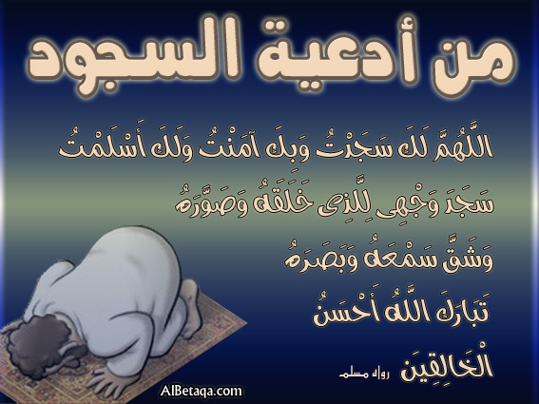
Ahmed : Hello Emad. Emad : Hi ,Ahmed
Ahmed :……………….1……………
Emad :Yes, of Course .I'll see it at the club.
Ahmed :What time does the match start?
Emad :………………..2……………..
Ahmed :………………….3……………
Emad : Let's meet in the front of the club.
5-Rewrite the following using words in brackets.
1-The film was very boring .We couldn’t watch it (so……..that) (too…for….to)
………………………………………………………………………………..
………………………………………………………………………………..
2-Ahmed spoke very quickly ,so we didn’t understand him (so…that) (too….to)
………………………………………………………………………………..
………………………………………………………………………………..
3-The car is very expensive .I cant buy it.(so……..that) ( too……for…….to)
………………………………………………………………………………..
………………………………………………………………………………..
4-He is too short to touch the ceiling (so…..that)
………………………………………………………………………………..
5-Treika plays very well. He can score any goals.(enough).(so…….that)
………………………………………………………………………………..
………………………………………………………………………………..
6- The test is very easy .Any one can answer it.(so….that) (enough….for…to)
………………………………………………………………………………..
………………………………………………………………………………..
Write a paragraph of six sentences about yourself by
Answering the following questions :-
How long have you been living in Alexandria?
Was anything hard for you at first or not? How are things now?
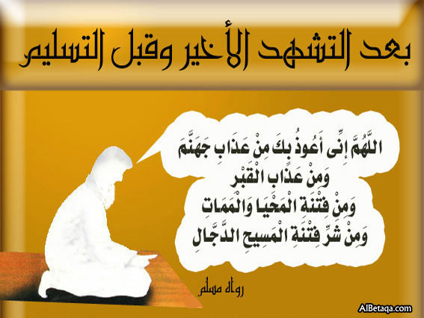
What do you do? How do you spend you spare time?
How are you going to do good for your country?
6-Supply the missing parts in the following dialogue:-
Ahmed : What does Egypt sell to other countries?
Yara : …………………. 1………………….
Ahmed : ………………… 2………………….?
Yara : The lorry carries a massive container.
Ahmed : Where do we import some of our food?
Yara : ……………….. 3…………………...
7-Write a letter of six sentences to your pen friend George:-
Apologizing for not being able to visit him during the summer holiday.
Your name is Yara and you live at 11 Mubarak Street, Shubra.
8-Write a letter to your friend, Tafeed who lives in London telling him, you will go there to do postgraduates studies. Your name is Ahmed Khaled and you live at 55 Ghobashy Street, Giza.
9-Write a paragraph a bout, "A visit to an oasis"
Which oasis- where it is situated- Kinds of trees you have seen- Crops grown there- What the weather is like- How nice it was.

