

Broadcast

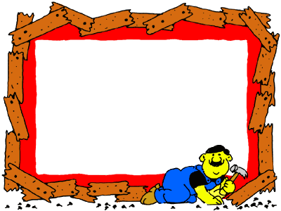

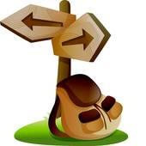

Mr. Mohamed Shabaan



English Broadcast






Mr. Mohamed Shabaan

تقديم اذاعى باللغة الإنجليزية

✓ بسم الله الرحمن الرحيم

✓ السيد الفاضل مدير المدرسة
✓ معلمي الأفاضل
✓ اخوانى الطلبة و الطالبات
✓ السلام عليكم و رحمة الله و بركاته
✓ نحن إخوانكم جماعة اللغة الإنجليزية
نرحب بكم
✓ و يسرنا أن نقدم لكم برنامجنا الاذاعى باللغة الانجليزية لهذا اليوم

✓ و خير بداية القران الكريم مع الطالب / ............

✓ والآن نستمع إلى الحديث الشريف مع الطالب / ...........

✓ حكمة اليوم مع الطالب / ................

✓ نشيد اليوم مع الطالب / ....
✓ حوار اليوم والطلاب / ........................
✓ والآن نستمع إلى كلمة اليوم مع الطالب / ............

✓ وأخيرا نشكركم على استماعكم
✓ و هذا أخيكم ( ) يتمنى لكم يوما سعيدا

✓ نراكم الاسبوع القادم إن شاء الله
English Broadcast
✓ In the name of Allah the Most Gracious
The Most Merciful.
✓ Dear the principal,
✓ My dear teachers,
✓ My dear brothers and sisters
✓ Peace and blessing of Allah be upon you.
✓ We are your brothers, the English family,
we welcome you.
✓ We are glad to present you our English
Broadcast program for this day
✓ The best start is with the Holy Quraan
with the pupil /………
✓ Now we are listening to the Holy Hadith
with the pupil /……
✓ Today's proverb with the pupil /………
✓ Today's rhyme with the pupil /………
✓ Today's dialogue with the pupil /………
✓ Now we are listening to today's word
with the pupil / ………
✓ Finally, thank you for listening.
✓ And this is your brother ( )
wishes you a nice day.
✓ See you next week in Shaa Allah.

6- Today's Dialogue:

Class : Hello Miss Noura.
Miss Noura: Hello everyone. Where's Omar?
He was here yesterday.
Omar : Good morning Miss Noura.
I'm sorry. I'm late.
Miss Noura: Omar, you must come to school on
time. You must get up early.
Omar : Yes, Miss Noura.
Miss Noura: You mustn't come to school ate.
Omar : I'm sorry Miss Noura.

7- Today's Word:

Siwa
Siwa is a small town in the Western Desert. It is about 700 km from Alexandria and about 800 km from Cairo. It has pure water and sand. It is very green with grass and palm trees. You can see olive trees and dates there. Also you can see hills and mountains there. Many tourists go to Siwa. They like visiting The Temple of Amun. Today you can see donkey carts and traditional houses.

1- Introduction
2- The Holy Quraan:
(بسم الله الرحمن الرحيم)
عَمَّ يَتَسَاءَلُونَ (1) عَنْ النَّبَإِ الْعَظِيمِ (2) الَّذِي هُمْ فِيهِ مُخْتَلِفُونَ (3) كَلاَّ سَيَعْلَمُونَ (4) ثُمَّ كَلاَّ سَيَعْلَمُونَ (5) أَلَمْ نَجْعَلْ الأَرْضَ مِهَاداً (6) وَالْجِبَالَ أَوْتَاداً (7) وَخَلَقْنَاكُمْ أَزْوَاجاً (8) وَجَعَلْنَا نَوْمَكُمْ سُبَاتاً (9) وَجَعَلْنَا اللَّيْلَ لِبَاساً (10) وَجَعَلْنَا النَّهَارَ مَعَاشاً (11)
3- The Holy Hadith:
قال رسول الله صلى الله عليه و سلم:
" أحب الاعمال إلى الله : الصلاة على وقتها ثم بر الوالدين ثم الجهاد
فى سبيل الله" رواه البخارى.
4- Today's Proverb:
Don't put off until tomorrow what you can do today.
لا تؤجل عمل اليوم إلى الغد.
5- Today's Rhyme:
A friend at home A friend at school
It's good to have a friend
Brothers are great sisters are nice
But it's good to have a friend
A friend for work A friend for play
It's good to have a friend.

6- Today's Dialogue:

Amr : Oh, Good it is Thursday.
Mustafa : Let's go to the park. We can ride our bikes
Amr : I like playing football. I like scoring goals.
I like playing tennis, too.
Mustafa : I don't like playing football.
Let's play tennis.
Mustafa : I' m tired now Amr. Can we have a rest?
Amr : Yes, let's buy an ice cream.
Mustafa and Amr : We like ice cream.

7- Today's Word:
Towers
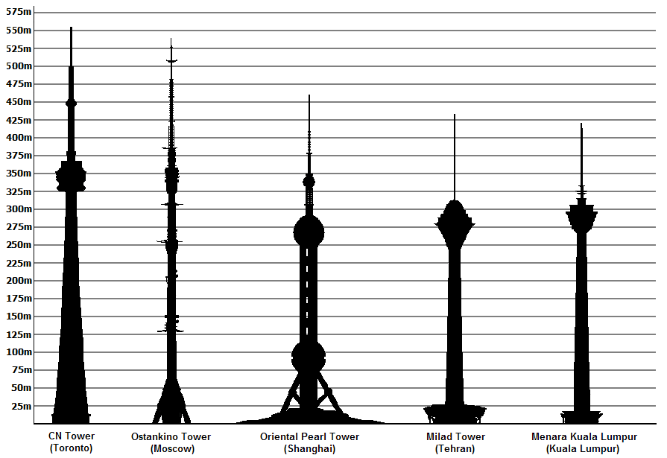
Towers are tall human-made structures that are always taller than they are wide, usually by a significant margin. They are built to take advantage of their height. Here are the names of some towers:
1- Milad Tower is in Tehran. It's 435 metres high.
2- Eiffel Tower is in Paris. It's 324 metres high.
3- Telecom Tower is in London. It's 175 metres high.
4- CN Tower is in Toronto. It's 553 metres high.

1- Introduction
2- The Holy Quraan:
(بسم الله الرحمن الرحيم)
وَالنَّازِعَاتِ غَرْقاً (1) وَالنَّاشِطَاتِ نَشْطاً (2) وَالسَّابِحَاتِ سَبْحاً (3) فَالسَّابِقَاتِ سَبْقاً (4) فَالْمُدَبِّرَاتِ أَمْراً (5) يَوْمَ تَرْجُفُ الرَّاجِفَةُ (6) تَتْبَعُهَا الرَّادِفَةُ (7) قُلُوبٌ يَوْمَئِذٍ وَاجِفَةٌ (8) أَبْصَارُهَا خَاشِعَةٌ (9) يَقُولُونَ أَئِنَّا لَمَرْدُودُونَ فِي الْحَافِرَةِ (10) أَئِذَا كُنَّا عِظَاماً نَخِرَةً (11) قَالُوا تِلْكَ إِذاً كَرَّةٌ خَاسِرَةٌ (12)
3- The Holy Hadith:
قال رسول الله صلى الله عليه و سلم:
" تبسمك فى وجه أخيك صدقة " صحيح الجامع.
4- Today's Proverb:
A bird in the hand is worth ten in the bush.
عصفور فى اليد خير من عشرة على الشجرة
5- Today's Rhyme:
Allah is one He is the only one
Allah is one He is the only one
Can you see the moon? Can you see the sun?
Allah is one He is the only one
Can you see the bird fly in the sky
Allah is one He is the only one
Allah can hear me He is with me
Allah is one He is the only one

6- Today's Dialogue:

Miss Noura: Today we have got history. We are
learning about the Ancient Egyptians.
Miss Noura: The pharaohs built the pyramids
at Giza.
Sara : How high is the Great Pyramid,
Miss Noura?
Miss Noura: It's one hundred and thirty seven metres
high. The Pharaohs also built gardens
and temples.
Omar : They were very beautiful.

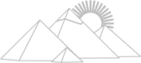
7- Today's Word:
The Pyramids
The Ancient Egyptians built the Pyramids at Giza 4000 years ago. They were built to bury the bodies of the kings. There are a lot of pyramids in Egypt. The Great Pyramid at Giza is about 137 metres high. It was built by King Khufu. They used large stones to built it. Thousands of workers and slaves built it. It took them 20 years to build the Great Pyramid. Now many tourists from all over the world come to see the Pyramids and to enjoy riding camels.

1- Introduction
2- The Holy Quraan:
(بسم الله الرحمن الرحيم)
عَبَسَ وَتَوَلَّى (1) أَنْ جَاءَهُ الأَعْمَى (2) وَمَا يُدْرِيكَ لَعَلَّهُ يَزَّكَّى (3) أَوْ يَذَّكَّرُ فَتَنْفَعَهُ الذِّكْرَى (4) أَمَّا مَنْ اسْتَغْنَى (5) فَأَنْتَ لَهُ تَصَدَّى (6) وَمَا عَلَيْكَ أَلاَّ يَزَّكَّى (7) وَأَمَّا مَنْ جَاءَكَ يَسْعَى (8) وَهُوَ يَخْشَى (9) فَأَنْتَ عَنْهُ تَلَهَّى (10) كَلاَّ إِنَّهَا تَذْكِرَةٌ (11) فَمَنْ شَاءَ ذَكَرَهُ (12) فِي صُحُفٍ مُكَرَّمَةٍ (13) مَرْفُوعَةٍ مُطَهَّرَةٍ.
3- The Holy Hadith:
قال رسول الله صلى الله عليه و سلم:
" لا يؤمن أحدكم حتى يحب لأخيه ما يحب لنفسه "
رواه البخارى و مسلم عن أنس.
4- Today's Proverb:
Easy come, easy go.
ما يأتي بسهولة يذهب بسهولة.
5- Today's Rhyme:
A, B, C, D, E, F, G
sing the alphabet with me
H, I, J, K, L, M, N
clap your hands and sing again
O, P, Q, R, S, T, U
I like English, just like you.
V, W, X, Y, and Z hand in hand for you and me.

6- Today's Dialogue:

Yasmeen: Yesterday was Friday. I went to a farm in
Sharkia. The farmer has got lots of animals.
Heba : What did you see?
Yasmeen: We saw goats, donkeys and cows.
We also saw buffaloes and sheep.
Heba : Did you see a horse and a cart?
Yasmeen: Yes, I did. I saw a cart with lots of
tomatoes. It was a nice visit.
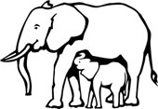

7- Today's Word:
Elephants
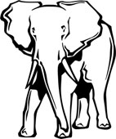
Elephants are large animals. They have hard grey skin. They have big ears and long trunks. They live in Africa and India. The African elephant is the biggest land animal. They don't eat meat. They only eat grass and fruit. They live for about 60 years. They sleep for about 6 hours everyday. The Indian elephant carries people and goods. All people enjoy watching and riding elephants in the zoo.

1- Introduction
2- The Holy Quraan:
(بسم الله الرحمن الرحيم)
إِذَا السَّمَاءُ انفَطَرَتْ (1) وَإِذَا الْكَوَاكِبُ انتَثَرَتْ (2) وَإِذَا الْبِحَارُ فُجِّرَتْ (3) وَإِذَا الْقُبُورُ بُعْثِرَتْ (4) عَلِمَتْ نَفْسٌ مَا قَدَّمَتْ وَأَخَّرَتْ (5) يَا أَيُّهَا الإِنسَانُ مَا غَرَّكَ بِرَبِّكَ الْكَرِيمِ (6) الَّذِي خَلَقَكَ فَسَوَّاكَ فَعَدَلَكَ (7) فِي أَيِّ صُورَةٍ مَا شَاءَ رَكَّبَكَ (8) كَلاَّ بَلْ تُكَذِّبُونَ بِالدِّينِ (9) وَإِنَّ عَلَيْكُمْ لَحَافِظِينَ (10) كِرَاماً كَاتِبِينَ (11) يَعْلَمُونَ مَا تَفْعَلُونَ (12) إِنَّ الأَبْرَارَ لَفِي نَعِيم.
3- The Holy Hadith:
قال رسول الله صلى الله عليه و سلم:
" خيركم من تعلم القرآن و علمه " رواه البخارى .
4- Today's Proverb:
Always has been, always will be.
من شب على شئ شاب عليه.
5- Today's Rhyme:
A, B, C, D, E, F, G
sing the alphabet with me
H, I, J, K, L, M, N
clap your hands and sing again
O, P, Q, R, S, T, U
I like English, just like you.
V, W, X, Y, and Z hand in hand for you and me.

6- Today's Dialogue:

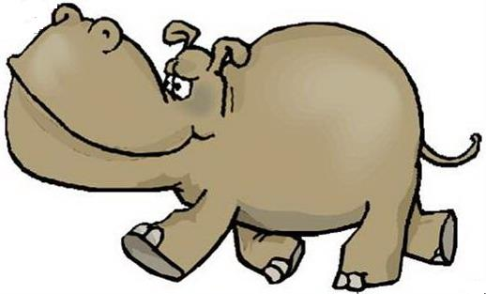
Teacher: Look at the animals.
Pupil : That's a hippo.
Teacher: Yes, hippos can swim.
Can crocodiles run.
Pupil : Yes, they can, but they can't jump.

Teacher: They have got short legs.
Can crocodiles swim?
Pupil : Yes, they can.

7- Today's Word:
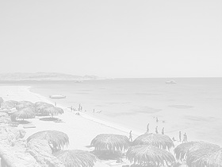
Hurghada
Hurghada was a tiny fishing village. Now it is a beautiful resort beside the Red Sea. Visit the little islands. Swim in the clear water. In the summer Hurghada is hotter than Cairo but the water is cool. Visitors can fly from Cairo or go by boat from Sinai to the harbour at Sigala. Hurghada stretches for about 36 km along the seashore. You can see beaches, hotels and an airport there. It's a fantastic place to spend the holiday in.

1- Introduction
2- The Holy Quraan:
(بسم الله الرحمن الرحيم)
إِذَا السَّمَاءُ انشَقَّتْ (1) وَأَذِنَتْ لِرَبِّهَا وَحُقَّتْ (2) وَإِذَا الأَرْضُ مُدَّتْ (3) وَأَلْقَتْ مَا فِيهَا وَتَخَلَّتْ (4) وَأَذِنَتْ لِرَبِّهَا وَحُقَّتْ (5) يَا أَيُّهَا الإِنسَانُ إِنَّكَ كَادِحٌ إِلَى رَبِّكَ كَدْحاً فَمُلاقِيهِ (6) فَأَمَّا مَنْ أُوتِيَ كِتَابَهُ بِيَمِينِهِ (7) فَسَوْفَ يُحَاسَبُ حِسَاباً يَسِيراً (8) وَيَنقَلِبُ إِلَى أَهْلِهِ مَسْرُوراً (9) وَأَمَّا مَنْ أُوتِيَ كِتَابَهُ وَرَاءَ ظَهْرِهِ (10) فَسَوْفَ يَدْعُو ثُبُوراً (11) وَيَصْلَى سَعِيراً (12)
3- The Holy Hadith:
قال رسول الله صلى الله عليه و سلم:
" خيركم من تعلم القرآن و علمه " رواه البخارى .
4- Today's Proverb:

The sound mind is in the sound body.
العقل السليم فى الجسم السليم.
5- Today's Rhyme:

I was born in Cairo What about you?
Were you born in Cairo? Are you Egyptian, too?
I was born in Assiut What about you?
You were born in Cairo? You are Egyptian, too.

6- Today's Dialogue:

Amr : How was your trip, Dad?.
Dad : It was amazing. I had a good time, but it was
too hot.
Amr : Is Aswan hotter than Cairo?
Dad : Yes, it is always hotter than Cairo.
It was 35 degrees.
Dad : Look, it is 30 degrees in Cairo, today.
Amr : Yes, it is colder than yesterday.
Dad : It's hotter today in Hurghada. It’s 32 degrees.
Amr : My friend Hesham is there on holiday.
He is diving in the Red Sea.

7- Today's Word:
Aswan
Aswan is in the south of Egypt. You can visit the amazing High Dam there. It is 15 km from there. Engineers built the High Dam between 1960 and 1971. It is 111 metres high. On the south side of the Dam , visitors can see Lake Nasser. They can also visit the Temple of Philae on a beautiful island. They can enjoy sound and light show every evening.

1- Introduction
2- The Holy Quraan:
(بسم الله الرحمن الرحيم)
وَالسَّمَاءِ ذَاتِ الْبُرُوجِ (1) وَالْيَوْمِ الْمَوْعُودِ (2) وَشَاهِدٍ وَمَشْهُودٍ (3) قُتِلَ أَصْحَابُ الأُخْدُودِ (4) النَّارِ ذَاتِ الْوَقُودِ (5) إِذْ هُمْ عَلَيْهَا قُعُودٌ (6) وَهُمْ عَلَى مَا يَفْعَلُونَ بِالْمُؤْمِنِينَ شُهُودٌ (7) وَمَا نَقَمُوا مِنْهُمْ إِلاَّ أَنْ يُؤْمِنُوا بِاللَّهِ الْعَزِيزِ الْحَمِيدِ (8) الَّذِي لَهُ مُلْكُ السَّمَوَاتِ وَالأَرْضِ وَاللَّهُ عَلَى كُلِّ شَيْءٍ شَهِيدٌ (9) إِنَّ الَّذِينَ فَتَنُوا الْمُؤْمِنِينَ وَالْمُؤْمِنَاتِ ثُمَّ لَمْ يَتُوبُوا فَلَهُمْ عَذَابُ جَهَنَّمَ وَلَهُمْ عَذَابُ الْحَرِيقِ (10) إِنَّ الَّذِينَ آمَنُوا وَعَمِلُوا الصَّالِحَاتِ لَهُمْ جَنَّاتٌ تَجْرِي مِنْ تَحْتِهَا الأَنْهَارُ ذَلِكَ الْفَوْزُ الْكَبِيرُ
3- The Holy Hadith:
قال رسول الله صلى الله عليه و سلم:
" المسلم من سلم المسلمون من لسانه و يده " رواه البخارى.
4- Today's Proverb:
A friend in need is a friend indeed.
الصديق الحق هو من تجده وقت الشدة.
5- Today's Rhyme:
Oh my dear
Allah is near
Ask Him aid
He will hear
Leave the play
Come to pray
You will be happy everyday

6- Today's Dialogue:

Walid : What time is the match?
Mustafa: It’s at seven o'clock.
Amr : I like playing football. I want to be
a footballer.
Mustafa: I want to be an athlete because
I like running
Amr : What do you want to be, Walid?
Walid : I want to be a pilot because I like
flying planes.
Mustafa: My sister wants to be an English teacher.
Walid : Why?
Mustafa: Because she likes speaking English.

7- Today's Word:
Sinai
Sinai is in the east of Egypt. There are beautiful beaches in Sinai. Many tourists go to Sharm El- Sheikh. They like diving in the Red Sea. The water is very clear. Tourists also visit St Catherine's. Some people like walking up Mount Sinai. It's Two thousand two hundred and eighty- five metres high.

1- Introduction
2- The Holy Quraan:
(بسم الله الرحمن الرحيم)
وَالسَّمَاءِ وَالطَّارِقِ (1) وَمَا أَدْرَاكَ مَا الطَّارِقُ (2) النَّجْمُ الثَّاقِبُ (3) إِنْ كُلُّ نَفْسٍ لَمَّا عَلَيْهَا حَافِظٌ (4) فَلْيَنظُرْ الإِنسَانُ مِمَّ خُلِقَ (5) خُلِقَ مِنْ مَاءٍ دَافِقٍ (6) يَخْرُجُ مِنْ بَيْنِ الصُّلْبِ وَالتَّرَائِبِ (7) إِنَّهُ عَلَى رَجْعِهِ لَقَادِرٌ (8) يَوْمَ تُبْلَى السَّرَائِرُ (9) فَمَا لَهُ مِنْ قُوَّةٍ وَلا نَاصِرٍ (10) وَالسَّمَاءِ ذَاتِ الرَّجْعِ (11) وَالأَرْضِ ذَاتِ الصَّدْعِ (12) إِنَّهُ لَقَوْلٌ فَصْلٌ (13) وَمَا هُوَ بِالْهَزْلِ (14) إِنَّهُمْ يَكِيدُونَ كَيْداً (15) وَأَكِيدُ كَيْداً (16) فَمَهِّلْ الْكَافِرِينَ أَمْهِلْهُمْ رُوَيْداً (17)
3- The Holy Hadith:
قال رسول الله صلى الله عليه و سلم:
" طلب العلم فريضة على كل مسلم " صحيح الجامع
4- Today's Proverb:
Actions speak louder than words.
الأفعال خير من الأقوال.
5- Today's Rhyme:
Head, shoulders , Knees and toes
Knees and toes
Head, shoulders , Knees and toes
Knees and toes
Ears and eyes and chin and nose
Chin and nose

6- Today's Dialogue:

Miss Noura: Today we have got history. We are
learning about the Ancient Egyptians.
Miss Noura: The pharaohs built the pyramids
at Giza.
Sara : How high is the Great Pyramid,
Miss Noura?
Miss Noura: It's one hundred and thirty seven metres
high. The Pharaohs also built gardens
and temples.
Omar : They were very beautiful.

7- Today's Word:
The Pyramids
The Ancient Egyptians built the Pyramids at Giza 4000 years ago. They were built to bury the bodies of the kings. There are a lot of pyramids in Egypt. The Great Pyramid at Giza is about 137 metres high. It was built by King Khufu. They used large stones to built it. Thousands of workers and slaves built it. It took them 20 years to built the Great Pyramid. Now many tourists from all over the world come to see the Pyramids and to enjoy riding camels.

1- Introduction
2- The Holy Quraan:
(بسم الله الرحمن الرحيم)
إِذَا السَّمَاءُ انفَطَرَتْ (1) وَإِذَا الْكَوَاكِبُ انتَثَرَتْ (2) وَإِذَا الْبِحَارُ فُجِّرَتْ (3) وَإِذَا الْقُبُورُ بُعْثِرَتْ (4) عَلِمَتْ نَفْسٌ مَا قَدَّمَتْ وَأَخَّرَتْ (5) يَا أَيُّهَا الإِنسَانُ مَا غَرَّكَ بِرَبِّكَ الْكَرِيمِ (6) الَّذِي خَلَقَكَ فَسَوَّاكَ فَعَدَلَكَ (7) فِي أَيِّ صُورَةٍ مَا شَاءَ رَكَّبَكَ (8) كَلاَّ بَلْ تُكَذِّبُونَ بِالدِّينِ (9) وَإِنَّ عَلَيْكُمْ لَحَافِظِينَ (10) كِرَاماً كَاتِبِينَ (11) يَعْلَمُونَ مَا تَفْعَلُونَ (12)
إِنَّ الأَبْرَارَ لَفِي نَعِيمٍ
3- The Holy Hadith:
قال رسول الله صلى الله عليه و سلم:
" لا يؤمن أحدكم حتى يحب لأخيه ما يحب لنفسه "
رواه البخارى و مسلم عن أنس.
4- Today's Proverb:
Easy come, easy go.
ما يأتي بسهولة يذهب بسهولة.
5- Today's Rhyme:
A, B, C, D, E, F, G
sing the alphabet with me
H, I, J, K, L, M, N
clap your hands and sing again
O, P, Q, R, S, T, U
I like English, just like you.
V, W, X, Y, and Z hand in hand for you and me.

