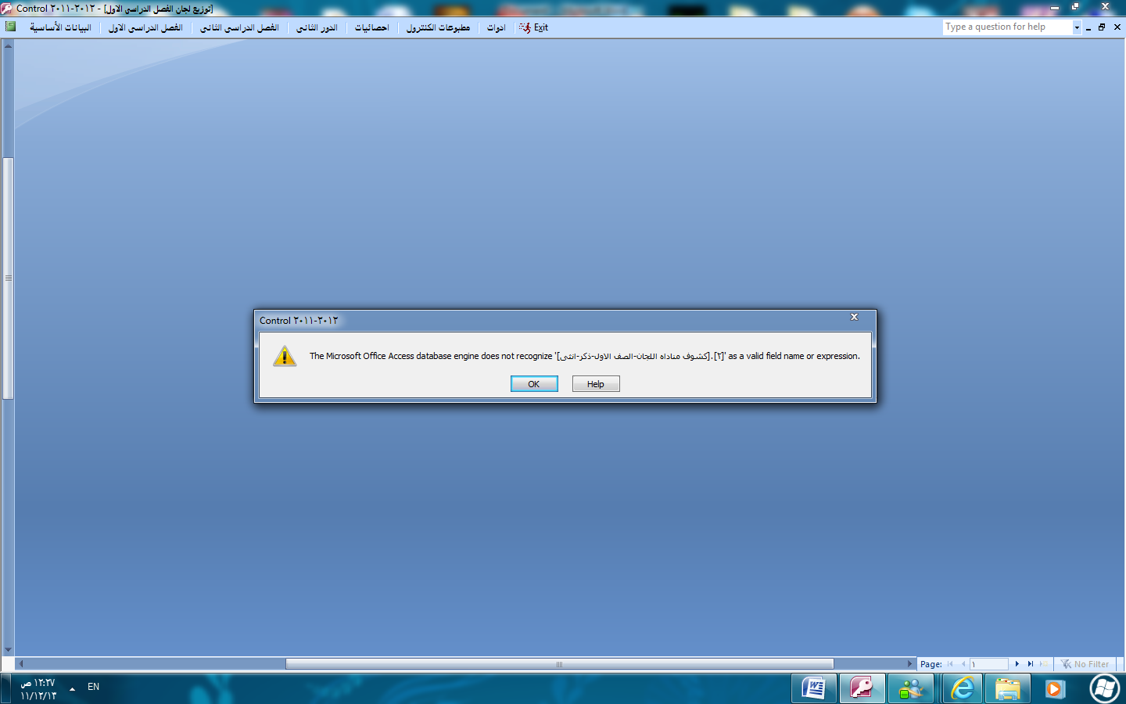

The Microsoft office access database engine does not recognize ]. 2 as a valid field name or expression كشوف مناداة اللجان الصف الاول –ذكر-انثي[

