Chapter One - Two Terms

Atomic structure - Summary

Atomic structure
- Atom: "A" means "no" and "tom" means "divide".
- Aristotle: Believed that all matters are composed of four componenets (water – air – dust – fire).
- Boyle define the element as "a pure simple substance that cannot be changed to simpler forms by the traditional chemical methods".
- Dalton's atomic theorys – the matter is composed of atoms which are undividable and each element have a certain type of atoms.
- Cathode rays: Consists of fine negative particles, move in straight lines, and have a thermal effect. They are affected by both electric and magnetic field. They do not differ in behavior or in nature if the material of the cathode or the used gas are changed. All element contain cathode rays.
- Thomson's model: the atom is a sphere of a uniform positive electricity and embedded in it equal number of –ve electrons. So, the atom is electrically neutral.
Rutherford's experiment:
1- The most of alpha)α) particles hit the same places, so, most of the atomic volume is empty sapce.
2- very small % of )α (particles did not penetrate the gold foil and reflected back, so, the atom contain high density nucleus.
3- A very small % of) α ( particles deflected, so the nucleus is positive charge.
Rutherford's Atom:
It is a vast space, its structure is similar to the solar system.
- The nucleus of the atom is very small, at the centre (positivly charged)
- The atom is electrically netural because the number of positive charges (protons) equals the No. of negative charges (electrons).
- The electrons never fall inside the nucleus because the electrons are affected by two equal forces in quanitity and oppose direction:
* The attractive force.
* The centrifugal force.
- Most of the atomic mass is concentrated in the nucleus because the mass of electrons can be neglected if it is compared to the mass of nucleus components.
- Maxwell's theory is the most important that contradicted RutherFord's theory, it states that when an electrically charged particle moves in an orbit around a fixed body of a different charge, it loses apart of its energy in the form of light radiations resulting a gradual decrease in the orbit radius.
- By applying this theory; the electron as a negative particle moves around the nucleus as a fixed positive particle, we would expect that the electron is in a state of continous emission to energy therefore the electron revolves in a spiral orbit until it fall in the nucleus causing removing of the atomic system.
Bhohr's atom:
- The atom is a positive nucleus, and negative electrons rotate around the nucleus in definite energy levels.
- Each level has a definite energy which increases as the distance from the nucleus increases, i.e the energy levels differ in energy from each other.
(K) energy level has a principle quantum no. equal (1) , and (L) level has a principle quantum no. equal (2) and so on until the seventh level.
- The electrons revolve around the nucleus in a number of energy levels which are constant and definite. So electrons can not be found at intermediate distances.
- The atom never emit radiations in the normal state, but emission is only produced from the excited atom.
- The difference in energy between the energy levels is not equal, and decreases gradually further from the nucleus.
- The electron does not leave its energy level to another unless the energy absorbed or emitted is equal to the energy difference between the two levels.
- The quantum: is the amount of energy absorbed or emmitted when the electron jumps from one energy level to another, and it differs according to the difference between the two levels.
- The quantum is neither divided nor doubled; i.e there is no half quantum or 2 quantums.
The advantages of Bohr's theory:
1- He explained the hydrogen atom spectrum.
2- He was the first who introduced the idea of quantized energy states for the electron in the atom.
3- He reconciliated between Ruhterford and Maxwell theories, that he considered that radiations are emited from the excited atom only.
The disadvantages of Bohr's Theory
1- He failed to explain the spectra of atoms of the heavier elements.
2- He postulated that both the speed and the location of the electron can be determined at the same time.
3- He did not consider the wave properties of the electron, he only considered the electron as a particle.
4- He considered the electron moving in a circular plannar orbit i.e The atom is planar. It is proved that the atom has the three dimensions in space x, y, z.
De Broglie Principle
Every moving body is associated with a wave motion which has some properties of light waves.
The Heisenberg uncertainty principle
: It is practically impossible to determine both position and velocity of the electron exactly at the same time, but it undergo to propabilities laws.
The electron cloud:
It is the propability of finding the electron in all direction and dimensions around the nucleus of the atom.
Quatum numbers:
They are numbers that define orbitals, their energy, their shapes, and their directions according to the atom axis.:
a- The principal quantum number)n)
b- The subsidiary quantum number (l)
c- The magnetic quantum number (m)
d- The spin quantum number (m_{s}(
Principal quantum number (n):
It defines the number of the main energy levels in the atom, the number of orbitals in each energy level from the role (n²), and the number of electrons in each energy level from the role )2n²(.
Subsidiary quantum numberl (l):
It defines the no. of energy sublevels in each principal energy level, its no. equals the no. of the principal energy level that it follows until the fourth principal level. For example (K) level contains one energy sublevel, (L) level contains two, (M) level contains three, and)N) level contains four energy sublevels.
Magnetic quantum number (m(:
It defines the no. of orbitals in the energy sublevels, and their space directions. They are odd numbers (1), (3), (5) or (7).
- Sublevel (s) has nonorbital ospsherical symmetrical shape.
- The sublevel (p) consists of three orbitals (x, y and z) each one is perpendicular to the other two.
- The electron could of each oritbtal take the form of two pears meeting head to head (dumb – bell. Shaped) at a node.
Spin quantum number (m_{s}):
It describes the type of the spin motion of an electron around its axis in either a clockwise or anti-clockwise.
- Sublevel (s) is saturated with two electrons, since it contains one orbital.
Sublevel (p) is saturated with six electrons, that it contains three orbitals.
- Sublevel (d) is filled with ten electrons because it has five orbtials.
- Sublevel (f) is filled with 14 electrons that it contains 7 orbitals.
Aufbaul (building-up) principle
Electrons must occupy sublevels which have the lowest energy at first then occypy sublevels which have higher energy.
[ 1S < 2s < 2p < 3p < 4s < 3d ]
Hund's Rule:
The electrons in sublevel preffered to occupy independent orbitals beofre its pairing.
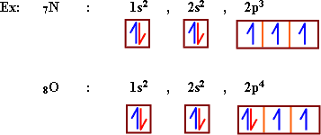

Questions and Answers:

I. M.C. question: (Multiple choice):
* Choose the correct answer from those between brackets:
1- ................. believed that all matters are composed of four components.
a) Boyle b) Aristotle c) Dalton d) thomson
- Aristotle

2- ................ said that matter is composed of solid individual atoms.
a) Boyle b) Aristotle c) Dalton d) Thomson

c) Dalton

3) ............... Said that the atom is a sphere of a uniform positive electricity with equal number of electron in it.
a) Boyle b) Rutherford c) Dalton d) Thomson
d) Thomson

4) ............... said that the atom is complicated structure and as the solar system.
a) Boyle b) Bohr c) Rutherford d) Dalton
c- Rutherford

5- The Rays emitted from the plate connected to the negative pole of electric source in the discharge tube is called ..............
a) alpha b) gamma c) Cothode d) Bea
c) Cathode

6) The rays which has a thermal effect and eimitted from the - ve rod is called ................
a) Alpha b) gamma c) cahtode d) Beta
c) cathode

7) On changing the material of cathode in the discharge tube, ………...:
a) the rays will changed b) the rays not changed c) Some of the rays will changed d) Most of the rays will changed.
b) the rays not changed.

8) The scientist who, refused Aristotle's idea about the nature of the substances.
a) Dalton b) Thomson c) Rutherfor d) Boyle
d) Boyle

9) The scientist who said that, the atom of each element are different from the atoms of any other element.
a) Dalton b) Thomson c) Rutherford d) Bohr.
b) Thomson

10) In the Rutherford experiement some of alpha particles reflected back due to ............
a) the nucleus is +ve b) The electrons are - ve
c) The nucleus is small d) The nucleus is very high density.
d) The nucleus is very high density.

11) In the Rutherford experimente some of alpha particles deflected due to ...............
a) The nucleus is +ve b) The electrons are negative.
a) The nucleus is small d) The nucleus is very high density.
a) The nucleus is +ve

12) In the Rutherfor experiment of most alpha particles pass through gold foil without any change. due to ...............
a) Most of the atom is empty sapce
b) The nucleus is so small
c) greater mass of electrons
d) a and b are correct.
d) a and b are corrected

13) Alpha particles eimmitted from the Raidoactive material has .................
a) positive charge
b) the same structure of the helium nucleus.
c) negative charge
d) a and b are correct.
d) a and b are correct.

14- The number of orbitals in the sublevel 3d is ........... (1,3,5,7)
1-5

15- The number of orbitals in the sublevel 4s is .............. (1,3,5,7)
2- 1

16- The Number of orbitals in the sublevel 2P is............ (1,3,5,7)
3- 3

17- The number of oribtals in the sublevel 4f is .............. (1,3,5,7)
4- 7

18- The sublevel which consist of (1) orbital only is ......... (s,p,d,f)
5- s

19- The sublevel which consist of (5) orbitals only is ............ (s,p,d,f)
6- d

20- The sublevel which consist of (3) orbitals only is............ (s,p,d,f)
7- p

21- The sublevel which consists of (7) orbitals only is ......... (s,p,d,f)
8- f

22- The No. of electrons which saturate sublevel (s) is ........ (2,6,10,14)
9- 2

23- The No. of electrons which saturate sublevel (p) is ............ (2,6,10,14)
10- 6

24- The No. of electrons which saturate sublevel (d) is ............ (2,6,10,14)
11- 10

25- The No. of electrons which saturate sublevel (f) is ............ (2,6,10,14)
12- 14

26- The No. of electrons which saturate the 4th. Energy level is …………. (2,8,18,32)
13- 32

27- The No. of electrons which saturate the 3rd. Energy level is …………. (2,8,18,32)
14- 18

28- The No. of electrons which saturate the 2nd. Energy level is …………. (2,8,18,32)
15- 8

29- The No. of electrons which saturate the 1st. Energy level is …………. (2,8,18,32)
16- 2

30- The No. of electrons which saturate the principal energy level (n) equals ......
17- .

31- The maximum number of prinicpal energy levels in the heaviest known atoms equals ........... (5,6,7,8)
18- 7

32- When an electron transferres from the energy level (K) to the energy level (M), it gains a quantity of energy equals .............. (2 quantum , one quantum, 3 quantum)
19- one quantum.

33- The orbitals of the same sub-shell are .................. (different in shape, equal in energy, different in energy).
20- equal in energy.

34- An element 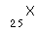, its electronic configuration is ..............
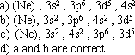
22-

35- Number of orbitals in sublevel (3d) is .............
a) 3 b) 4 c) 5 d) 7
c) 5

36- An element of atomic number (10) the number of sublevels filled with electrons are
a) 2 b) 3 c) 5 d) 7
b) 3

37- Sublevle (f) saturated with number of electrons equals .....
a) 6 b) 16 c) 14 d) 32
c) 14

38- The fourth energy level is saturated by a number of electrons equal:
a) 8 b) 16 c) 64 d) 32
d) 32

39- An element with atomic number 17 its electrons can be distributed in a number of orbitals equal:
a) 3 b) 5 c) 9 d) 10
c) 9

40- The energy sublevel that conists of three orbital is........
a) s b) p c) d d) f
b) p

41- The number of orbital in the sublevel 5f is ............
a) 5 b) 6 c) 7 d) 4
c) 7

42- The scientist who interoduced the main energy levels and defined its number is........
a) Heisenberg b) Schrodinger c) Hond d) Bohr
d) Bohr

43- The maximum number of electrons occupying an energy level of a prinicpal quantum number (n) can be calculate from the law....
a) 2n b)
c) d)
c)

44- The scientist who introduced the sublevel and defined its number is.....
a) Bohr b) sommerfield c) Schrodinger d) Heisenberg

b) sommerfield

45- The scientist who used the term electron cloud to describe an orbital....
a) Hund b) Heisenberg c) Schrodinger d) Bohr
c) Schrodinger

46- The number of orbitals in principle energy level (n) equals....
a) b) c) 2n d)
a)

47- When the atom is in the ground state its electrons....
a) lose energy b) gain energy c) emit light continuosly d) do not lose or gain energy
d) do not lose or gain energy

48- The second principle energy level (l) is saturated by number of electrons equal....
a) 16 b) 8 c) 18 d) 32
b) 8

49- When the electron transfer to higher energy level it .....
a) loses a quantum of energy
b) gains a quantum of energy
c) Do not lose or gain energy
d) emit continuous light
b) gains a quantum of energy

50- The magnetic quantum number defines
a) No of sublevels
b) No of orbitals in a definit sublevel
c) The maximum No of electrons which the sublevel can be saturated.
d) The type of motion of the electrons around its own axis
b) No of orbitals in a definit sublevel

51- An element of atomic number (8) its eletronic configuration is....
a)
b)
c) 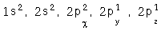 d) a and c
d) a and c

52- From the modification of Bohr's theory by the modern theory are....
a) Dual nature of the electron b) Heisenberg uncertainty principal
c) Schrodinger equation d) All previous
d) All previous

53- The modern term for finding the electron around the nucleus is...
a) The electron rotates around the atom
b) The electron present in orbits around the nucleus
c) The electron exitsts in a region around the nucleus termed by the electron cloud
d) b and c together
c) The electron exitsts in a region around the nucleus termed by the electron cloud

54- The 5th prinicple energy level is saturated by No of electrons equal...
a) (8) b) (18) c) (32) d) (72)
c) (32)

II) Put the sign in front of the correct answer, and the sign in the front of the worng areas.
1- Aristotle believed that all matters are composed of (air, water, dust , fire)
1-

2- The element is a pure simple substance that can not be changed to simpler one by the traiditonal chemical methods.
2-

3- The atoms of each element are similar to the atom of any other element.
3-

4- The gases do not conduct electricity under normal conditions of pressure and temperture.
4-

5- Cathode rays are affected by electric fields only.
5-

6- Cathode rays differ in behavior, if the material of the cathode is changed.
6-

7- Thomson believed that the atom is a sphere of a uniform positive electricity inside it equal number of electrons.
7-

8-When alpha particles collide zinc sulphide, it glows at site of collision.
8-

9- Most of the atomic volume is uniformly dense.
9-

10- The positive nucleus causes deflection some alpha particles on passing through the gold foil.
10-

11- The atomic No. of an atom represents the no. of electrons around the neucleus of its ion.
11-

12- The atomic No. of an atom represents the no. of protons in its nucleus. ( )
12-

13- The atomic no. of an atom represents the no. of neutrons in its nucleus. ( )
13-

14- The quantity of energy needed to excite an electron from the 1st. Energy level to the 4th. Energy level equals 3 quantum
14-

15- The sublevel (s) consist of one spherical orbitals.
15-

16- The sublevel (d) consist of three perpindicular orbitals.
16-

17- The sublevel (p) consist of three perpindicular orbitals.
17-

18- The sublevel (f) consist of five orbitals.
18-

19- The orbitals of the same sub-level are equal in energy.
19-

20- The sublevel 4s is filled with electrons before the sublevel 3d.
20-

21- It is impossible to determine both the velocity and location of the electron at the same time.
21-

22- The principal energy level (N) consist of 4 orbitals.
22-

23- The principla energy level (O) is saturated by 50 electrons.
23-

24- By using Quantum mechanics theory, shrodinger postulated the uncertaintiy principle.
24-

25- The electron has a dual nature.
25-

26- There are two forces affect the electron-towards the nucleus-during its movement.
26-

27- Applying "Hund's rule"; the electronic configuration of sulphere atom 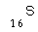is 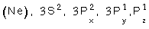( )
27-

28- The sublevel 3d is filled with 6 electrons, while 4d is filled with 8 electrons.( )
28-

29- The sublevel (4f) contains (4) orbitals while the sublevel (5f) contains (5) orbitals
29- (x)

30- The No. of energy sublevel in any energy level equals the principle quantum no of the level.
30- ()

31- It is practically impossible to dtermine both the location and the velocity of the electron at the same time.
31- ()

32- The subsidiary quantum No. determines the no of the electrons in any energy.
32- (x)

33- The number of orbitals in the principle energy level (M) is 14.
33- (x)

34- The principle energy level (p) is saturated by (64) electrons.
34- (x)

35- The electrons occupy the lower energy sublevels firstly then the higher ones.
35- ()

36- The quantum is the amount of energy absorbed or emitted when an electron jumps from one energy level to another.
36- ()

37- Electrons orbit the nucleus with emmission or absorption an amount of energy.
37- (x)

38- Rutherford's concept was contradicted by Bohr's theory.
38- ()

III) Give Reasons:
1) Most of the alpha (α) particles hit the same places in which, they appeared before placing the gold foil.
- because most of the atomic volume is an empty space

2) A very small % of alpha particles did not penetrate the gold foil and reflected back.
- because the contain a tiny part of very high desnity

3) - The rule () indicates the number of electrons till the 4th level only.
- Because the atom becomes unstable if the number of electrons exceeds 32 electrons in any level.

4) - Some of alpha particles penetrated the foil, but were deflected.
- Because the nucleus have a similar positive charge to that of alpha particles.

5) The atom is electrically netural.
- Because the number of the postitive charged particles (protons) equal to the number of the negative charged particels (electrons).

6) The two electrons in the same orbital have the same negative charge, but without repulsion force.
- As a result of spining of each electron on its own axis in opposite directions, a magnetic field arises in a direction opposing the direction of the other magnetic field arising from the spinning of the other electron, and the two electrons are in a spin paired state.

7) The sublevel (s) is saturated by two electrons, whereas the sublevel (f) is saturated by 14 electrons.
- The sublevel (s) consists of one orbital saturated by 2 electrons where the sublevel (f) consists of seven orbitals, each saturated 2 electrons (2x7 = 14).

8) In the same orbital, an electron spins clock-wise, while the other spins anti.chockwise.
- To cancil the magnetic field which arises by the spinning of one electrons, with the other magnetic field arising from the spinning of the other electron in an opposite direction.

9) The principal energy level (O) does not take more than 32 electrons.
- Because if the no. of electrons exceeds 32 electrons in any level, the atom, however, becomes unstable.

10) electrons occypy the sublevel (4s) beofre the sublevel (3d).
- According to Auf bau principle, the electrons occupy the sublevel 4s (lowest in energy) before sublevel 3d (higher in energy).

11- The matter waves differ from electromagnetic waves.
11- Because they are not seperated from the moving body and their speed does not equal the speed of light.

12- The electron doesn't drop in the nucleus in spite of the large space in the atom.
12- Because there is attraction force between the electrons (-ve) and the nucleus (+ve) which is overcome by another force called centrifugal force and the two forces are equals in quantity and opposite in direction.

13- The elctronic configuration of 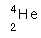atom is and not
13- This is according to the Auf-bau principle which states that the lower energy sublevels are filled first then the higher ones so the electronic configuration of atom is ( ) but not because (1s) is lower energy than (2s)

14- The sublevel (f) is saturated with (14) electrons
14- Because it contains seven orbitals and each orbital is filled with (2) electrons.

15- It is impossible practically to determine both of location and the speed of electron at the same time.
15- Because the apparatus used will change either the speed or the location of the electron.

16- It is wrong to consider the electron as a negative charged it is particle only.
16- Because the electrone according to "De broglie" principle has a dual nature i.e. it has wave property in addition to its partical property.

17- The atom is electrically neutral according to Rutherford's concept.
17- Because the number of protons (+ve) charge inside the nucleus equals to the number of electrons (-ve) charge out side the nucleus.

19- The electron prefers to be single in the orbital than to be paired with another one.
19- Because this is preferable to the atom from the energy point of view due to the repulsive force between the two electrons in the same orbital.

20- Any orbital can not be occupied by more than two electrons.
20- Because the electron rotate around its own axis in either a clockwise and anticlockwise direction. This mean that the spin quantum number has only two possible values.

d) Complete the following sentences
1- The electrons prefer to occupy the orbitals of the same sublevel...... then .......... and not transfer to higher ........... because that is more stable to the atom.
1- Alone - pairing - energy sublevel

2- The maximum number of electrons in the (p) sublevel is ......... while in the (d) sublevel is ..........
2- (6) - (10)

3- The third level saturated with ....... electrons while the 5th level saturated with .....
3- (18) - (32)

4- The 4th principal energy level (N) has ....... sublevels, ....... orbitals and ......... electrons.
4- (4) - (16) - (32)

5- The excited atom is the atom which gained ............ and then ......... or .............. is transfered from its original level to ..............
5- energy - one electron - more - higher one.

6- The number of orbitals in (3p) sublevel is ........... and that in the (4p) sublevel is ..........
6- three - three.

7- The energy of the electron depends on ....................................... while the energy of the level increases ...........................................
7- The energy of the level where it is found. as go far from the nucleus.

8- The sublevel (4s) is filled with electrons before the sublevel (3d) because ...................
8- it is less in energy

9- The number of orbitals in (f) sublevel is ............
9- seven

10- An element with atomic number (18) its electrons can be distributed in a number of sublevel equal ............... and number of orbitals equal ........
10- (5) - (9)

11- The number of sublevels in any prinicipal energy level (n) is ........ and the number of orbitals is ...... and the number of electrons are ........
11- n - -

c) Write the scientific expression "term" questions:
1- A pure simple substance that cannot be changed to simpler forms by the tradiational chemical methods.
- Element

2- A very fine negative particles, move in straight lines, and have a thermal effect.
- Cathode rays.

3- Atomic model, which considered the atom as a sphere of a uniform positive electricity inside it equal number of negative electrons.
- Thomson's atomic model.

4- Chemical susbtance that lays glowing of alpha particles on collision it.
- Zince sulphide ZnS

5- A stream of invisible rays was emitted from the cathode causing a fluorescent glow on the tube wall.
- Cathode rays.

6- The amount of energy absorbed or emitted when an electron jmups from one energy level to another.
- The quantum.

7- The amount of energy gained to or emitted when the electron transferred from one energy level to another.
- (The quantum)

8- Regions of space around the nucleus in which the electron most probable exists.
- The electron cloud

9- The region of space around the nucleus which has a great probability of finding the electron.
- (The electron cloud)

10- No electron pairing takes place in a given sublevel until each orbital contain one electron.
- (Hund's rule)

11- An expression is used to describe any orbital.
- The electron cloud.

12- A number that defines the energy sublevel.
- subsidiary quantum number.

13- The electrons occupy orbitals in the order of increasing orbital energy, the lowest energy orbital are filled first
- (Auf-bau principle)

14- It is impossible practically to determine both the loaction and the velocity of the electron at the same time.
14- (Heisenberg unsertainty principle)

15- A number that defines the principal energy levels in the atoms.
- Principla quantum no.

16- A number that defines the orbitals of a given energy sublevel.
- Magnetic quantum No.

17- Every moving body is assoicated with a wave motion which has some properties of light waves.
- (Dual nature of the electron or De Broglie principle)

18- A number that defines the describs the motion of an electron around its own axis.
- Spin quantum No.

19- When an electrically charged particle moves in an orbit it will lose its energy gradually by emmission of radiation resulting in a gradual decrease in the orbit radius.
- (Maxwell's theory).

20- Electrons occupy the orbitals in the order of increasing orbital energy the lowest energy orbitals are filled first.
- Auf bau principle.

21- The number which defines the principal energy level and the number of electrons which saturate every principle energy level.
- The principal quantum number.

22- The number which describes the spin motion of an electron around its own axis.
- (the spin quantum number )

23- No electron pairing takes place in a given sublevel until each orbital contains one electron.
- Hund's rule.

24- An atom acqires an amount of energy sufficient to transfer one electron from its original energy levels to a higher ones.
- (The excited atom).

25- The no. of the positive charges (protons) inside the atomic nucleus.
- atomic number.

V) Write down a short account on:
1) Dalton's atomic theory:
- The matter is composed of atoms, which is solid and undividable, and the atom of each element are different from the atoms of any other element.

2) Properties of Cathode rays:
- They are very fine negative particles
- They are affected by both electric and magnetic fields.
- They do not differ in behavior, if the material of the cathode or the gas used are changed.

3) Thomson's model of the atom.
- The atom is a sphere of a confirom positive electricity in which a number of negatively charged electrons are embedded in to make the atom electrically netural.

4) The atomic number
- The Atomic number: is the no. of protons inside the nucleus of an atom, or the no. of electrons around the nucleus.

5) Auf-bau principle.
- Auf bau principle: "Electrons occupy the orbitals in the order of increasing orbital energy, the lowest energy orbitals are filled first".

6) Hund's rule.
- Hund's rule: "No. electron pairing takes place in a given sublevel unitl each orbital contains one electron",

7) Heisenberg uncertainty principle.
- Heisenbergy uncertainity principle: "The determination of both the velocity and the position of an electron at the same time is practically impossible".

8) The dual nature of the electron.
- The dual nature of the electron : i.e, the electron has wave property in addition to its particular property.

9) Bohr's model of the atom.
- Bohr's model of the atom:
a- Electrons orbit the nucleus in a rapid movement without emission or absorption of any amount of energy.
b- electrons orbit the nucleus only in definite allowed energy levels, they cannot be found at intermediate distances.
c- Each electron in the atom had a definite amount of energy depending on the distance between its energy level and the nucleus, the energy of any level increases as its radius increases.
d- The electron remains in the lowest allowed energy level in its ground state. However, if it aquires a quantum; it becomes excited and jump to some higher energy level... to return to its original level it loses the same absorped quantum in the form of radiations.

10) The electron cloud.
- The electron cloud: an expression which is used to describe any orbital.

11) The principal quantum no. (n) see no. 5 in Q. IV
- The principal quantum no. : (n): see No. 5 in Q IV.

12) The subsidiary quanutm no. (l).
- The subsidirary quanutm no. : (l): see No. 4 in Q. IV.

13) The magnetic quantum no. (m).
- The magnetic quantum no.: (m) see No. 6 in Q. IV.

14) The spin quantum no.
- The spin quantum no. : (ms) see No. 7 in Q IV.

15) The quantum
- The Quantum: see No. 1 in Q. IV.

VI. Draw a diagram to show:
The quantum numbers of the electrons occupying the first three energy levels.
- Show the diagram

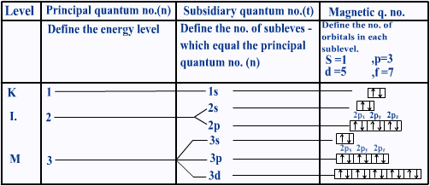

Questions and Answers 2:

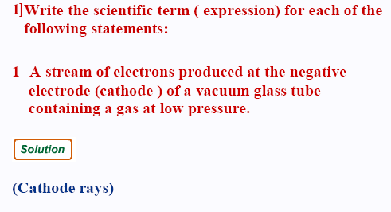

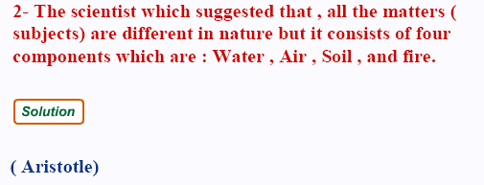
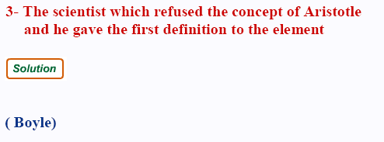
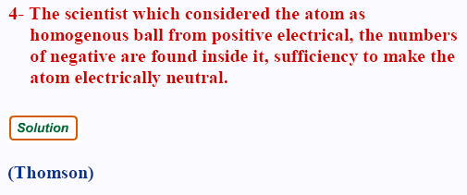
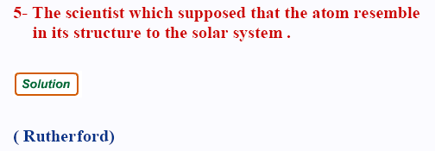

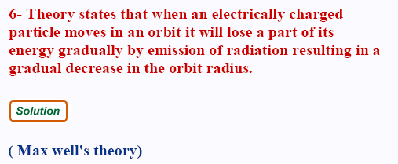
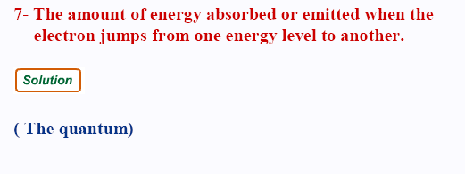
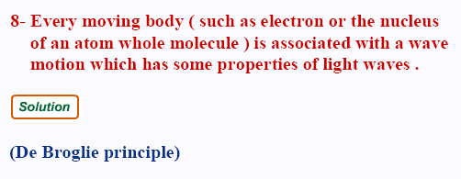
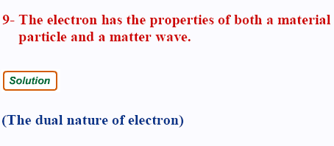

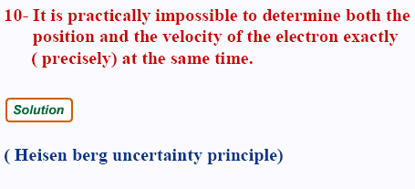
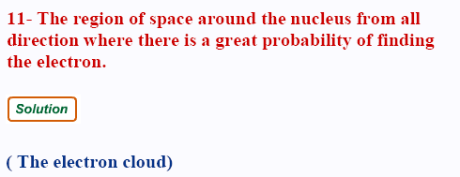
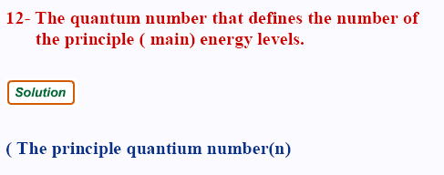
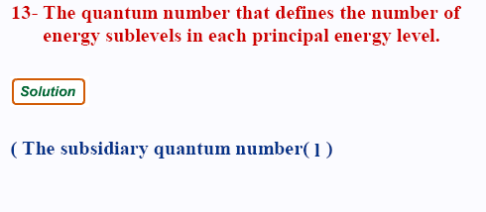
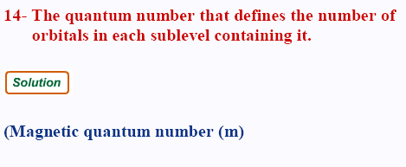
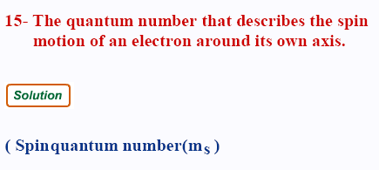
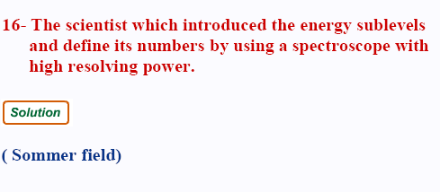
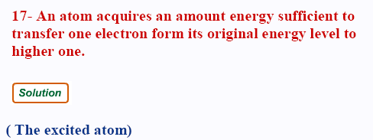

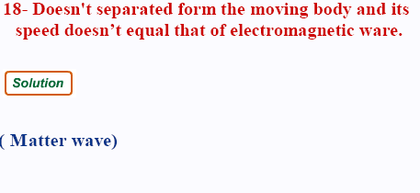
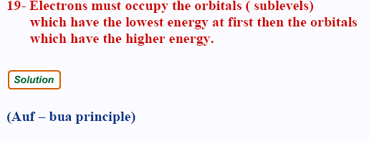
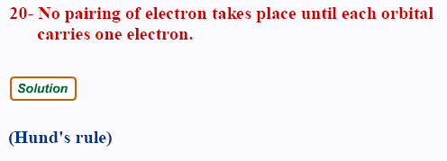
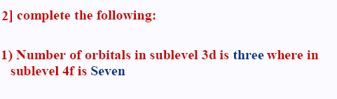

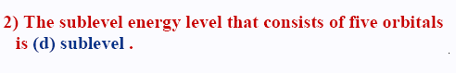
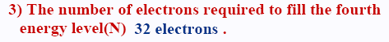
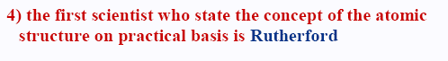
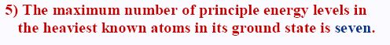
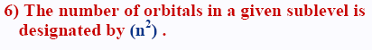
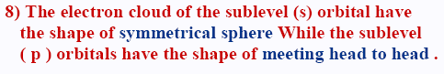
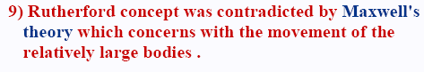
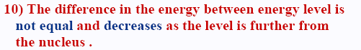

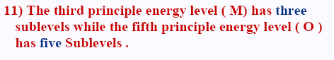
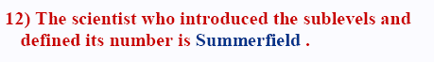
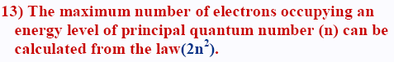
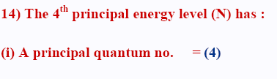
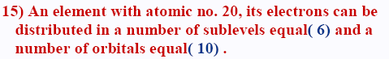
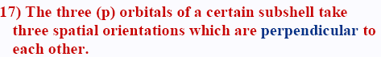
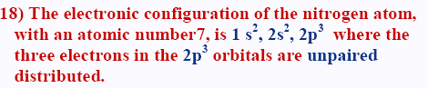
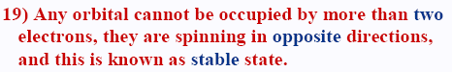
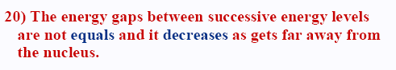

SOLVE BY YOURSELF :

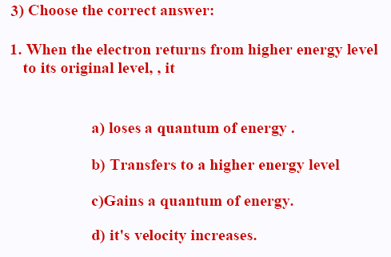
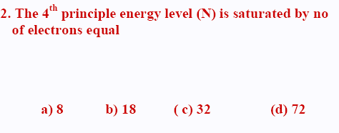

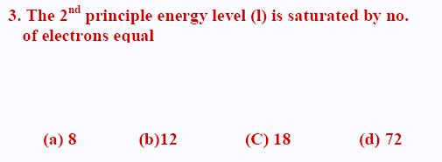
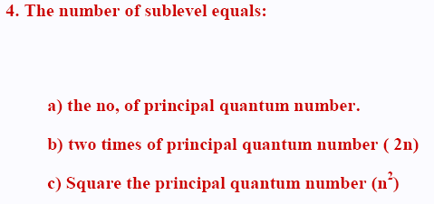
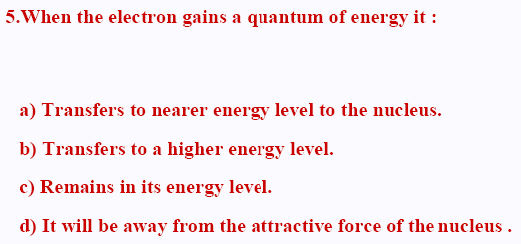
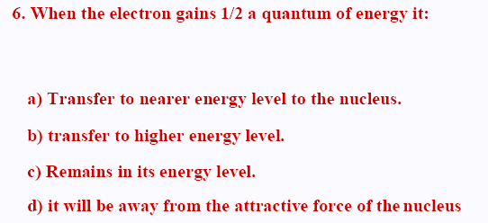
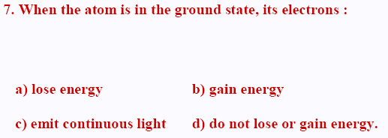
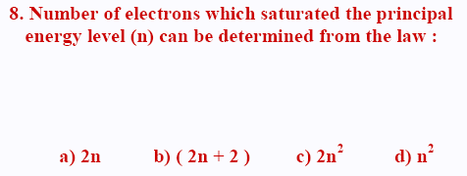
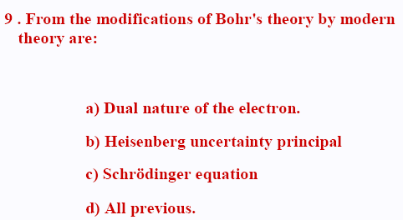
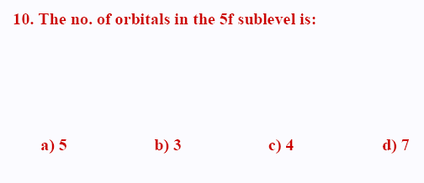
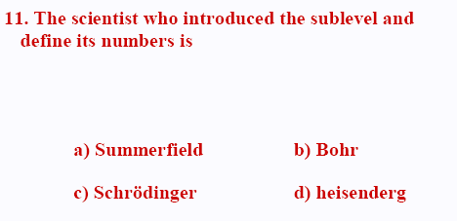
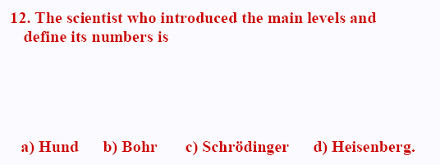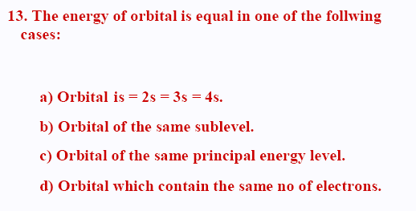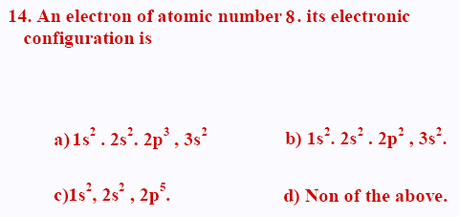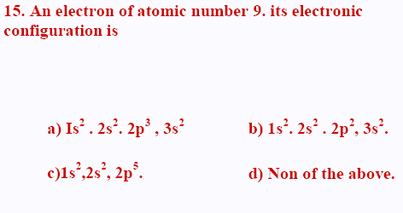
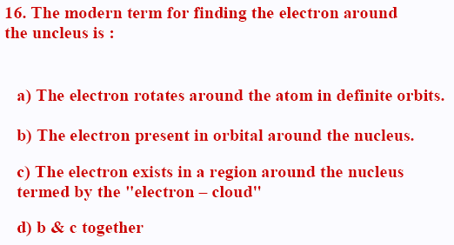
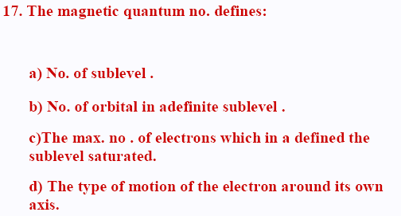
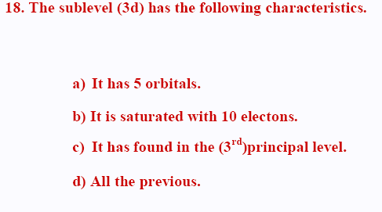
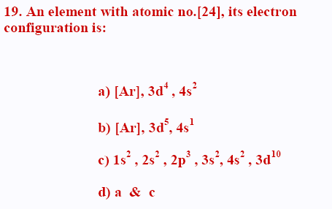
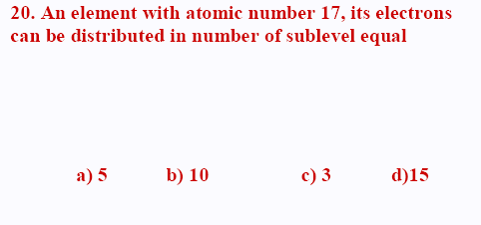

الاستاذ محمد الجمل
استاذ الكيمياء البيطاش الاسكندريه

0122535614
0168373736

