the pyramids

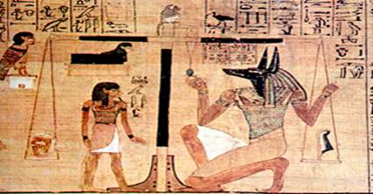

Search for the pyramids area
Before talking about the famous pyramids of Giza, we must know how the emergence of the idea of the pyramid or the pyramid in general.
The pyramid is a tomb which is the maximum reached in the thought of ancient Egyptian architecture, and the graves were considered the most important thing is for the ancient Egyptian belief in immortality, and was dependent on the state of the cemetery on the material and social status of the family graves in the general population was composed of a vertical oval hole sector,
Cover the cut stone and placed by the pieces of wood or stone to indicate the location of the graves in the cemetery was a rich-room mud-brick or stone and there is a hole in one of the elements of the sector or the terrible header placed at the bottom of a rectangular stone sarcophagus of the mummy for the development and filling it with stones after the burial and the sand Tombs of Kings was composed of two main parts: --
The first above ground and consists of a room where the effects are mainly held by the deceased's funeral concerts before and after the burial, and the sacrifices made by the walls of the room was filled with Balnicoc and graphics that show the status of the deceased and Positions held and the work was carried out by this and along the main room there is another room separated by thick walls are all the dead and put valuables where smart incense, perfumes, the smell of the room so that the verses.
Tutankhamen's tomb model of a full-fledged royal tombs
The second part in the underground chamber is a vertical one of the pillars in the room, terrible sector ranges from 13 m depth, 26 m Bosfielha there is a horizontal tunnel 1.5 m high, up to the burial chamber in which the coffin for the development of the mummy and burial after the close of the stone basement Bbabin thick and then filling the hole with stones and sand the exterior of the terrace is a building free from all the rectangular ribs parallel to the main entrance points of the original east wall and a horizontal surface was completely normal work of a group of false doors in the northern East.
There was, until the beginning of the third family, ie, the difference between the employee's grave and the tomb of the great and the noble tomb of the king in terms of planning, but since then, the staff and nobles buried in the terraces, while the kings are buried in the graves of a hierarchical form.
Then established Zoser, who was perhaps the first kings of the family, a new form of the graves, which was no doubt inspired by the famous architect architectural Imahotb.
The magnificent tomb in Saqqara, is the architectural wonders of the ancient times.
Pyramid is not the right sense of engineering, but in the range of six degrees or large terraces of the four aspects, to about 60 m high, and the length of its base about 109 m from north to south and about 121 meters from east to west.
There is proof that the architect of this pyramid is a series of these dimensions and the pyramid on Altkberat
Pyramid of Zoser the first of the pyramid or the pyramid-like
The subject of a bench above the square, as developed over the piles of brick terrace regular before. There is room to bury the king and the eleven members of his family on the bottom of the pyramid deep in the rock beneath the surface of the earth, and there are a number of rooms and other Almamran, some decorated Balvians blue mat to simulate the jungle, and stone inscriptions Ptahenia, is King and is the various religious ceremonies.
The present fence rectangular pyramid some 10 meters high

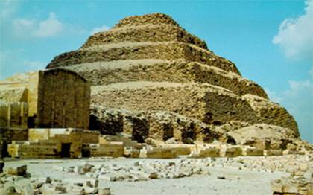

and its surroundings about 1650 meters.
There is a strange phenomenon in this wall, namely, that a terrace at the southern sector, similar to the lower Hjradtha, rooms on the pyramid, with the carved inscription of the king and the internal wall lined Bagayhani blue.
We do not know yet the purpose for which it was built this terrace. It includes the space between the wall and the pyramid on the open courtyards, and buildings of the celebrations, some of solid stone, not by the internal rooms. And as well as the columns of the courtyard in front of the entrance, the buildings on the eastern and southern sides of ad hoc King to be celebrated in his life on the ground. It is the buildings on the northern side of the pyramid, and which were not solid, the basement of the stone statue of the king, sitting, and the funerary temple of the priests for the service which may amount to several years after the death of the King, as well as religious rites Nilbp King.
Built at least three of the kings who left the throne of Zoser, pyramids included. However, it is one of them can be compared to the wonderful Zoser pyramid, even if we take into account their dilapidated condition.
One of the pyramids and is attributed to the King invited Sekhemkhet, has raised global attention when he was found during the excavation (in 1954), as was the coffin of marble in the burial chamber, it was found that at the hands of the thieves did not tamper with, however, that the lifting of coverage even if empty.
You can see the second phase in the evolution of the building of the pyramids, the pyramid in Maidum located at a distance of 80 kilometers south of Giza.
Honi and probably built the last king of the family and then completed the third Snfro the first kings of the fourth dynasty (about 2670 BC. M.), The first pyramid was built on and then filled the eight degrees of the aspects of the pyramid are the four straight diagonal from the bottom to the top, and perhaps we can guess that the top was pointed However, it can not be demonstrated, because the summit had been destroyed.
Then follow the following format in the pyramids to look on the new image (the pyramid), and shows the buildings adjacent to this development continued after the pyramid with some changes in the details at the end of the history of building the pyramids.
The pyramid was built beside a small burying it perhaps the Queen, on the south side of the pyramid of the original, while built upon the eastern side, and in almost a straight line, and the funerary temple corridor open up the second temple, the Temple, located at a distance of approximately 200 m at the border between the desert and agricultural land.
There Herman Eenspan in Dahshour to the King family Snfro IV (close to south of Saqqara), which are worth mentioning because Mnzerehma feat. In the southern two-mile point of view of the gradient increases abruptly at the point after the mid-high, so-called pyramid, curve, or "twisted pyramid.
The northern neighbor Vmbeni the slope angle of 36'', 43 (approximately equal to the angle of dip of the upper
part of the pyramid curved)

عمل الطالبة / ايه ابراهيم

