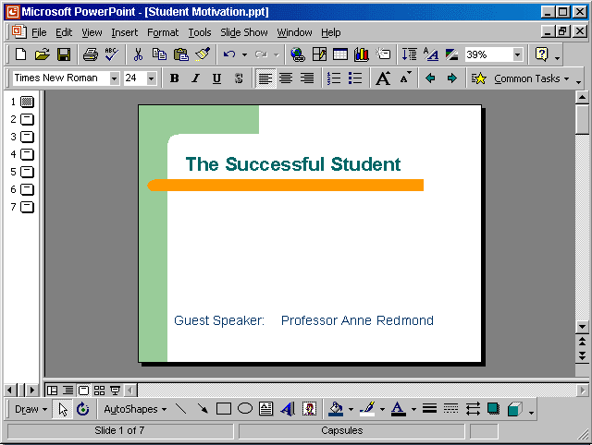

Click on open tool → click on my documents → select Training.ppt →open

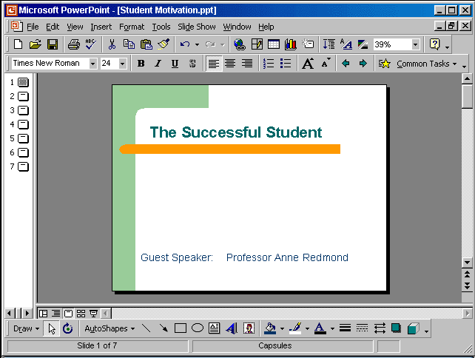


Click on the new tool from the standard toolbar

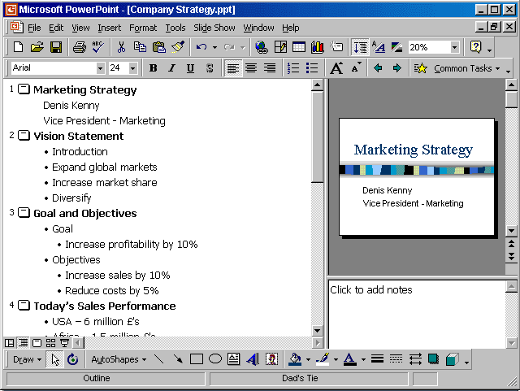
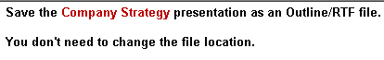

File → save as → use the drop down list in the save as type box and select outline/RTF→ save

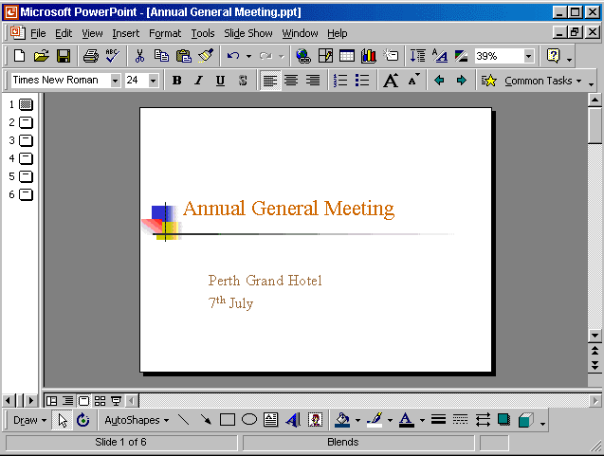
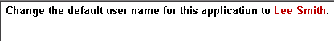

Tools → options → General tab → in the name box delete msingh → type Lee Smith

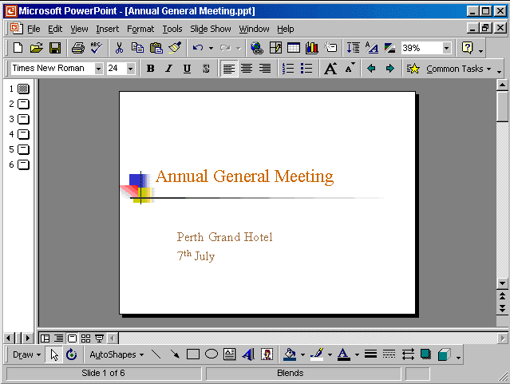


View → select slide sorter

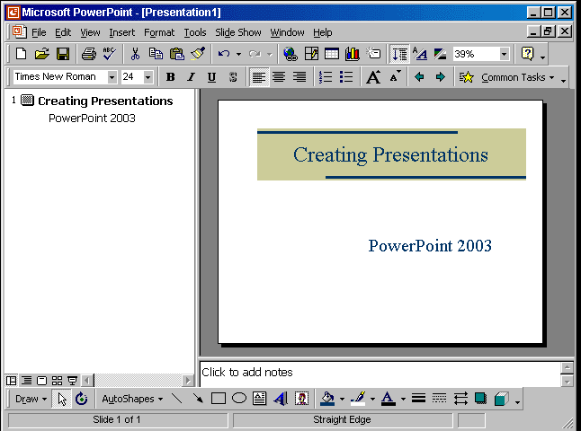

Insert → new slide → select the title slide

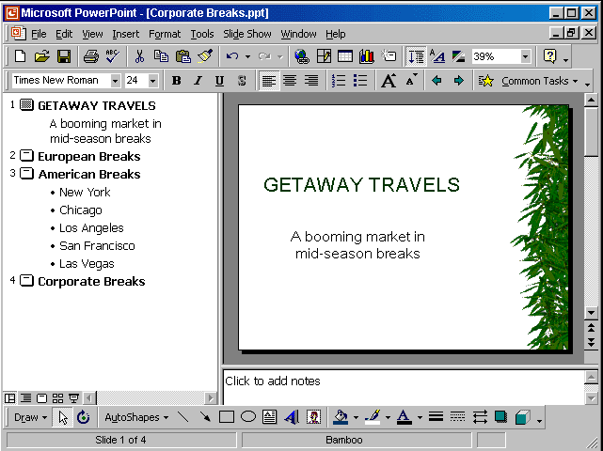


Format → apply design template → select Sunny Days → Apply

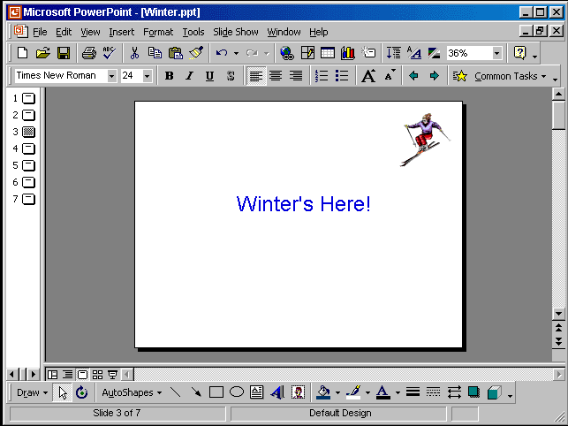

View → master → slide master → select the graphic → press delete from the keyboard

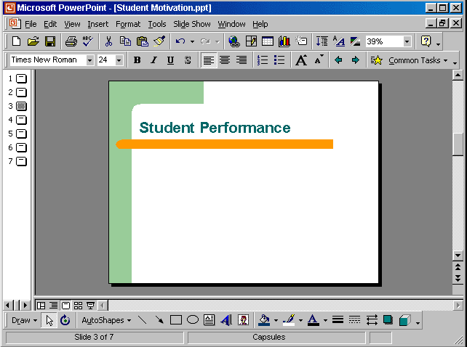

View → header and footer → check the slide number → check don't show on title slide → apply to all

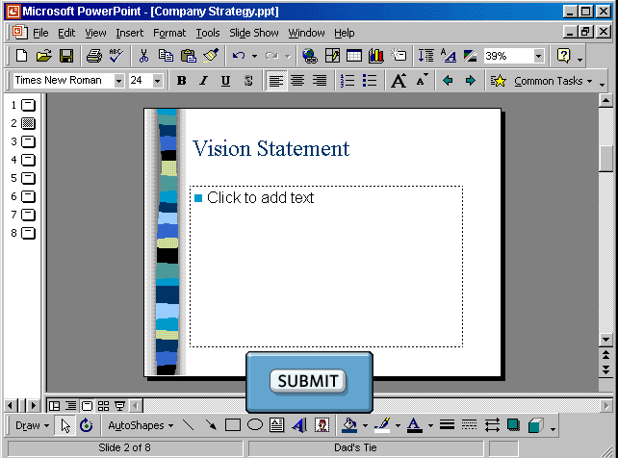


Put the cursor on click to add text → type Introduction

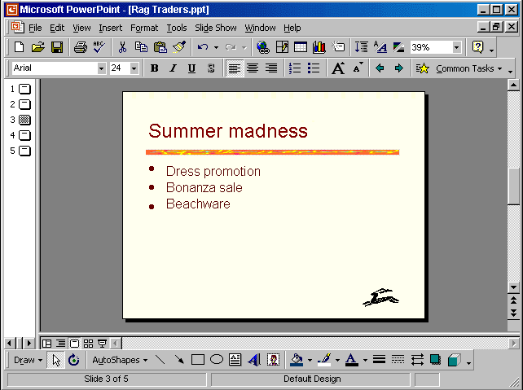


Delete the name Bonanza sale and type Mammoth sale

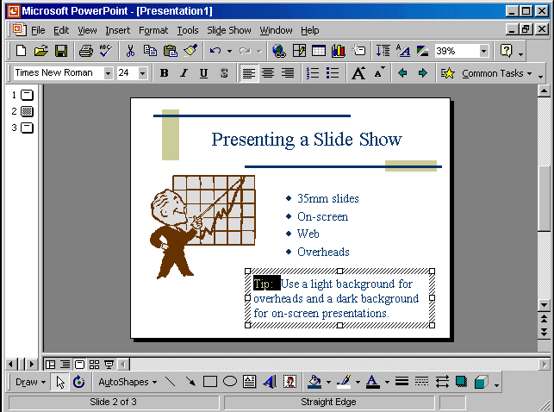

Format → change case → select upper-case → ok

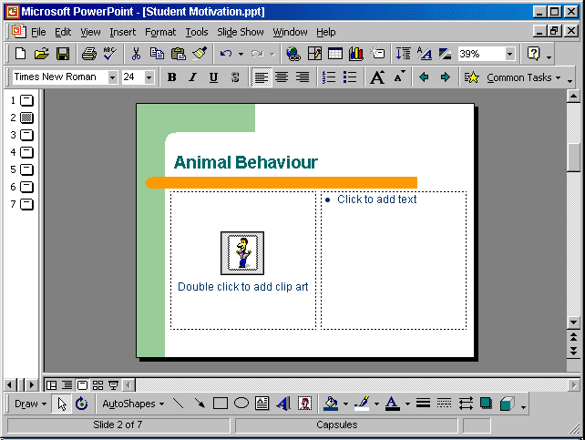

Double click on the clip art icon → select animals → select the lion → apply

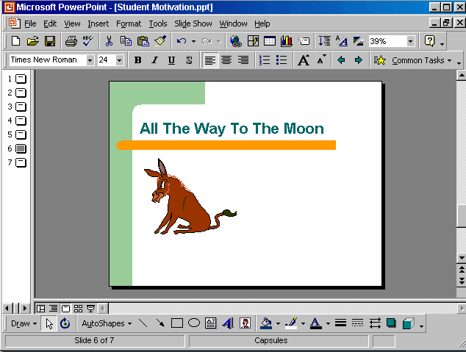


Right click on the graphic → cut → select slide number 7 → right click paste

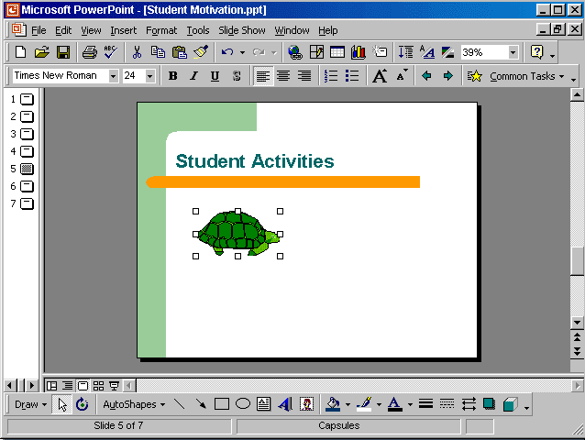



Put the cursor here

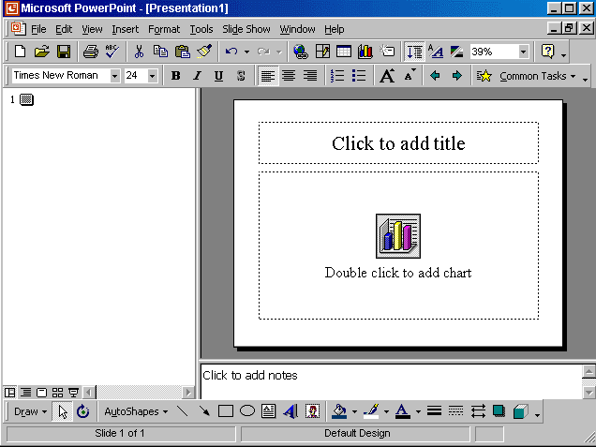


Double click on the add chart → select the cell b1 and type 50.3 → press enter from the keyboard

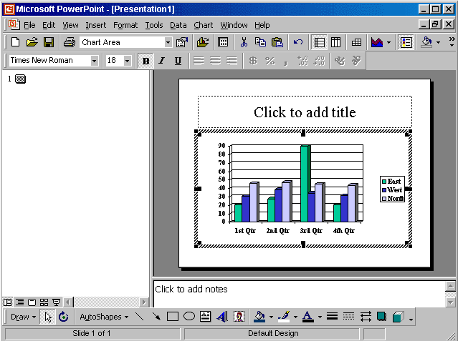


Click on the chart type tool from the standard toolbar → from the drop down list select bar chart

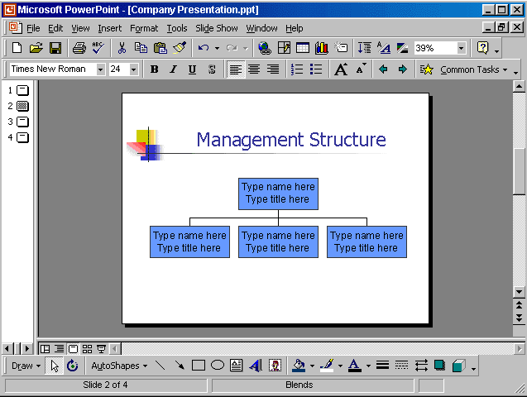


Double click on the organisation chart → in the first box → select the type name here and type Sam Elliot → select type title here and type Chairperson → click on any box from the below

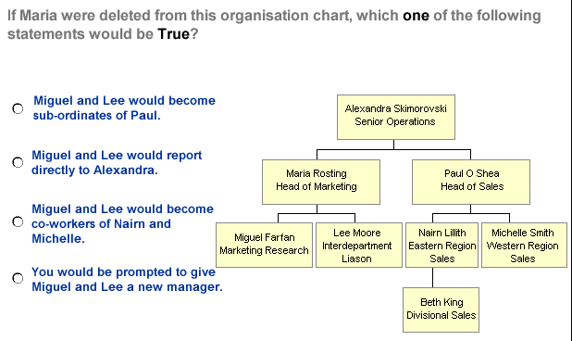
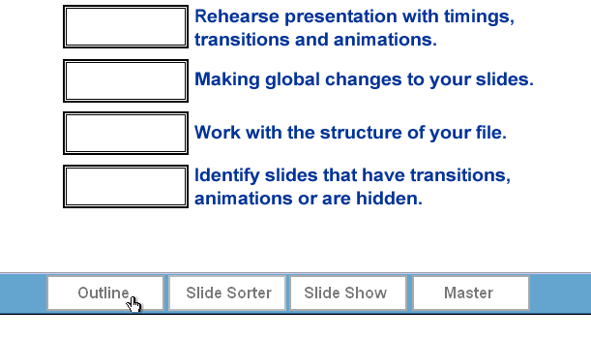

- Miguel and Lee would report directly to Alexandra

Slide show

Master

Outline

Slide sorter

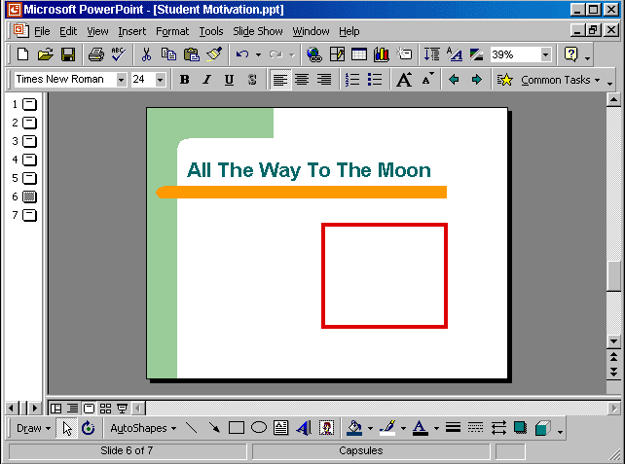


Click on the rectangle tool from the drawing toolbar → put the cursor in the red square and drag

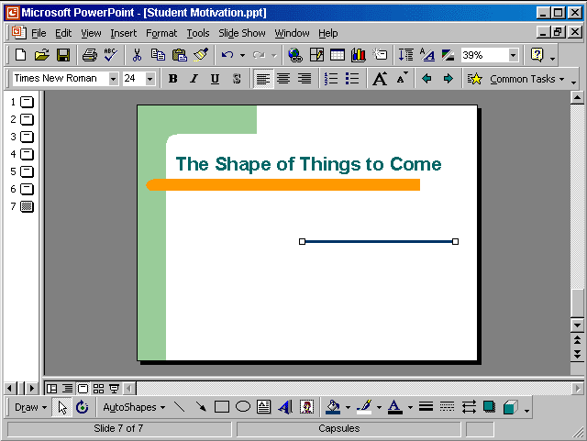


Click on the arrow style tool from the drawing toolbar → select any line with arrow

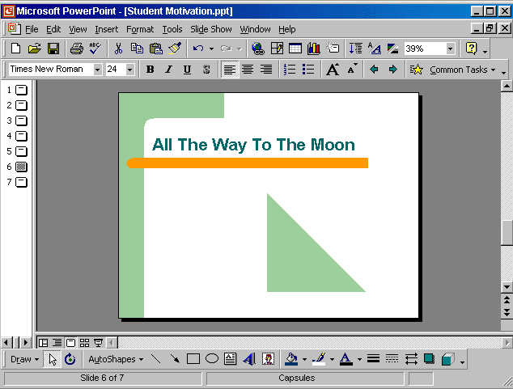

Select the triangle → select the shadow tool from the drawing toolbar → select any shadow

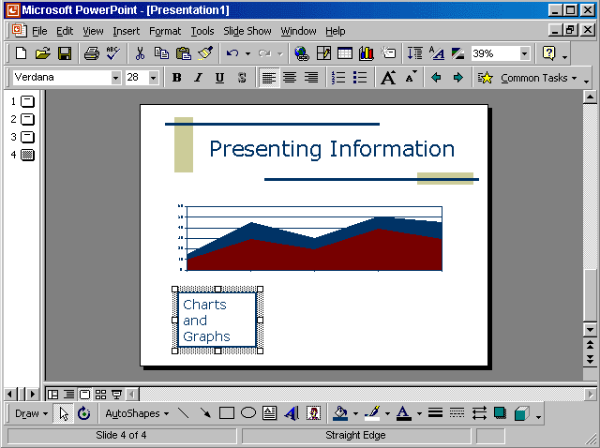




Click here

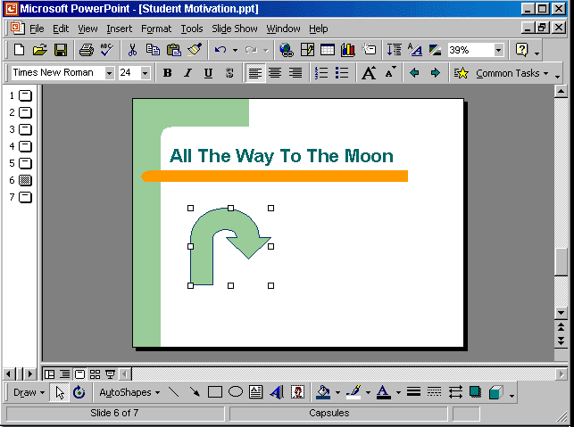


Right click on it and select copy → select slide 7 → right click and select paste

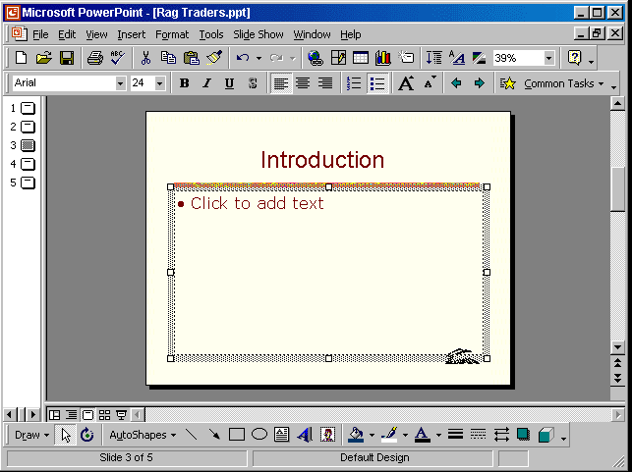

Slide show → preset animation → select flying

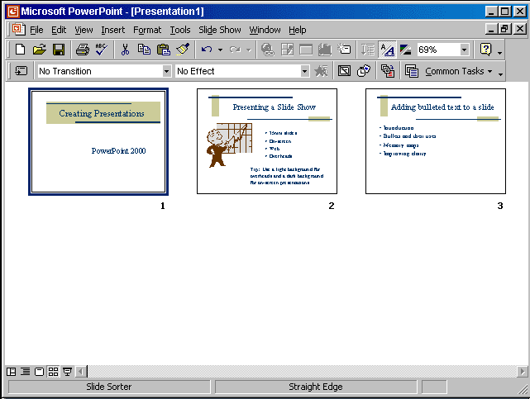


Slide show → slide transition → in the effect section select from the drop down list box in → select medium → apply

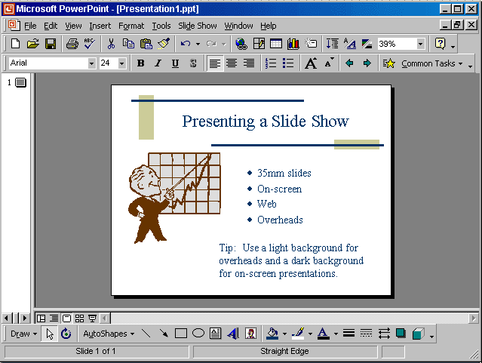


File → page setup → from the slide size for select A4 paper → ok

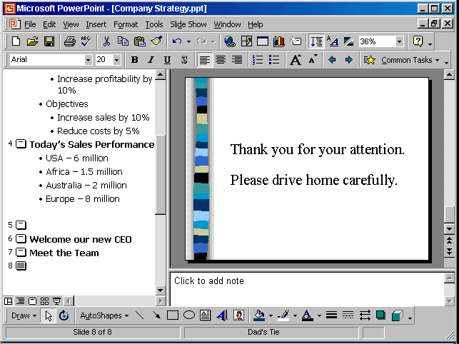


Click on the click to add note → type Presentation available online → click any where

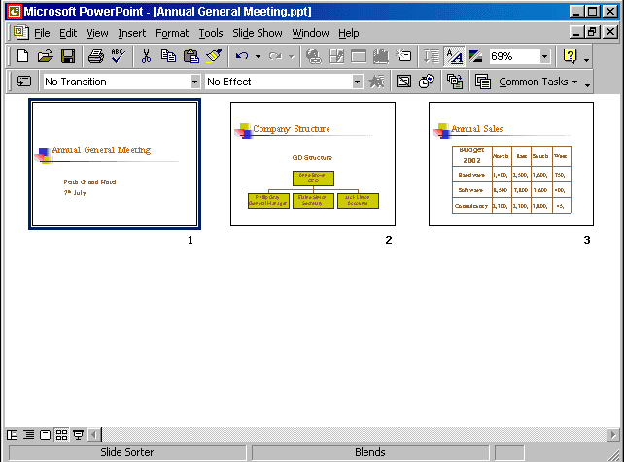


Right click on slide number 2 select copy →right click after slide 3 select paste

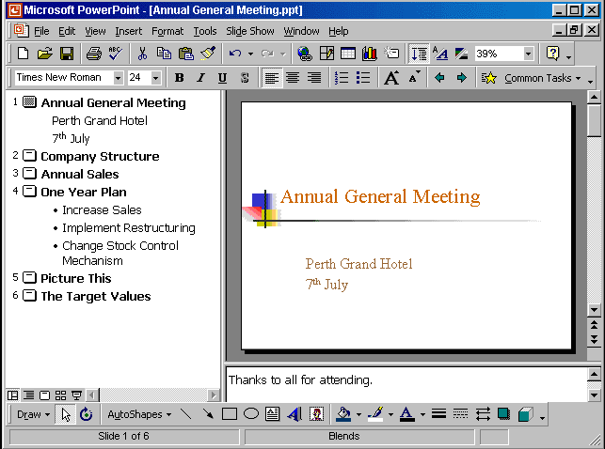
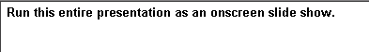

Slide show → view show

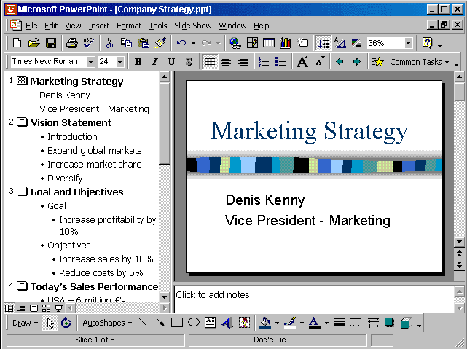


Help → Microsoft PowerPoint help → type 35 mm slides → search

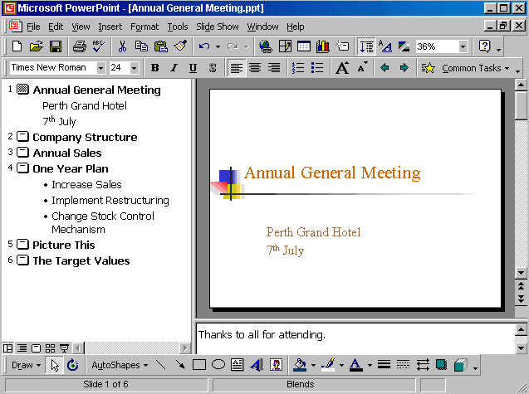

View → notes page

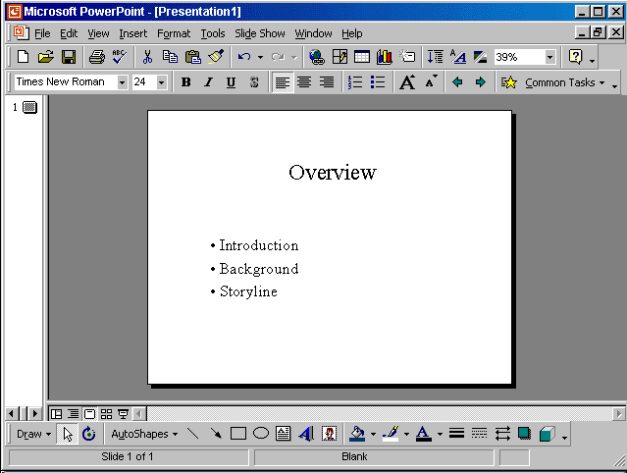

Format → slide layout → select 2 columns text →reapply

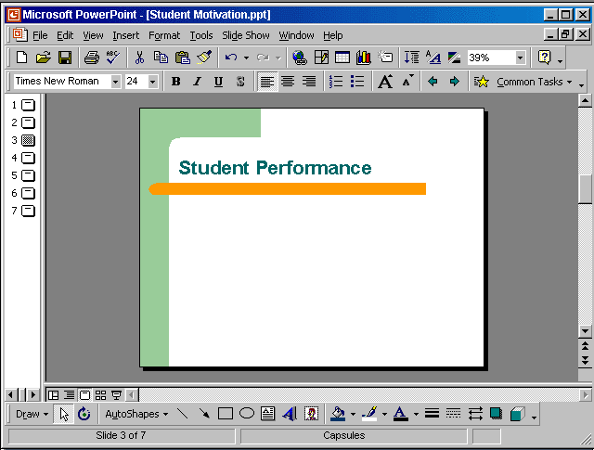

View → header and footer → in the footer box type Draft → apply

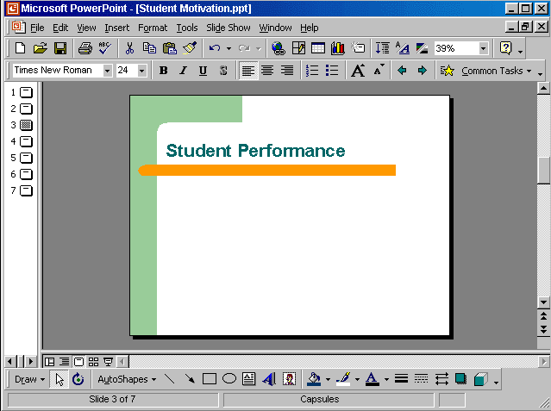

View → header and footer → in the fixed box type 04/05/03 → apply all

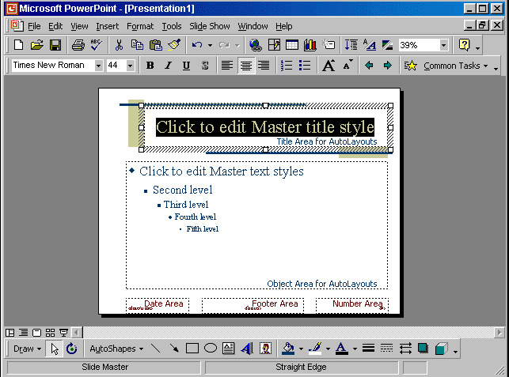

From the font color tool in the drawing tool bar select the purple color

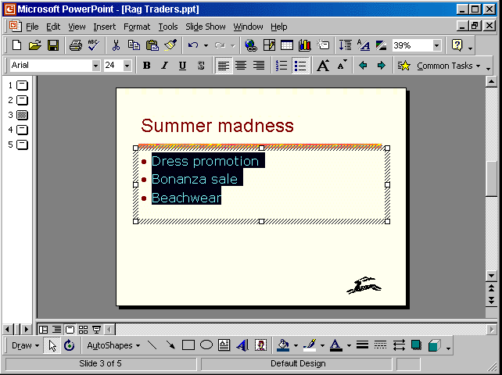


Format → line spacing → in the after paragraph section select 0.2 → ok

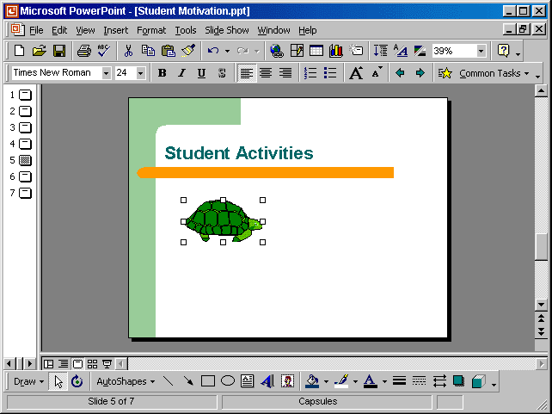

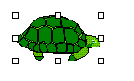

Click here

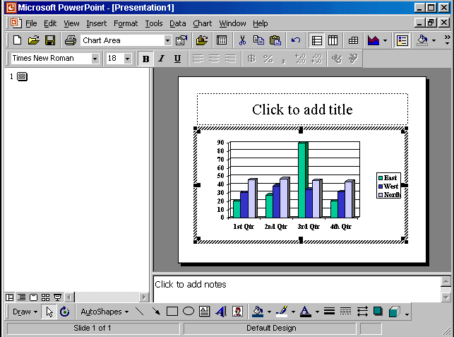

From the chart objects drop down list select series west → from the fill color tool in the standard tool bar select yellow

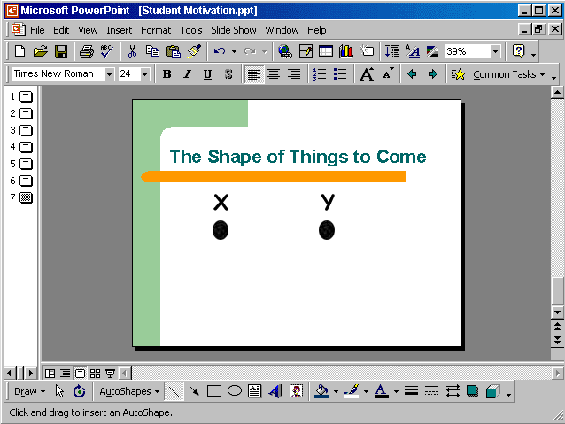


Click on the line tool from the drawing toolbar → draw the line from x to y

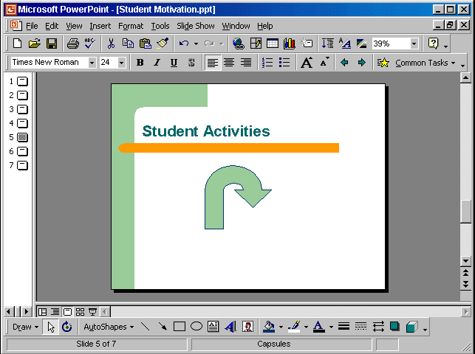


Select the auto-shape → select draw from the drawing toolbar → select rotate or flip → select rotate right

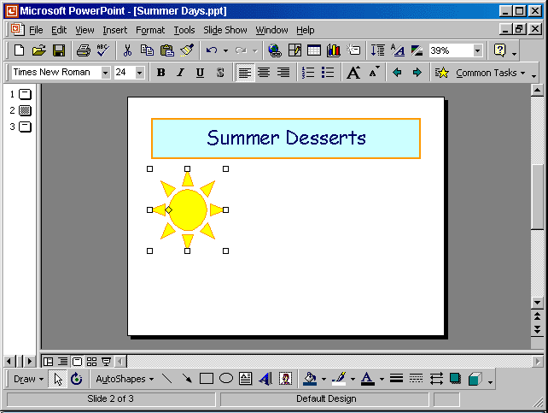
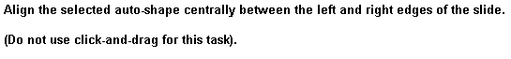

Double click on the auto shape → position tab → in the horizontally form select center

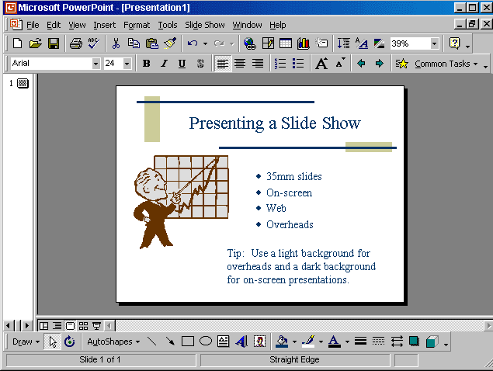


File → page setup → in the slides size for select onscreen → ok

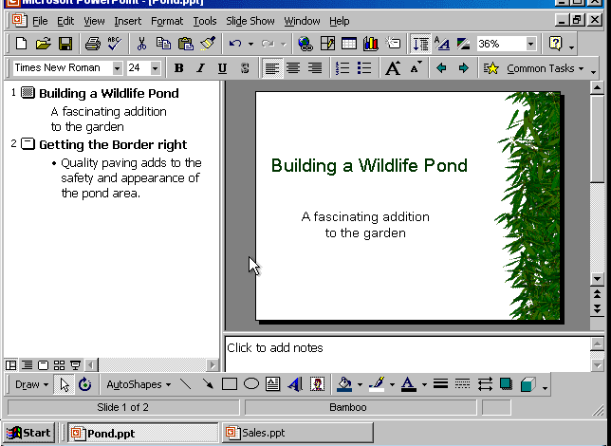


Select sales.ppt from the task bar

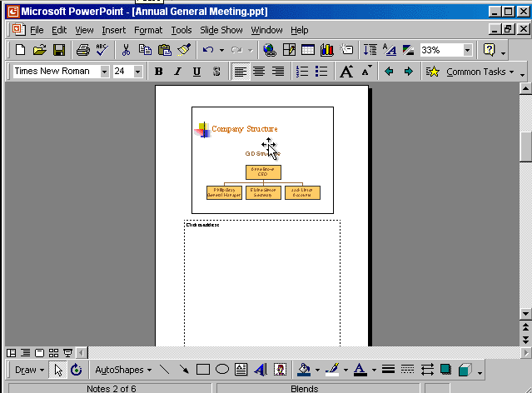


From the zoom tool from the standard toolbar → use the drop down list and select fit

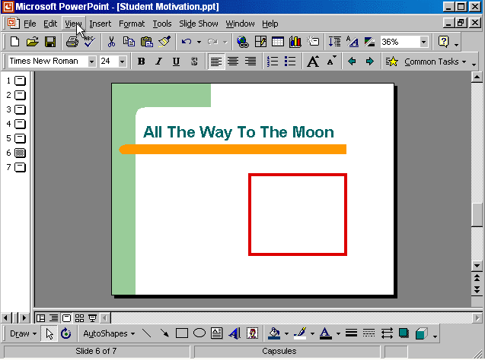


View → slide master → select the oval tool from the drawing toolbar → draw it in the red box

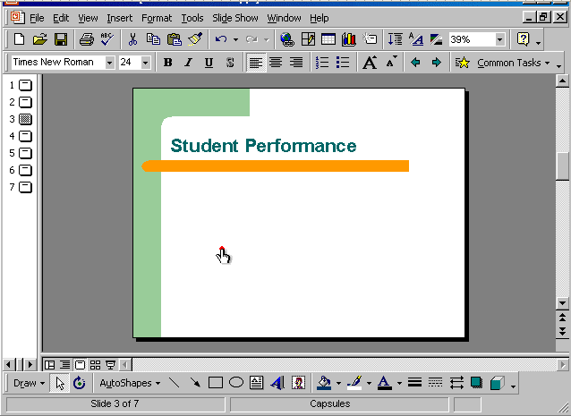

View → header and footer → check the date and time → and select update automatically → apply to all

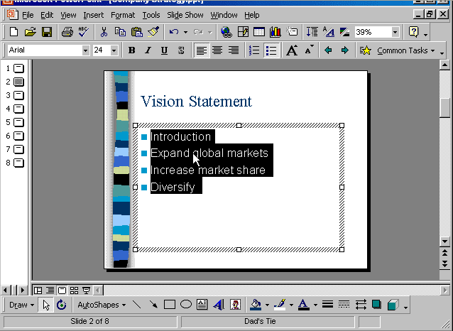

Format → bullets and numbering → select this bullet → ok

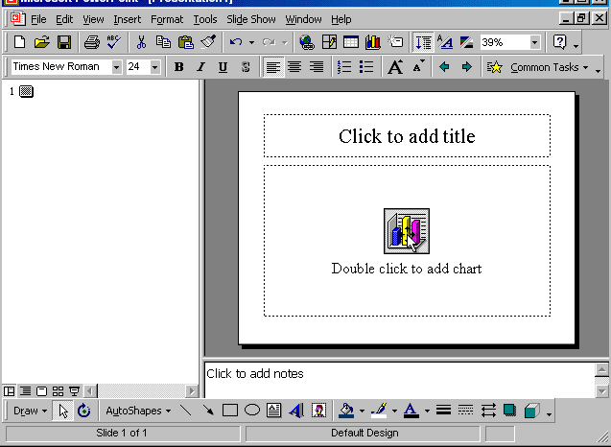

Double click on the add chart → select the cell contains the word East and type Sales → press enter

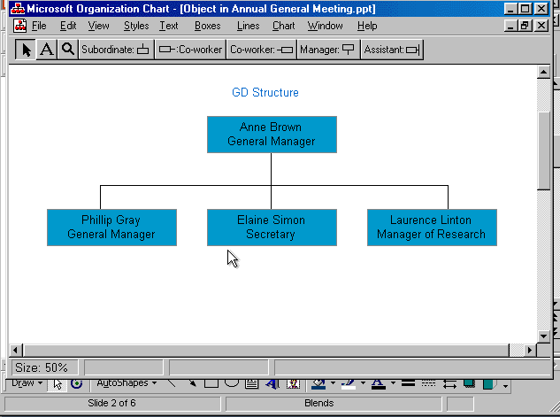


Click on the subordinate button → click on the Laurence box

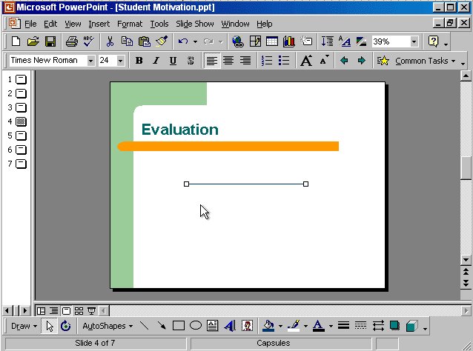


Click on the line color tool from the drawing toolbar → select blue

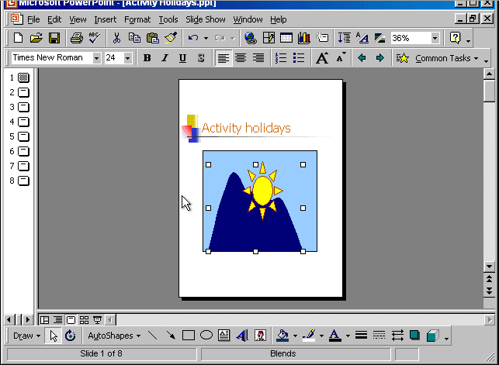


From the draw tool in the drawing toolbar → select order → bring to front

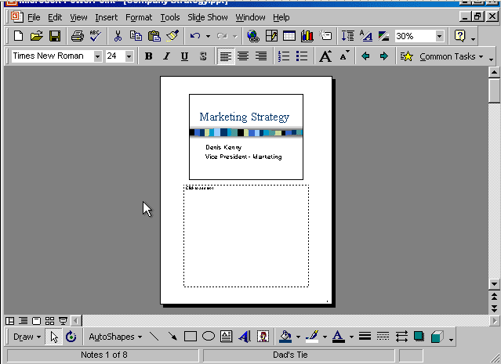

File → print → in the print range section →in print what section select Notes pages → select slides and type 2-5 → ok

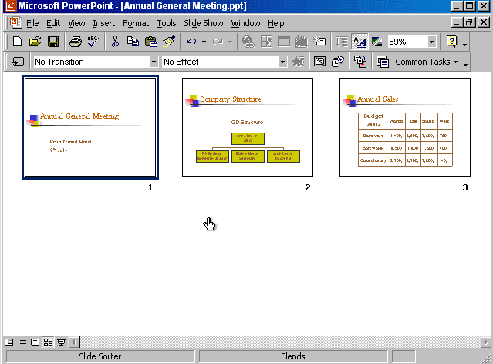


Right click on slide 3 → select hide slide

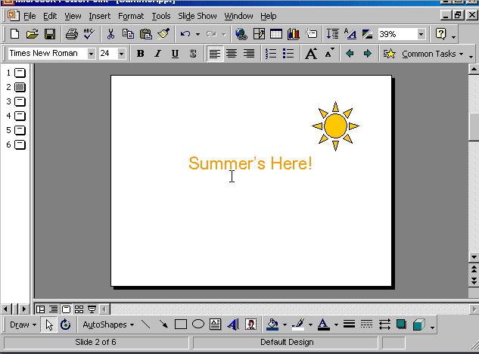


Format → back ground → from the drop down list select this color → apply

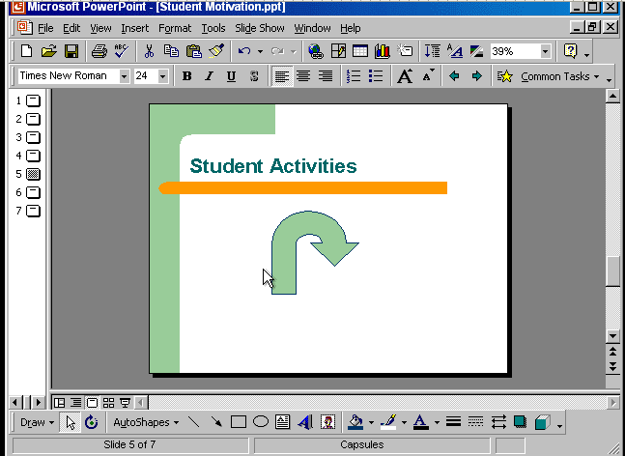


Select the auto shape → click on the draw tool from the drawing toolbar → select flip horizontally

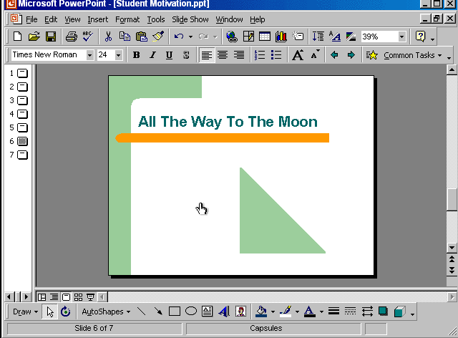


Select the auto shape → press delete from the keyboard

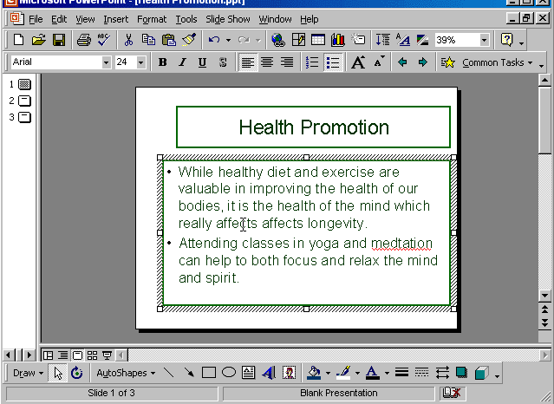


Right click on the word meditation

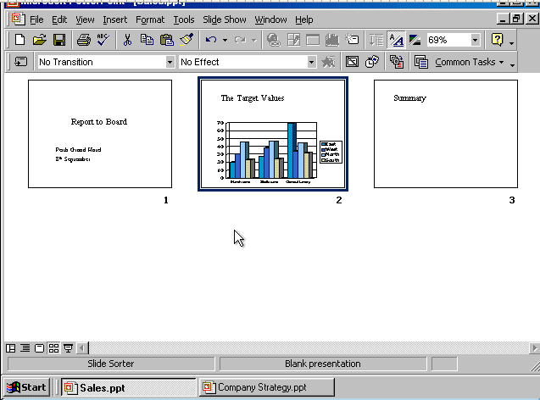


Right click on slide 2 → select copy → Select Company Strategy from the taskbar → right click after slide 1 and select paste

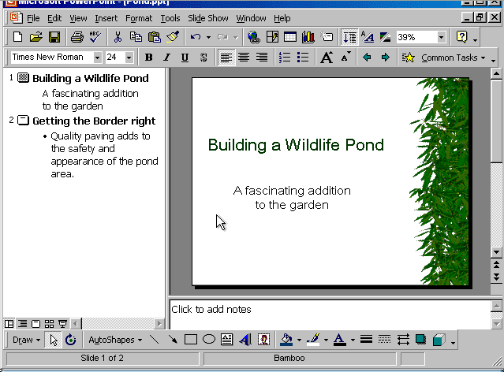

Insert → picture → clip art → animals → select frog → insert

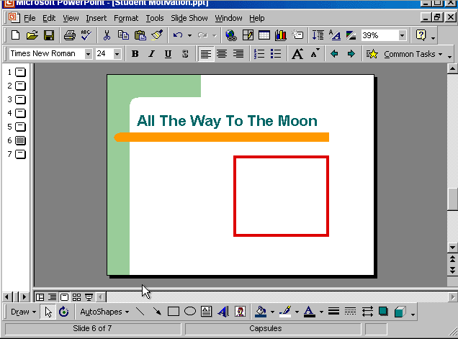


Select text box tool from the drawing toolbar → put the cursor in the red square and draw the text box

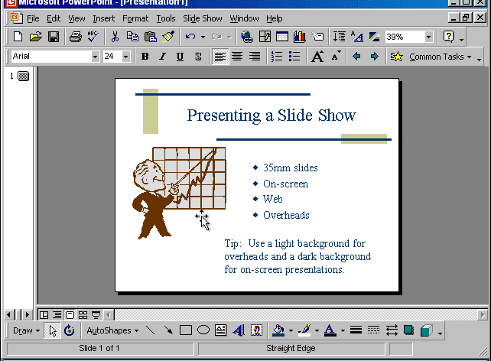

File → page setup → in the slides sized for from the drop down list select 35 mm slides → ok

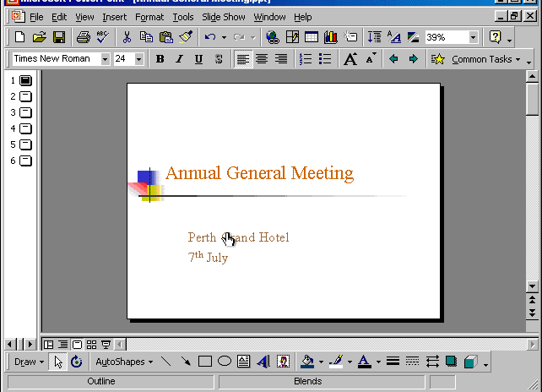


File → print → in print what section → select outline → in the number of copies section select 3 → ok

