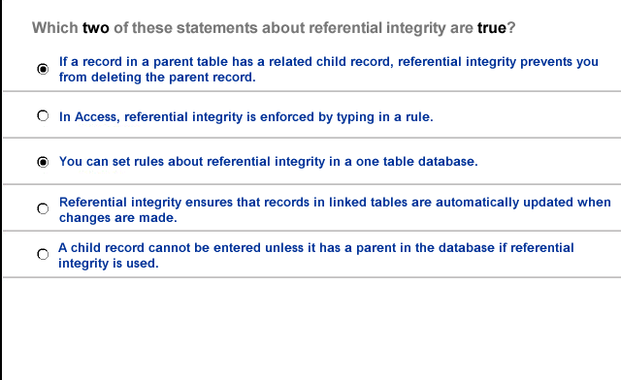

- If a record in a parent table has a related child record referential integrity prevents you from deleting the parent record
- A child record cannot be entered unless it has a parent in the database if referential integrity is used

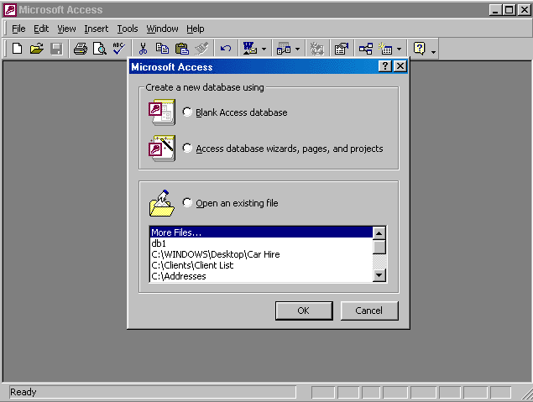

Select open an existing file → select c:\windows\desktop\car hire → ok → type icoffey in the name box → ken*72 in the password box

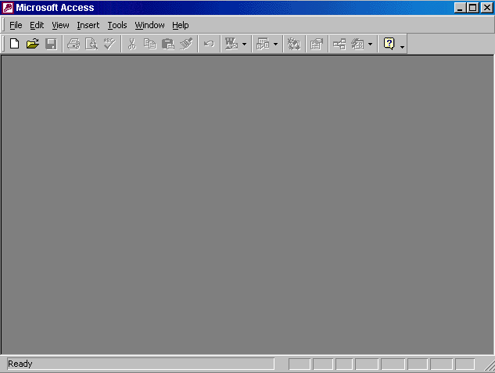
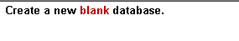

Click on the new tool from the database toolbar → select database → ok

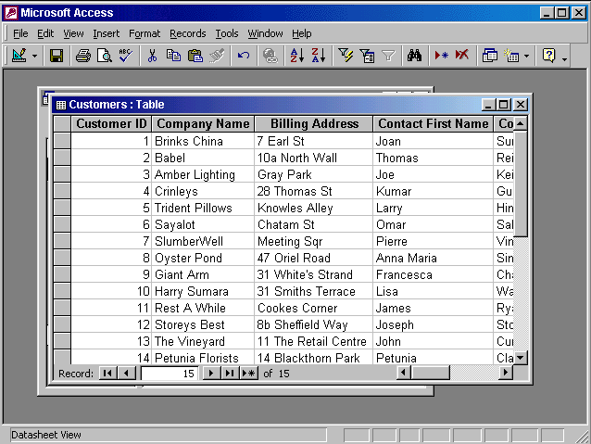
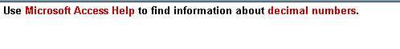

Help → Microsoft access help → type decimal numbers → search

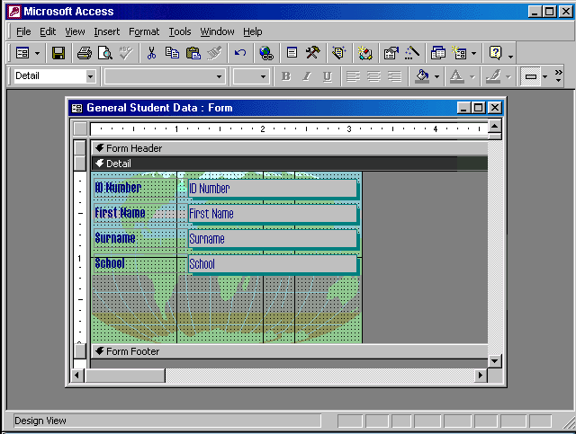


View → toolbars → select formatting (form/Report)

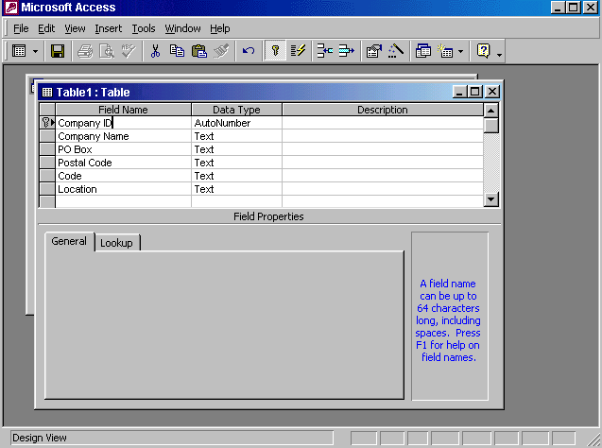
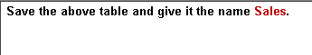

Click on the save tool from the table design toolbar → type Sales → ok

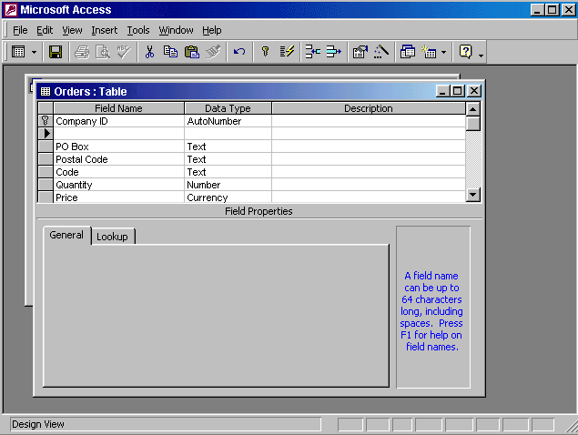
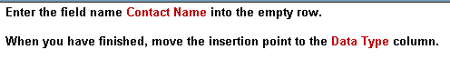

Type Contact Name → press Tab from the keyboard

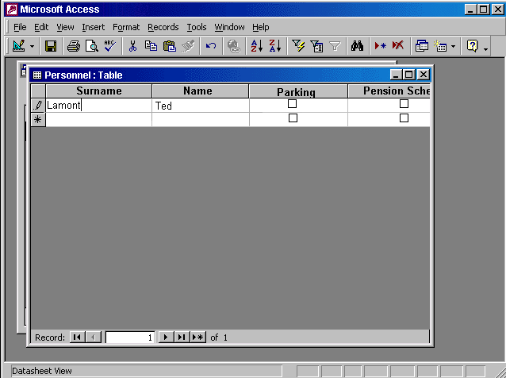


Use the back space from the keyboard to delete Lamont → type Dawson → press Tab from the keyboard

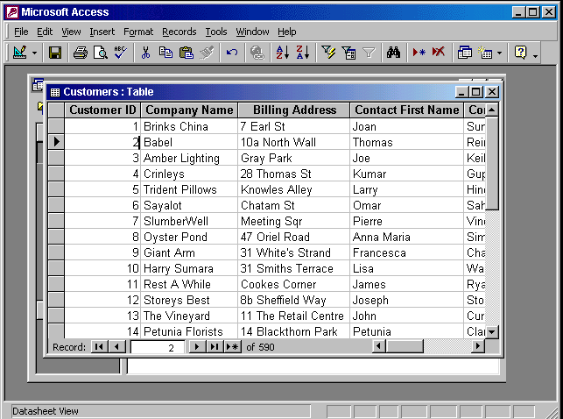
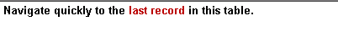

Click on the button

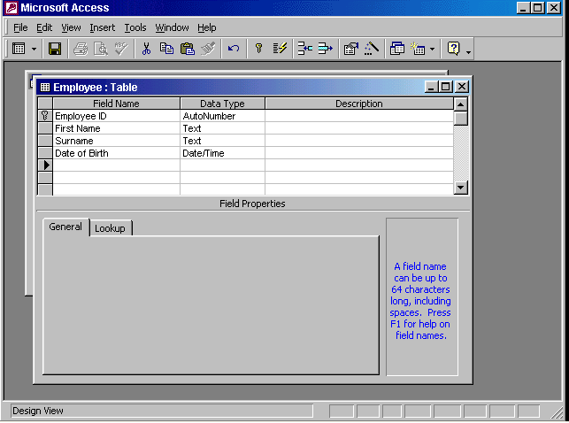


Click on save tool from the table design toolbar → close the table

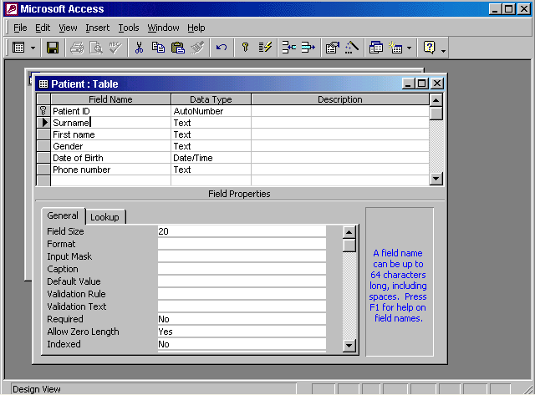
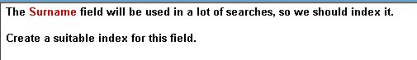

In the indexed box → choose yes (duplicates ok)

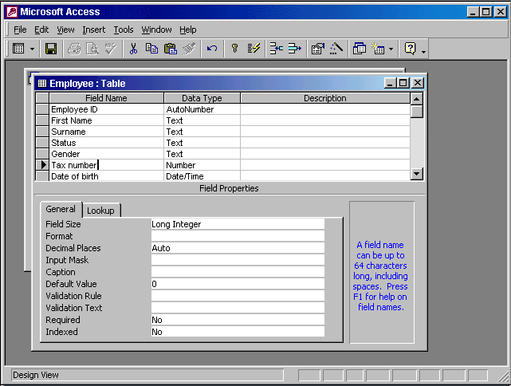

Put the insertion point in the Date of birth field → in the format box → select long date

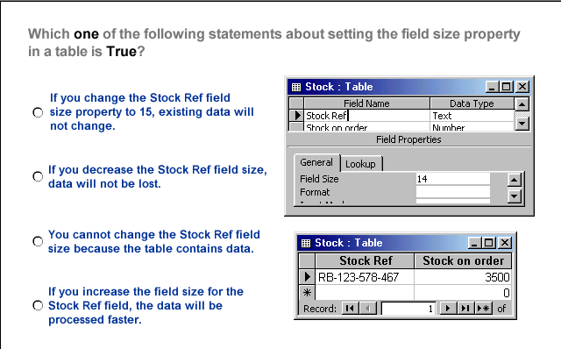

- If you change the stock Ref field size property to 15 existing data will not change

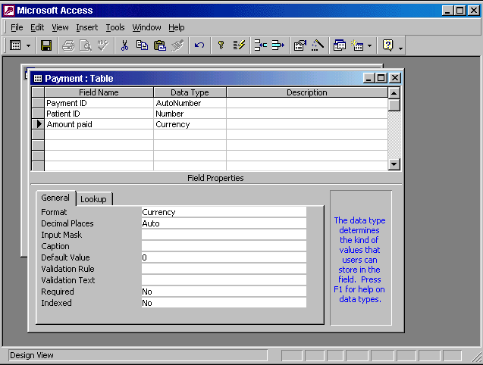
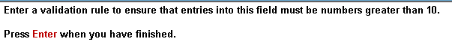

In the validation Rule box type >10 → press enter from the keyboard

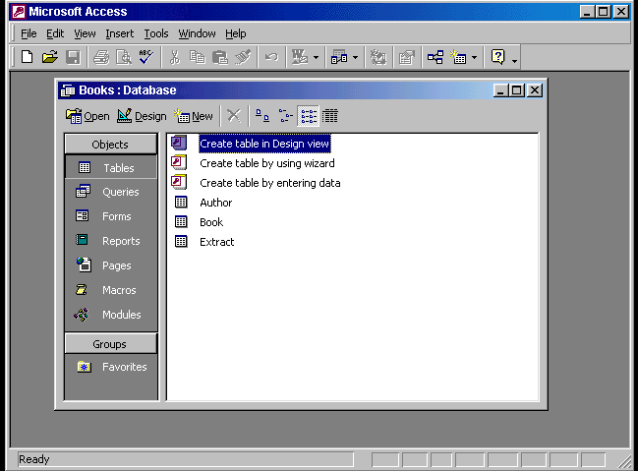

Click on the Relationships tool in the database toolbar → click on the Author
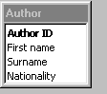
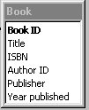
ID drag and drop it to the Author ID

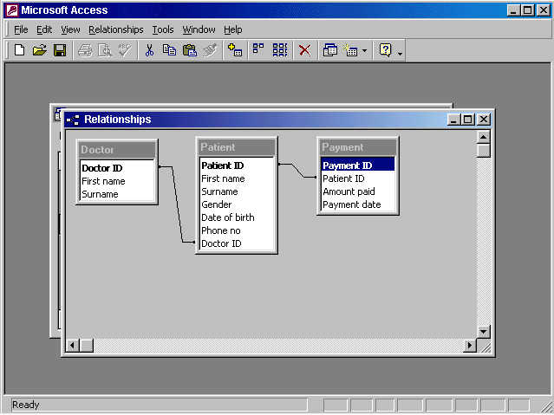


Right click on the line between Patient table and Payment table → select Edit Relationship ….. → check the Enforce Referential Integrity → ok

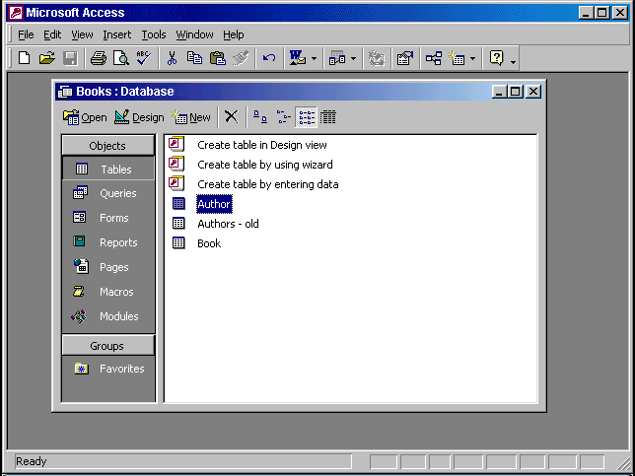

Select forms from the objects pane → double click on the create form in Design view

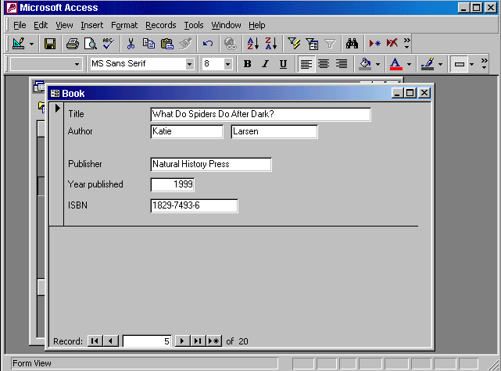


Click on the Delete Record tool from the form view toolbar → yes

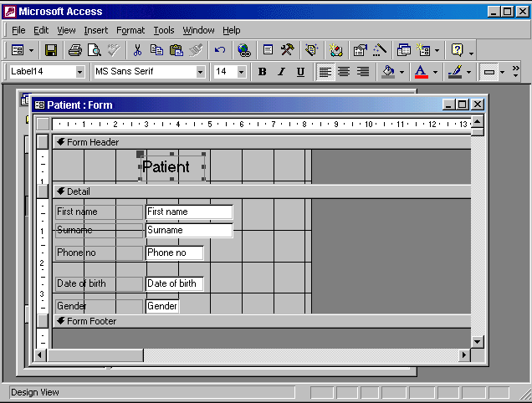

Click on the Patient box and type details → press enter from the keyboard

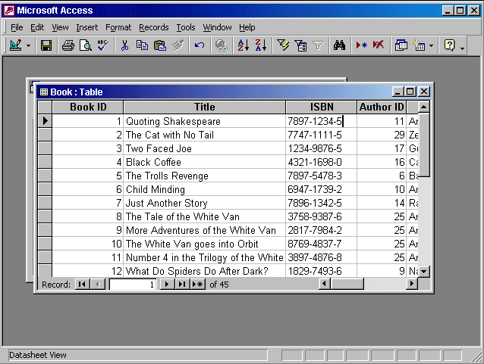
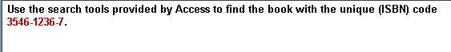

Edit → find → type 3546-1236-7 in the find what box → click find next button

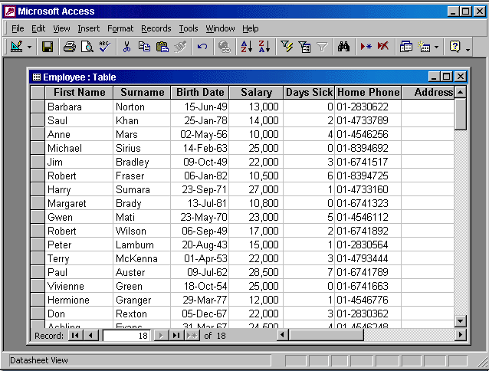

In the first name select the S letter from the word Saul → click on the filter by selection tool from the Table datasheet toolbar
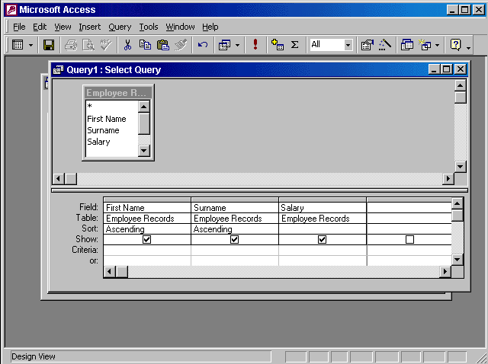

Click on save tool → type the name Employee Salaries → ok
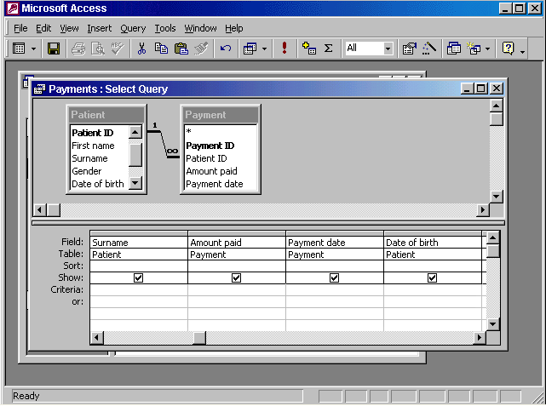


In the payment date column → in the criteria box → type >= 06/06/2002 →press enter

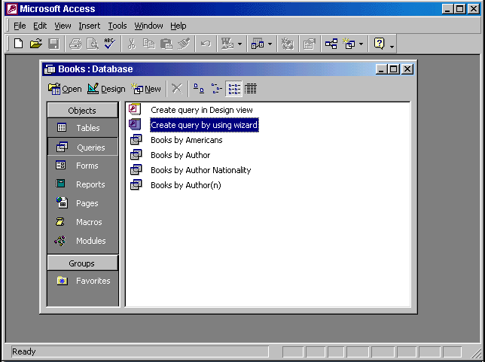


Right click on the Books by Americans → select Delete → yes
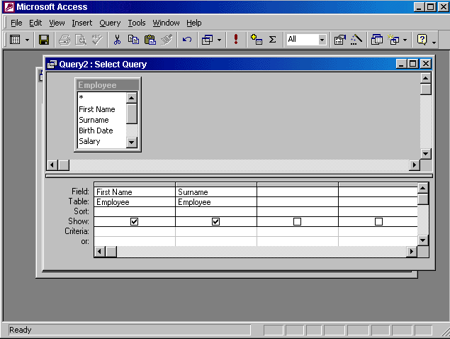

In the third column → in the field box → use the drop down list to select the Birth Date

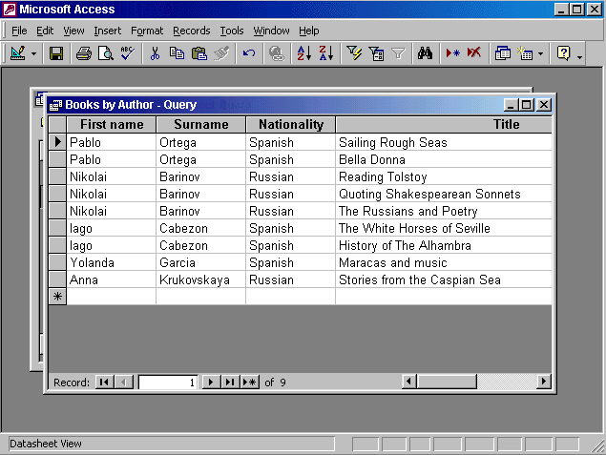

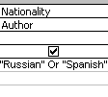
Click on the view tool from the Query datasheet toolbar → use the back space to delete the word Russian and or and then press the button Run from the query design toolbar

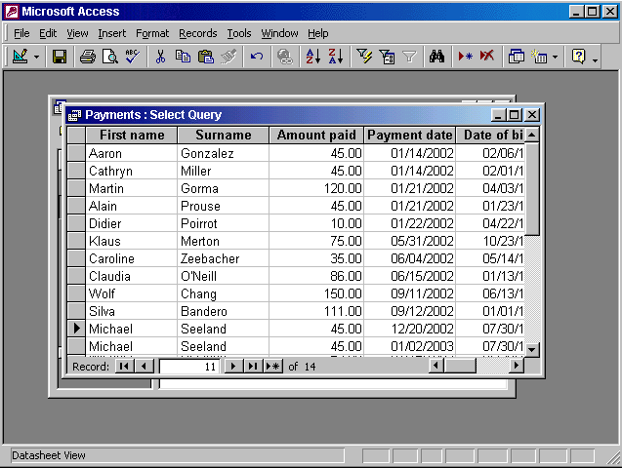

Put the insertion point in the payment date field → click on the sort descending tool from the Table datasheet toolbar

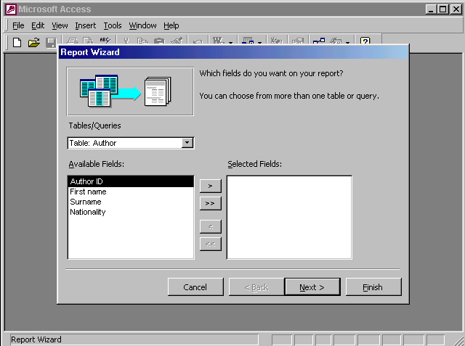

From the Tables/Queries drop down list select Table: Extract → click on → click on the Next button

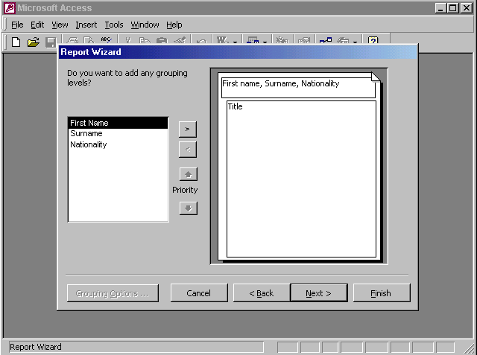
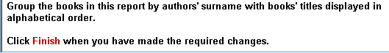

Select Surname → click on → click next → from the first drop down list

Select Title → click finish
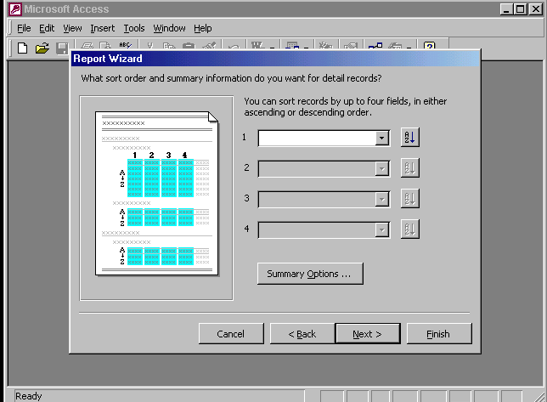
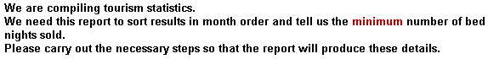

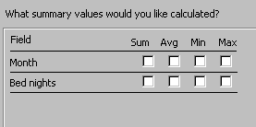
From the first drop down list select month → click on summary options… button → check the check box in the min column and bed nights row →ok

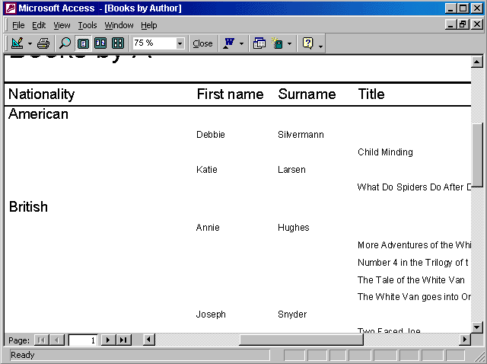

File → page setup → select the page tab → select the landscape
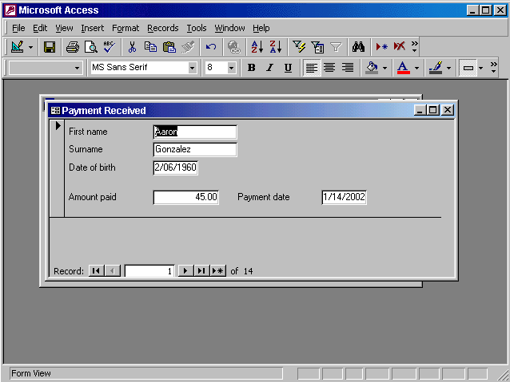
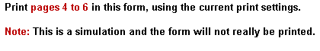

File → print → select pages → type 4 in the first box → type 6 in the second box → ok
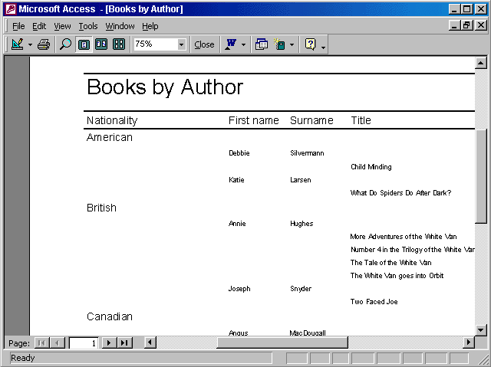

File → print → in number of copies use the arrows to select 2→ok
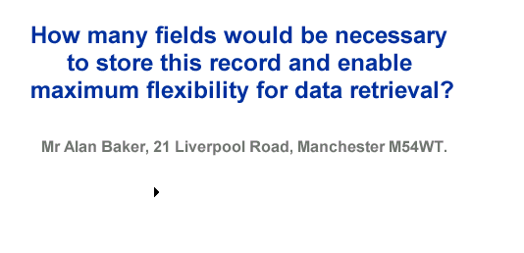
Type 6

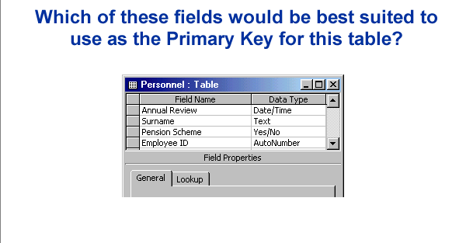

Select the gray area before the employee ID

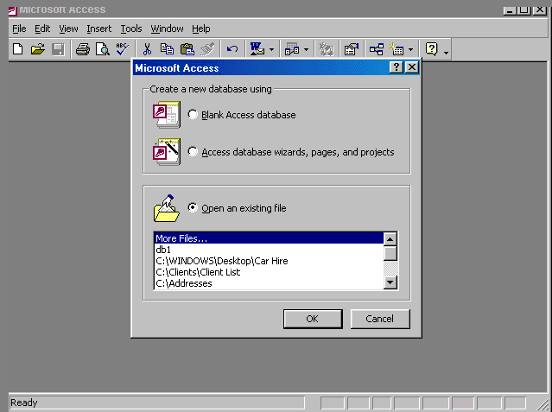
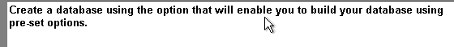

Select Access database wizards, pages, and projects → ok
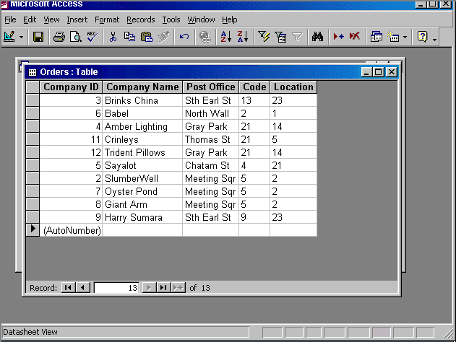
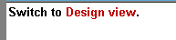

Click on view tool in the table datasheet toolbar
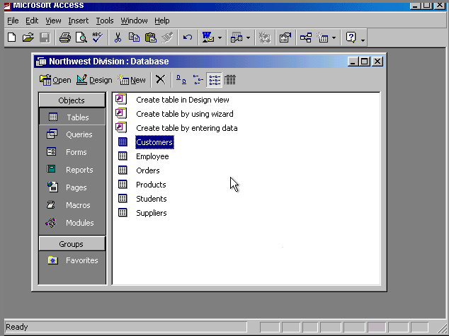
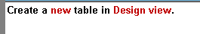

Double click on the create table in Design view
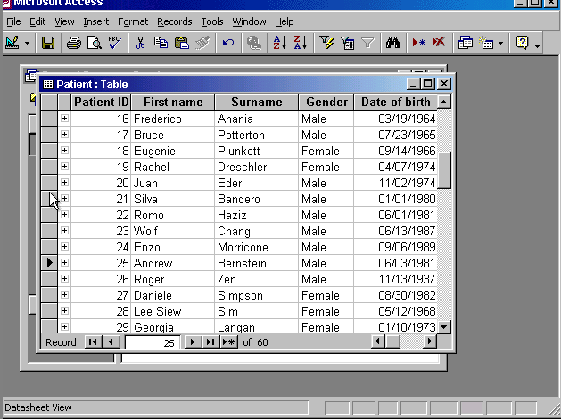


Click on the button

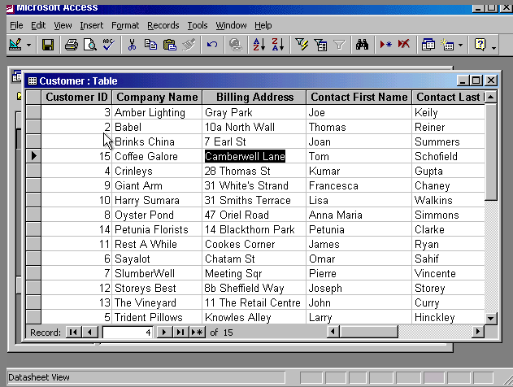
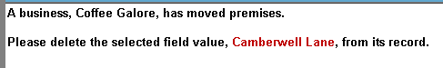

Press delete from the keyboard
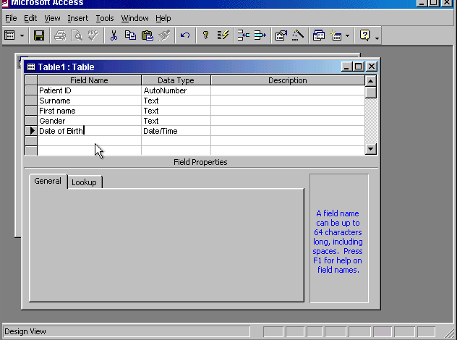
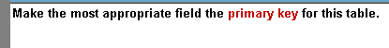

Click on the gray area before the Patient ID → click on the primary key in the table design toolbar
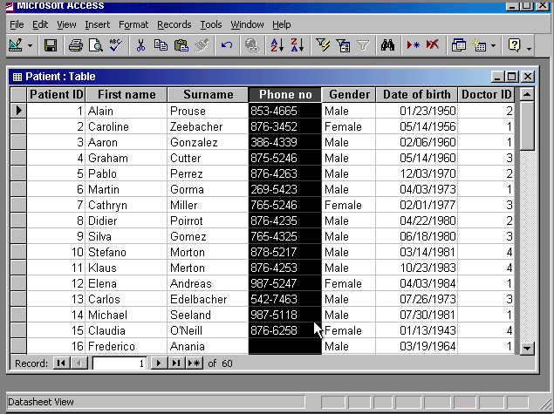
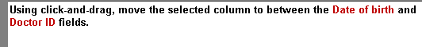

Click on the header of the field and drag it to between the date of birth and doctor id
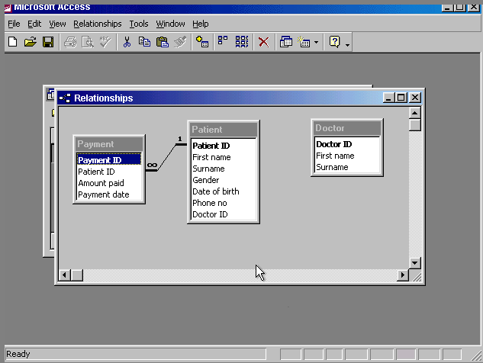

Right click on the line → select delete → yes
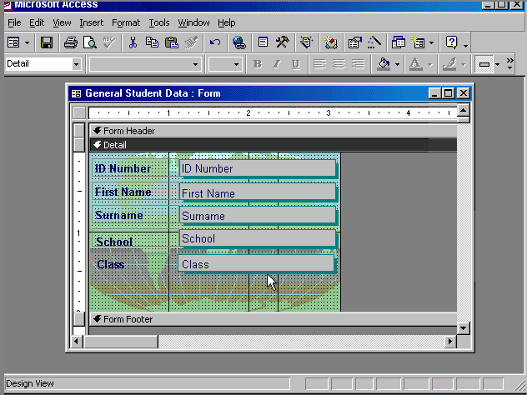
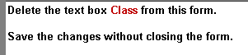

Select the gray box that has the word class → press delete from the keyboard → and then click save
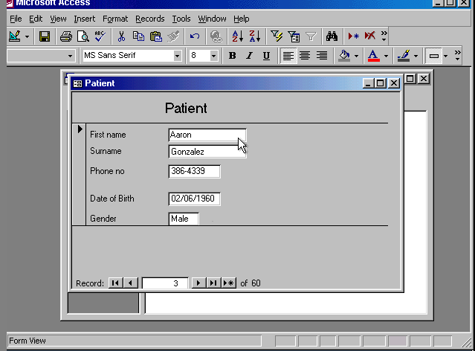
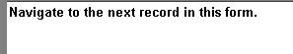

Click on the button

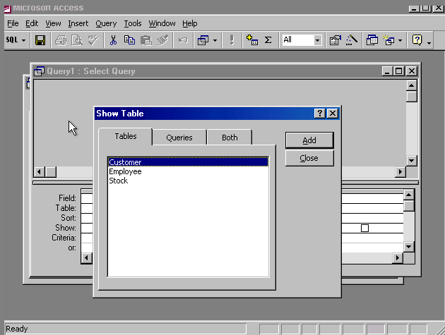
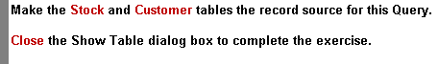

Click add → select stock → click add → click close

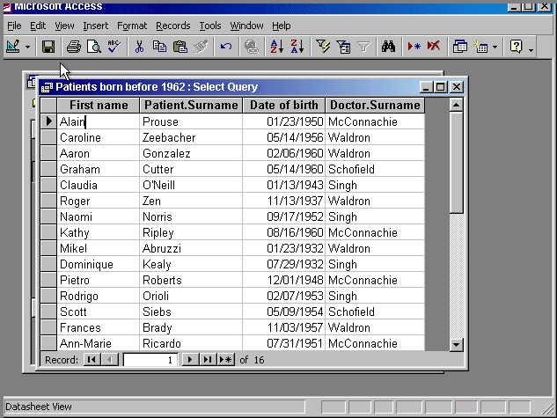


Click on the view tool → uncheck the date of birth
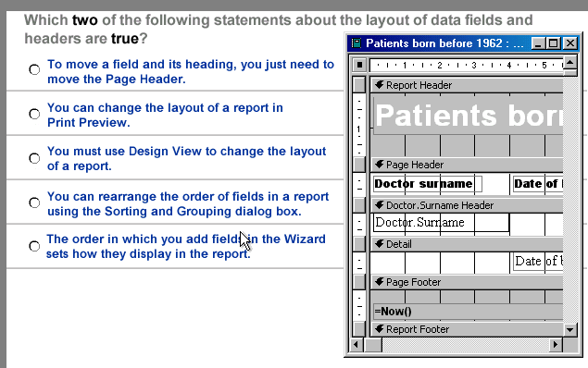

- You must use design view to change the layout of a report
- The order in which you add field in the wizard sets how they display in the report

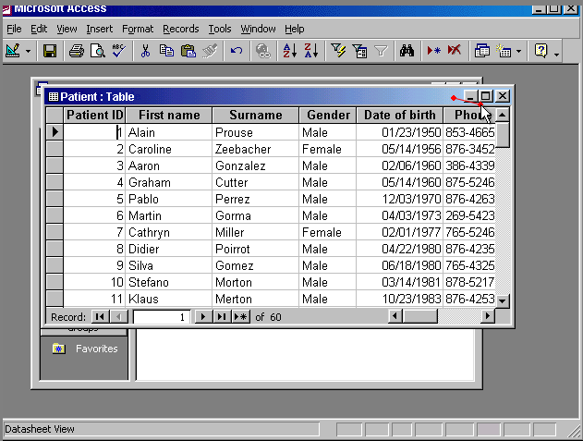
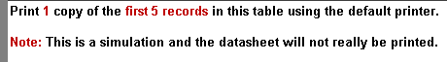

File → print → select selected records → ok

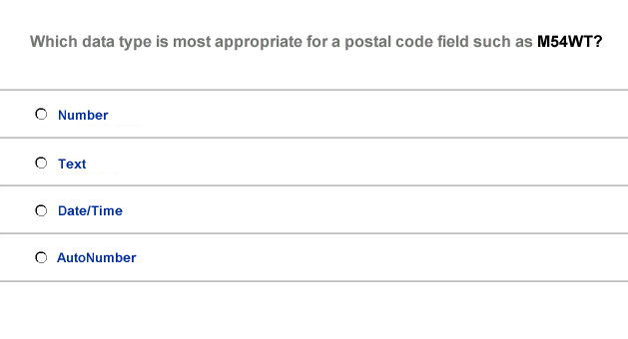
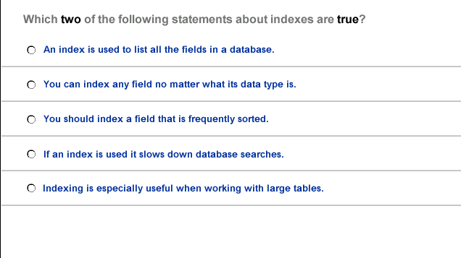

- Text

- You can index any field no matter what its data type is
- Indexing is especially useful when working with large tables

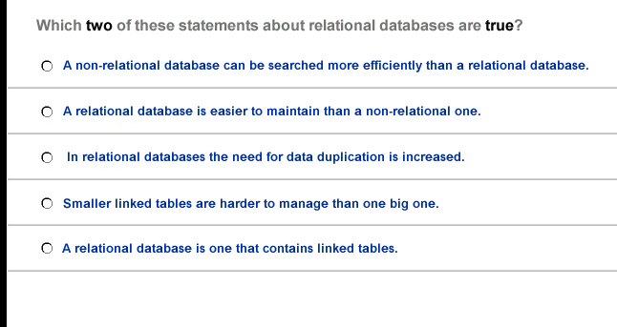
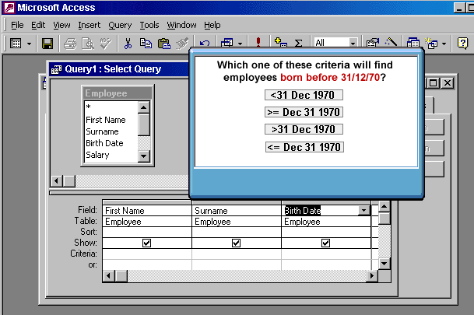

- A relational database is easier to maintain than a non relational one
- A relational database is one that contains linked tables

<31 Dec 1970

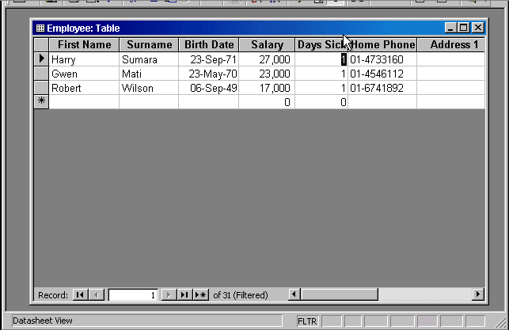


Click on the remove filter tool from the table datasheet toolbar

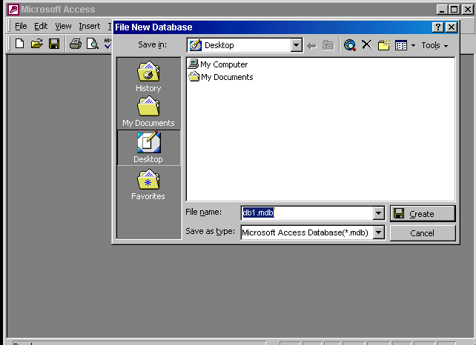
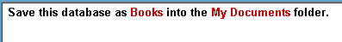

Select My Documents → type Books in the file name → press create

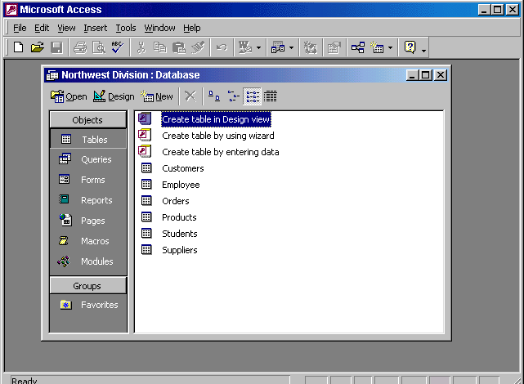

File → close

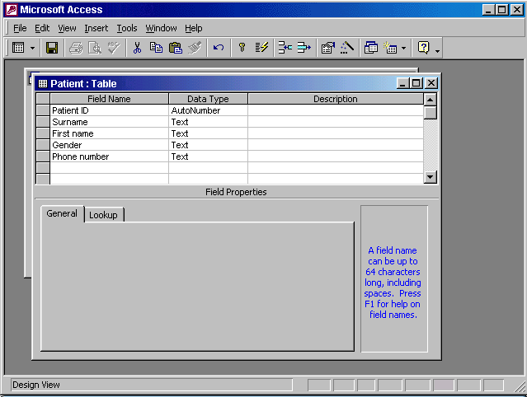


Put the cursor in the first name field → Insert → rows

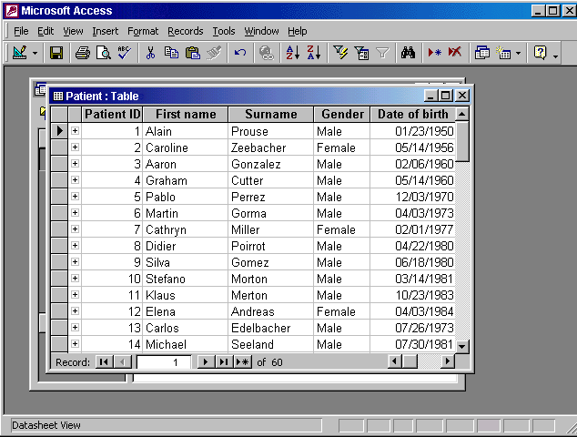


Put the cursor in this box and delete 1 and type 25 → press enter from the keyboard

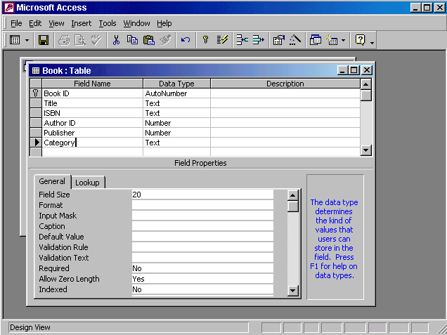


Put the cursor in the validation rule → type Full-time or Part-time → press enter from the keyboard

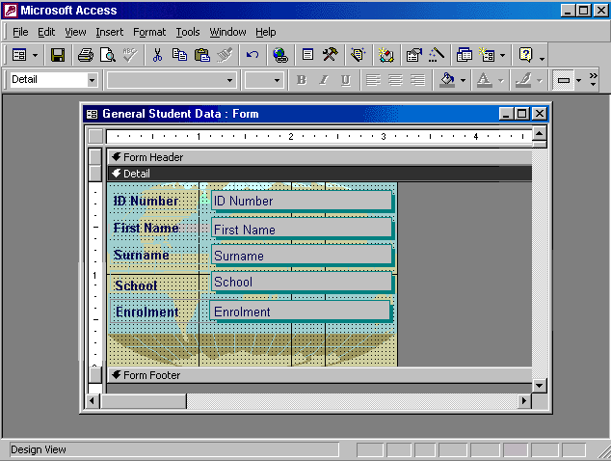
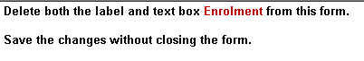

Select the gray box that contains the word Enrolment → press delete from the keyboard → click on the save button

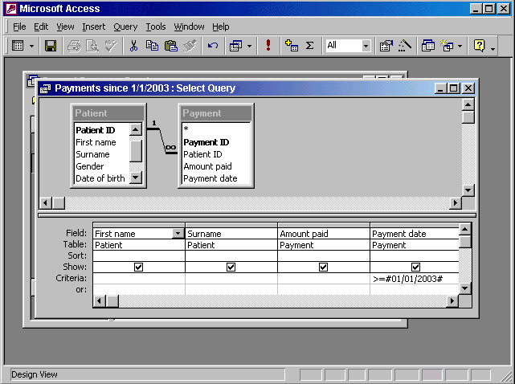
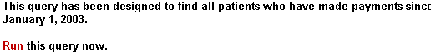

Click on this button

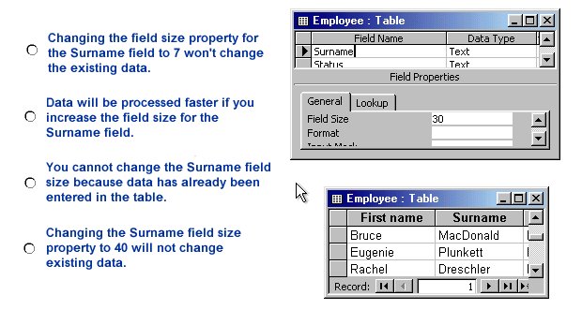

- Changing the surname field size property to 40 will not change existing data

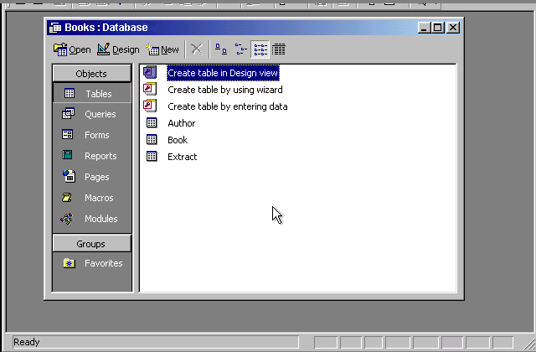
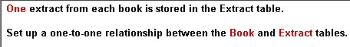

Click on the relationships tool → select the field Book ID from the Extract table and drag it to the field Book ID from the Book table

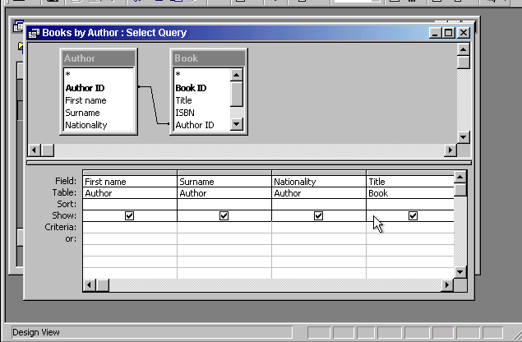


In the Nationality column put the in the criteria box → type <> Russian → press enter from the keyboard

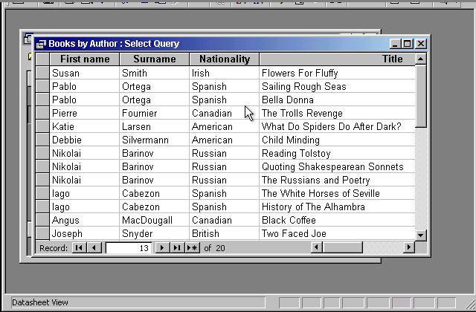

Click on the sort ascending tool

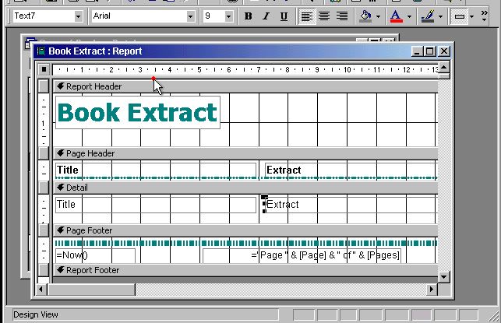


Select and then press delete from the keyboard

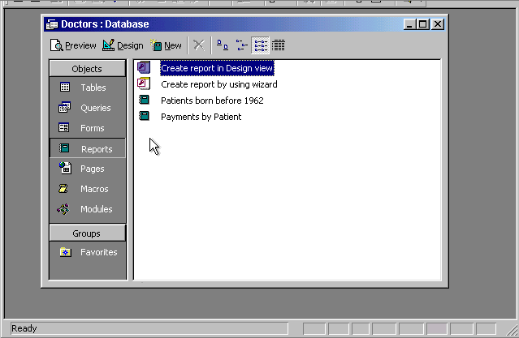


Select the payments by patient → click on preview

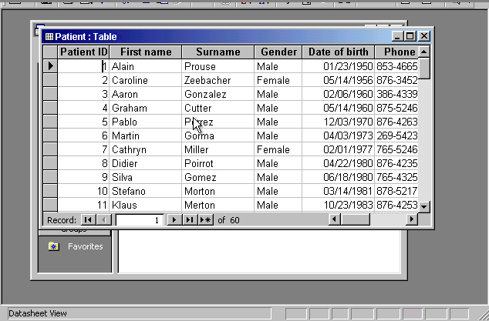
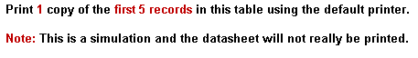

Select the first five records → file → print → select selected records → ok

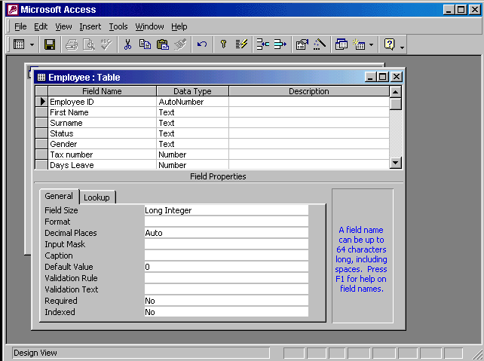

In the field size box use the drop down list → select single

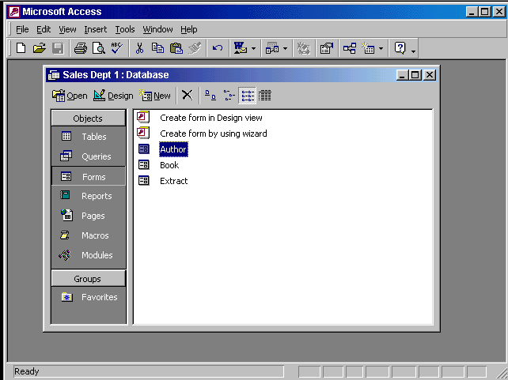

Select Queries from the objects pane → double click on create query in design view

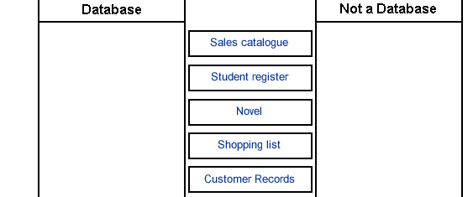
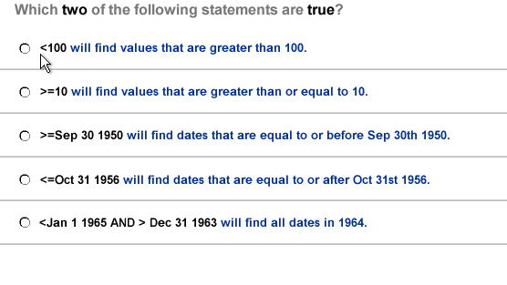
Sales catalogue novel

Student register shopping list

Customer records

- >= 10 will find values that are greater than or equal to 10
- <Jan 1 1965 And > Dec 31 1963 will find all dates in 1964
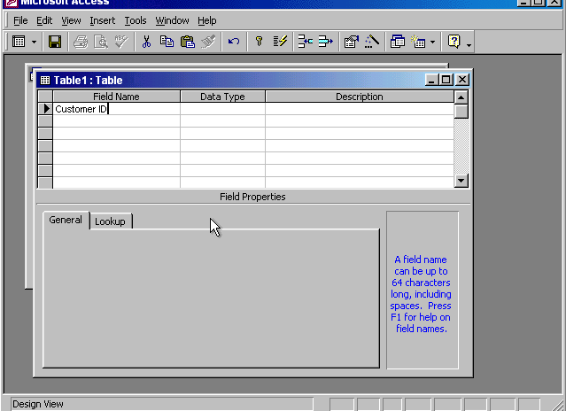
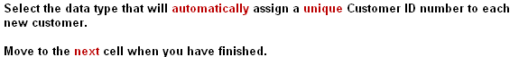

In the data type column → use the drop down list and select Auto number → press tab from the keyboard

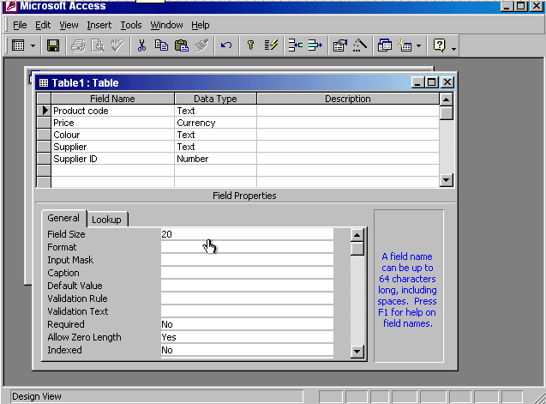
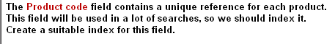

Put the cursor in the indexed box → from the drop down list select yes (No Duplicates)

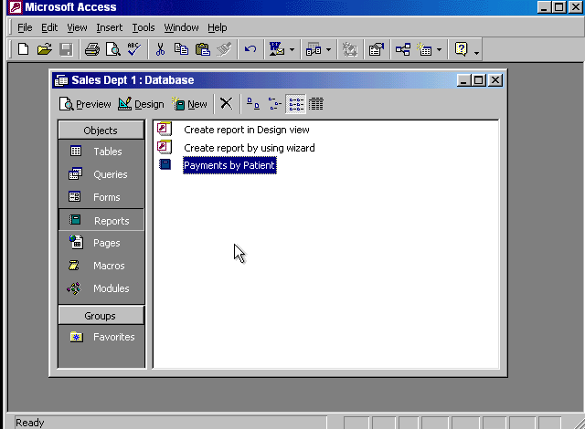


Select Queries from the object pane → double click on create query by using wizard

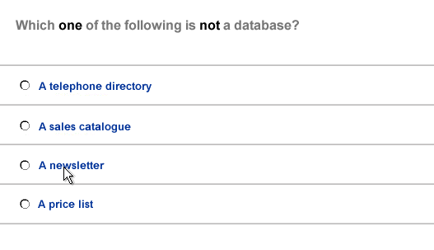
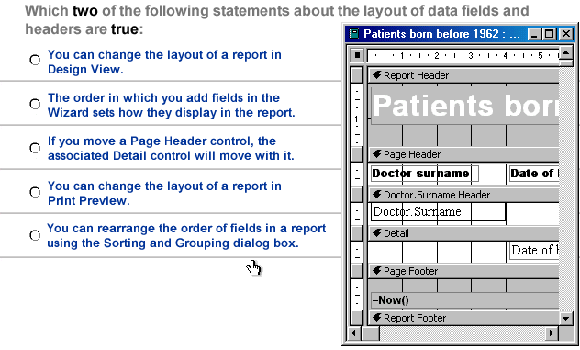

- A newsletter

- You can change the layout of a report in design view
- The order in which you add fields in the wizard sets how they display in the report

