اكتب فى مستطيل الانترنت العلوى : ((( مجلس مدينة فاقوس ))) ثم اضغط على الزر Enter
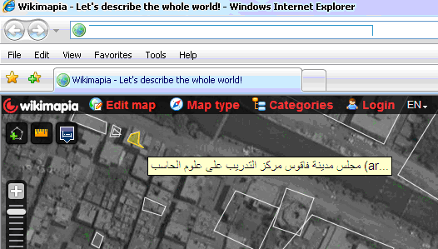

 | 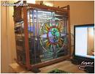 | 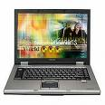 | 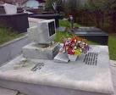 | 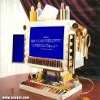
كيف اقوم بانشاء مركز امتحانات معتمد من هيئة اليونسكو؟
ما هى المتطلبات لاعتماد المركز ليصبح مركز اداء امتحانات icdl معتمد من اليونسكو ؟؟

How can I become accredited center ?
Centers wishing to become accredited for testing or training of ICDL should satisfy a list of requirenments and apply officially to UNESCO Cairo Office Testing &Training requirenments file, once all requirenments are fulfilled, please contact our office at m.ashraf@unesco.org to obtain necessary application forms.
http://www.unescoicdl.org/showpage.aspx?pageid=127
ما هى جميع المراكز المعتمدة من اليونسكو فى مصر ؟؟؟
http://www.unescoicdl.org/ListOfCities.aspx?CountID=5
Egypt
Operator: UNESCO Cairo Office  Address:  8 Adbel-Rahman Fahmy Street  Garden City  Cairo 11451  Email: m.ashraf@unesco.org  Phone: + 2 02 27945599 Fax: + (20) 2 7945296  Website: http://www.unescoicdl.org |  |  | 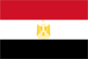
IMPORTANT NOTICE REGARDING ICDL REGISTRATION CODES IN EGYPT. For the avoidance of doubt, ECDL Foundation would like to confirm that candidate registration numbers worldwide are issued with a country prefix (e.g. ZA for South Africa) generated by the certifying authority in that country. In Egypt, in order to distinguish administratively between candidates registered and
 | 
Bottom of Form
الويب
إظهار الخيارات...

ICDL Certifications
-The ICDL is the world's largest end-user computer skills certification programme, with more than 6 million candidates in 146 countries. UNESCO Cairo office ...
www.unescoicdl.org/ -
Accredited Centers  New Testing and Training ...  Contact Information  Partners | Products  About Us  News  Advanced ICDL

