IBO archives : sample questions from previous IBO's
Note: students preparing themselves for their National Biology Olympiad are advised NOT to write to the IBO organizing staff asking for more IBO questions.
The questions below should be sufficient.

THEORETICAL PART

1. When the base composition of DNA from bacterium Mycobacterium tuberculosis was determined, 18 % of the bases were found to be adenine. What is the [G] + [C] content?
A 18%
B 32%
C 36%
D 64% +
2. When sunlight is on the chloroplast, pH is lowest in the
A stroma
B cytosol
C space enclosed by the thylakoid membranes +
D space enclosed by the inner and outer membranes
3. Red algae differ from the green algae and brown algae in having:
A no chlorophyll a
B no differentiated cells
C no phycocyanin within their cells
D no flagellated stages in their life cycles +
4. Tissues that form long, tough strands, as in the leaf stalk of celery, are:
A epidermis
B collenchyma
C sclerenchyma +
D parenchyma
5 Which of the following statements about the female reproductive system are true or false.
Indicate your views by putting + (true) or — (false) in the margin.
— 1 Both oestrogen and progesterone are necessary for ovulation to take place;
+ 2 Oestrogen tends to inhibit the production of FSH by the anterior pituitary gland;
— 3 Fertilization of the ovum by the spermatozoon normally takes place in the uterus;
+ 4 Progesterone production is largely under the control of Lh;
+ 5 Throughout the part of the mensual cycle that follows ovulation, there is a slight rise in body temperature.
6 Oxygen content reduction makes the glycolyse (glycogenesis) intensity increased due to:
A increase of ADP concentration in cell +
B increase of NAD+ concentration in cell
C increase of ATP concentration in cell
D increase of concentration of peroxides and free radicals
7 A heron standing in a cold water for a long time doesn’t get its legs overchilled because of:
A countercirculation in limbs +
B even thin fat layer under limbs’skin
C branched blood stream in limbs
D intensive metabolism in limbs
8 Which reactions are made with the help of system of giant axons?
A quick non differential reactions +
B quick differential reactions
C slow non differential reactions
D slow differential reactions
9 In situation that conflict between attack and flight animals have been noted to behave in a most peculiar fashion e.g. the behaviour of fighting cocks interrupting their fight to peck at the ground for food. What is this kind of behavior called.
A Feeding
B Ritualisation
C Displacement Activity +
D Aggressive Behaviour
10 What is this behavior (see former question) based on?
A lack of food or hunger
B lateral inhibition of two opposing behavior tendencies +
C irritation of a nerve
D displacement of an initial stimulus from one nerve to another
11 Reproduction is often connected with a shift from haploid to diploid or the other way round. Please regard the diagram and decide with group of organisms shows the below mentioned type of shift.
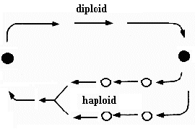
A humans
B angiosperm plants
C gymnosperm plants
D ferns +
12 In the blood of an adult man the total content of haemoglobin is, roughly:
A several hundred gram +
B tens of gram (10-100 g)
C several gram
D several hundred milligram
E tens of milligram
13 Ecological assemblies K through Q consist of species designated with numbers 1 through 8, present a various densities. Individual densities of these species in any particular assembly are given (as individuals per square meter) in the table. Which of the above assemblies is the least susceptible to a massive pest infection (gradation)?
assembly | K | L | M | N | P | Q
species 1 | 50 | 92 | 75 | 0 | 0 | 0
species 2 | 30 | 4 | 5 | 25 | 2 | 65
species 3 | 10 | 0 | 5 | 20 | 3 | 20
species 4 | 10 | 0 | 5 | 20 | 5 | 10
species 5 | 0 | 1 | 5 | 20 | 40 | 3
species 6 | 0 | 1 | 5 | 5 | 50 | 2
species 7 | 0 | 1 | 0 | 0 | 0 | 0
species 8 | 0 | 1 | 0 | 0 | 0 | 0
Answer:.............. (N)
14 Animal behaviour patterns, in which an individual endangers its life to benefit other members of the group, are called altruistic. It is believed that altruistic behaviour was favoured by kin selection. Which if the examples given below CANNOT be explained as kin-selection-favoured?
A suicidal attack by a worker bee guarding its hive
B protection of the queen of an ant species by "soldier ants"
C protection of lion cubs by a lioness NOT being their mother
D warning cries of a bird warning other individuals about approaching danger +
15 When a new male, takes over a lion pride, they sometimes kill or evict the cubs already present. This phenomena can be explained from behavioral ecology:
A the male doesn`t like cubs
B the male cannot afford too much for caring those cubs
C the male breed his own offspring +
D degeneration of the male`s parental behavior
16 Two organisms with a genotype of TtGg (T=height, G=color) are mated with each other. Which is the probability for the offsprings to carry only one of the dominant characters?
Answer:.................. (6/16)
17 A mollusc sample is given to a biologist. After examining the sample he says that it belongs to Bivalvia. Which of the followings may be the key that makes him to reach this conclusion?
A gills
B absence of radula +
C body symmetry
D mantle
18 The picture shows a schematic drawing of the cell cycle.
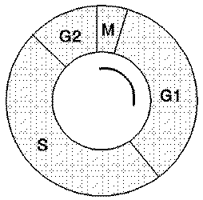
Somebody likes to determine the duration of the S-phase. This is done in adding a with tritium labeled compound R to the medium of the organism with the dividing cells. Which of the following compounds is most suitable to be R?
A adenine
B cytosine
C guanine
D thymine +
E ATP
19 Potatoes are stored during one week in pure air, after this during one week in pure nitrogen and in pure air again. During the experiment the excretion of CO₂ is measured. The diagram shows the results.
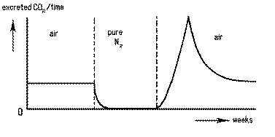
The extra amount of CO2 produced and excreted during the third week probably is originating from
A ethanol
B ethanal
C lactic acid +
D NADH2
20 A bee x has find a location with pollen supplies. His waggle dance in the hive is shown in the drawing. Another bee y also has find a location with food.
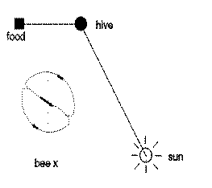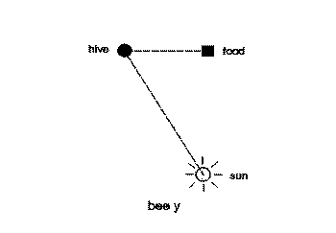
Which of the following drawings represents the waggle dance of bee y?
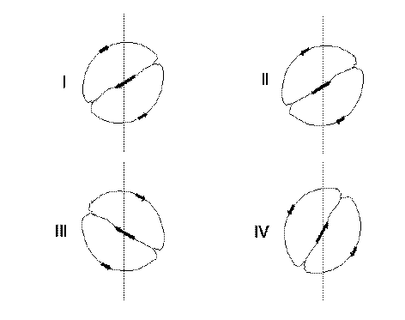6
A I
B II
C III +
D IV
21 The figure shows possible positions of the black headed gull (Larus melanocephalus). A gull has landed by accident in the territory of another gull and both gulls meet each other. Which position will probably be shown by the visitor gull.
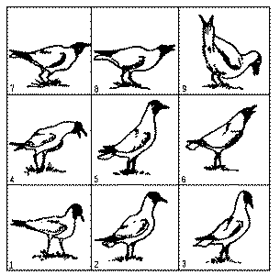7
A position 1
B position 3
C position 5
D position 7 +
E position 9
22 Someone has investigated the fitness of a population of the coletit (Parus major) in relation to the number of eggs per nest. He determined:
I the frequency of number of eggs per nest
II the average weight of the young birds at the moment they flew out
III the number of birds caught back per nest at the end of the summer
IV the average area of a territorium
The two diagrams A and B are showing the results of two of these four aspects.
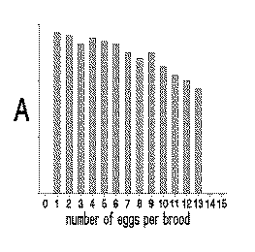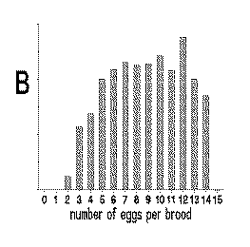
What are the diagrams representing ?
Aspect(s)
(fill in I, II, III and/or IV)
Diagram A
Diagram B
(answer: A»II and B»III)
23 A bacterial mRNA with a length of 360 nucleotides in length codes for a protein of:
A roughly 360 amino acids
B roughly 1080 amino acids
C exactly 120 amino acids
D less than 120 amino acids +
24 When a muscle cell has a shortage of oxygen will the pH decrease or increase? What substance is responsible for this change in pH?
change in pH caused by
A decrease carbon dioxide
B decrease lactate (lactic acid) +
C increase carbon dioxide
D increase lactate (lactic acid)
25 The concentration of an electrically neutral substance within a certain type of blood cell is much higher than it is in the surrounding blood plasma, yet the substance continues to move into the cell. The process by which this substance moves into the cell is called:
A osmosis
B simple diffusion
C facilitated diffusion
D active transport +
26 Which one of the following pairs is correctly matched?
A chloroplast - storage of enzymes
B peroxisomes - cellular transportation
C nucleolus - site of ribosomal subunit synthesis +
D lysosomes - power house of cell
27 What letter indicates the end of meiosis I (see figure)?
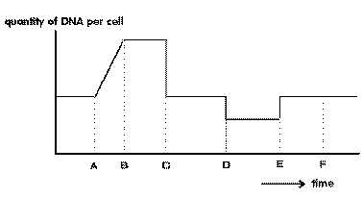
A A
B B
C C +
D D
28 The figure shows the movement of chromosomes during mitosis. Curve A shows the mean distance between the centromeres of the chromosomes and the corresponding pole of the spindle. At what time did the anaphase start?
A 0 minutes
B Somewhere between 0 and 10 minutes
C 10 minutes +
D After more than 10 minutes
29 Curve B (see figure former question) represents the distance between
A the chromosomes in the metaphase
B the centrioles
C chromatides of a chromosome +
D homologuous chromosomes during the anaphase
30 The belonging of a human erythrocyte to serotypes A, B, 0 is determined by chemical markers on its surface. These markers are:
A lipid molecules
B oligosaccharides +
C polypeptides
D antibodies
E. nucleic acids
31 Cells of the pancreas will incorporate radioactive amino acids into proteins. This labels newly synthesized proteins and enables to track the location of these proteins in a cell. In this case we are tracking an enzyme that is eventually secreted by pancreas cells. Which of the following is the most likely pathway for movement of this protein in the cell?
A endoplasmic reticulum - Golgi --> nucleus
B Golgi - endoplasmic reticulum --> lysosome
C nucleus - endoplasmic reticulum --> Golgi
D endoplasmic reticulum - Golgi --> vesicle that fuses with plasma membrane +
E endoplasmic reticulum -lysosome --> vesicles that fuses with plasma membrane
32 Four types of Phytoplankton (I, II, II and IV) were collected from different depths of the sea. For each of these types, the photosynthesis was measured, as represented in the following figure. Which type of Phytoplankton was collected at the greatest depth?
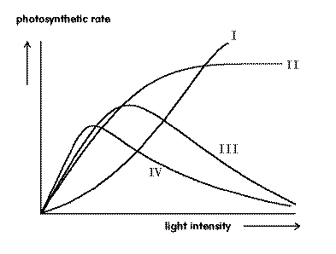
A I
B II
C III
D IV +
33 Under conditions of a high atmospheric humidity hardly any calcium (Ca) is transported to developing fruits. This is caused by:
A calcium only being transported through the xylem and this transport not taking place anymore +
B calcium only being transported through the phloem and this transport not taking place anymore
C transpiration stopping and, as a result both xylem and phloem transport stopping
D the stomata closing and transport to the fruit stopping
34 C4-plants can start photosynthesis with a lower concentration of CO2 in the atmosphere than C3-plants. This is because:
A respiration of C4-plants is higher
B respiration of C4-plants is lower
C C4-plants do not have photorespiration +
D C4-plants do have photorespiration
35 Only one of the following features of the phylum of the Chordata also is present in adult Tunicata (=Urochordata). Which feature?
A possession of a chorda
B possession of visceral slits ( = pharyngeal slits) +
C possession of a tail
D possession of a dorsal tubular nervous system
36 The increase in complexity of the vertebrate circulatory system is represented by one of the following combinations. Which combination?
A toad-rabbit-alligator-shark
B shark-frog-alligator-rabbit +
C shark-crocodile-rabbit-frog
D alligator-dog-shark-toad
37 Four possibilities for the transport of carbon dioxide from the body cells to the lungs are listed below. Which possibility does not exist?
A bound to the ferro-ions of hemoglobin in erythrocytes +
B as a hydrocarbonate ion in the buffering system of the blood
C bound to the protein of hemoglobin in erythrocytes
D dissolved in blood plasma and in erythrocyte cytoplasm
38 The vitelline sac (=yolk sac) is expected to be very small in one of the following groups. In which one?
A in groups that fertilize externally
B in groups with embryos that are fed from maternal blood +
C in groups that fertilize internally
D in groups that have an allantoic membrane
39 One of the alternatives below defines the layers of the retina in the correct sequence. Which one? (N.B! The first layer in each sequence is supposed to be located next to the jellylike vitreous humor that fills the eyeball.)
A pigmented cells-bipolar cells-ganglion cells-photoreceptors
B photoreceptors-pigmented cells-ganglion cells-bipolar cells
C ganglion cells-bipolar cells-photoreceptors-pigmented cells +
D photoreceptors-bipolar cells-ganglion cells-pigmented cells
40 One of the four statements given below is false. Which one?
A Certain innate patterns of behaviour can be modified by experience
B Taxis never occurs together with fixed action patterns +
C A super normal stimulus often produces a stronger response
D Fixed action patterns are highly stereotyped instinctive behaviours
41 The most important factor regulating seasonal migration is:
A the change in average air temperature
B the change in day length +
C the reduced availability of food
D the increased predator pressure
42 Which of the following alternatives is not an indication of annual photoperiodism?
A swarming
B moulting
C flowering
D sleep +
43 In Drosophila, the following crossing-over percentages were found:
gene | gene | crossing-over %
bi | ec | 1.4
bi | fa | 3.9
wi | ec | 4.0
wi | fa | 1.5
What is the order of these genes?
A bi - ec - fa - wi +
B bi - ec - wi - fa
C ec - bi - fa - wi
D ec - bi - wi - fa
44 Which form of natural selection can lead to differentiation in species and to polymorphism?
A directional selection
B stabilizing selection
C disruptive selection +
D density dependent selection
45 In the European population, about 1 in 2500 people suffers from Cystic Fibrosis, a genetically determined (descared), autosomal disease. Healthy parents have a child suffering from Cystic Fibrosis. The woman remarries a healthy man. What is the chance of a child from this second marriage suffering from Cystic Fibrosis:
A 1 : 25
B 1 : 50
C 1 : 100 +
D 1 : 625
46 The pedigree (see figure) shows an inheritance of a rare form of muscular dystrophy.
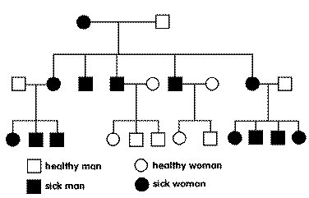
The disease is probably caused by a mutation on one locus which is:
A. recessive, autosomal
B. dominant, autosomal
C. recessive, related to the X-chromosome
D. related to the Y-chromosome
E. situated in the mitochondrial genome +
47 The order of appearance of the main groups of organisms during evolution can best be described as follows:
A autotrophic, anaerobic heterotrophic, aerobic heterotrophic
B aerobic heterotrophic, anaerobic heterotrophic, autotrophic
C anaerobic heterotrophic, aerobic heterotrophic, water oxydizing autotrophic
D anaerobic heterotrophic, water oxydizing autotrophic, aerobic heterotrophic +
48 The main trend in the evolution of land plant was:
A a sharp demarcation of the phases of sporophyte and gametophyte
B a shortening of the haploid phase +
C a shortening of the a-sexual phase
D an increase in the complexity of the gametophyte
49 A new characteristic usually appears in evolution as a result of:
A accumulation of point mutations in a gene which originally encoded for something else
B duplication of a gene and accumulation of point mutations in one of the copies coming from that duplication +
C a mutation in a regulator gene
D genotypical recording of favourable phenotypical adaptations
50 How many different phenotypes can be expected in the F2 of the crossing: AA BB * aa bb when:
I the genes are completely coupled and,
II the genes inherit independently:
 | I | II
A | 3 | 4
B | 3 | 9 | +
C | 4 | 9
D | 4 | 16
E | 9 | 16
51 In the domestic cat, the autosomal locus White is dominant and epistatic; the locus Orange is sex linked with allele O tabby and allele o red, while the heterozygous is tortoise. A white female mates with a tabby tomcat. The kittens turn out to be:
1 red male
1 tortoise female
1 tabby female
1 white male
1 white female
What is the genotype of the mother:
A WW Oo
B Ww OO
C Ww Oo +
D Ww oo
52 Nitrogen is fixed in ecosystems in ways stated below. One of the statements below is false. Which one?
A by cyanobacteria
B by electrical discharges in the atmosphere
C by industrially synthesized fertilizer
D by atmospheric deposition
E by denitrification +
53 The transfer of energy through a terrestrial ecosystem is often depicted by energy pyramids. Which of the following statements is true ?
A Ecological efficiency is highest for top consumers
B About 10 % of the energy from one trophic level is incorporated into biomass of the next level +
C The energy lost as heat or in cellular respiration is 10 % of the available energy of each trophic level
D Only 25 % of the energy in one trophic level is passed on to the next level
54 Nitrogen fertilization of rice fields can be low in the presence of one of the following types of organisms. Which one ?
A Water fern (Azolla species) +
B Green algae
C Brown algae
D Mosses
55 In a laboratory, a competition experiment is executed with two types of bacteria, which compete for food. During the experiment, it is determined what the relationship is between the frequency of type 1 in the mixed culture after 1 generation (zt+1) as a function of the frequency of type 1 during the previous generation (zt). In figure 23, the drawn line indicates the observed relationship between zt+1 and zt, the dotted line is the relationship zt+1 = zt. What happens to type 1 and type 2 in the long term?
A Type 1 co-exists with type 2
B Both type 1 and type 2 grow in number
C Type 1 excludes type 2 from the mixed culture
D Type 2 excludes type 1 from the mixed culture +
56 The growth speed of a population can often be described with the logistic growth equation:
dN/dt = rN(K-N)/K
In this equation, N is the number of individuals, r is the intrinsic relative rate, and K is the carrying capacity. According to this equation, the equilibrium number of individuals in the population is determined by:
A r only
B K only +
C r and K
D N and K
E r and N
57 If you keep a C3 plant and a C4 plant of comparable size in an air-light glass container and provide them with adequate sun light, you would expect the C4 plant to:
- grow better than the C3 plant after one year in that condition;
- grow slower than the C3 plant after one year in that condition;
- be able to survive longer than the C3 plant, but ultimately die;
- be able to survive not as long as the C3 plant.

58 The diagrams show vertical sections of kidneys of coypu, brown rat and kangaroo rat, showing the relative size of cortex and medulla.
Coypu are found in fresh water and are never short of water to drink. Brown rats are able to go some days without drinking. Kangaroo rats are able to live in deserts without drinking at all. Which kidney belongs to which animal?
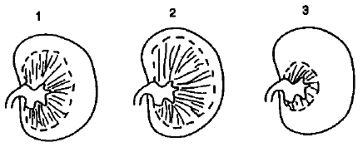
 | 1 | 2 | 3
a. | brown rat | coypu | kangaroo rat | +
b. | brown rat | kangaroo rat | coypu
c. | kangaroo rat | brown rat | coypu
d. | kangaroo rat | coypu | brown rat

PRACTICAL PART

The practical part is basically lab work. Questions asked are based on the lab and do not include any theory. Furthermore they show a large amount of versatility, according to the organizing country. So it is impossible to give an overall picture of what they really look like.

