Prep 3 Grammar Term1 Expressing Ability
مضارع | ماضي
can + مصدر | could + مصدر
am – is – are able to + مصدر  قادر على  am – is- are capable of + V + ing قادر على  have-has the ability to + ((لديه القدرة على) مصدر | was – were able to + مصدر  was – were capable of + V + ing  had the ability to + مصدر  managed to + مصدر  succeeded in + V _ ing
Ali can read English well. They can swim easily.
Ali is able to solve the exam.
♣Abla Wael from Cairo couldn’t do her maths homework .
♣Mahmoud was able to give all the answers to the sums.
وفي حاله الأستفهام بمعنى هل نستخدم الأتى وتكون الأجابة عادة مختصرة: -
Can / Could + فاعل + مصدر ---------------------------?
Is/ Are / Was / Were + فاعل + able + to + مصدر ------?

Could you read when you were six?
Yes, I could. * No, I couldn’t.
Were you able to do the homework?
Yes, I was. * No, I wasn’t.
وفي حاله السؤال الذي يبدأ بكلمة إستفهام : -
كلمة استفهام + could /can+ فاعل + مصدر ---------------------?
كلمة استفهام + Is/ Are /was /were + فاعل + able to + مصدر ---?

What could you do when you were 10?
I could ride a horse.
What were you able to see at the concert?
I was able to see many singers.
معلومة هامة : -
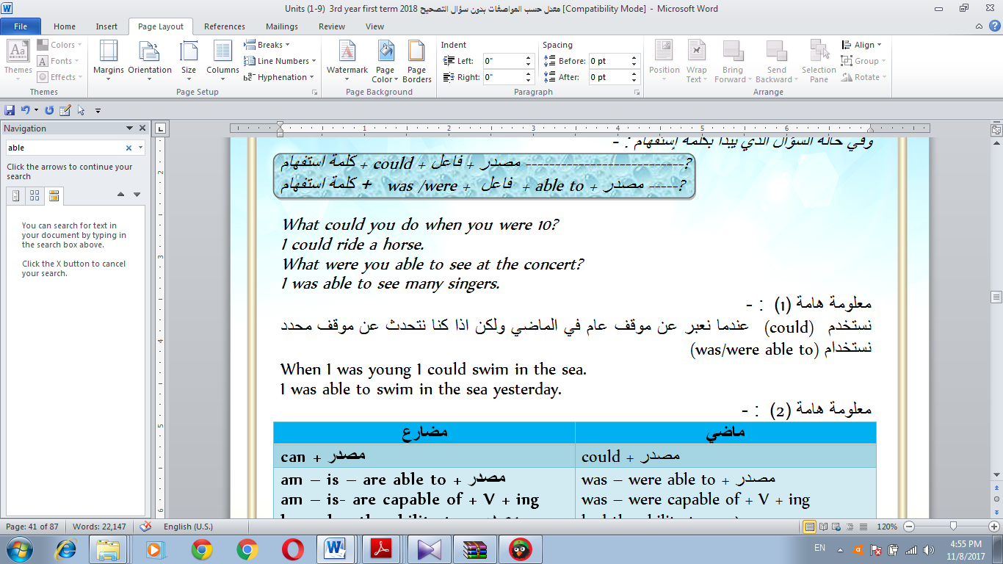

When I was young I could swim in the sea.
I was able to swim in the sea yesterday.

1-The maths homework was very difficult. Were .you ........ do it?
a- could b- able to c- able d- can
2- .............you speak English when you were six?
a- Were b- Do c- Able d- Could
3- …………….you able to speak to the teacher today about the homework?
a- Were b- Did c- Was d- Could
4- When you were ten, …………. you stand on one leg?
a- were b- are c- was d- could
5- She wasn’t……………. go to university when she was younger.
a- could b- able to c- able d- can
6- I …………………… walk until I was 18 months old.
a- weren't b- aren't c- wasn't d- couldn't
7- …………….you speak two languages when you were five?
a- Were b- Did c- Was d- Could
8- He ---------- in answering all the questions.
a-managed b- was capable c- was able d -succeeded
9- He had the -------- -- --- to speak French well.
a- able b- ability c- capability d- enable
1- I couldn't find the pen that you lost. (able)
2- Mona wasn't able to finish the project yesterday. (could)
3- Could you write stories when you were young? (Were)
4- Amany could draw some nice pictures last week. (able)
5- Were you able to run to the club at noon yesterday? (could)
6 – When he was young, he had the ability to read and write. (could)
7 – She was capable of crossing the bridge. (able)
8– Was he able to solve the mystery. (capable)

# She visited her aunt and gave her a present.
In addition to + v.+ing/ إسم….., جملة ثانية …
الجملة أولى ….. Furthermore /In addition, جملة ثانية
In addition to visiting her aunt , she gave her a present.
She visited her aunt . Furthermore /In addition, she gave her a present.
as well تأتى فى نهاية الجملة بمعنى أيضاً:
I visited London last year. I visited Paris as well .
→ She visited her aunt . She gave her a present as well.
- Rana did her homework. She also helped her mother. ( In addition to …..)
- Nora did her homework. She also washed the dishes. (In addition to)
- Eman cooked soup. She also made sandwiches for lunch. (In addition to)
- He played well. He scored three goals. (In addition , )
- In addition to going to the market, he went to the club. (In addition)
6-I went to the market and bought some fruits (Furthermore)
7-Tarek is very good at tennis. He's good at basketball, too. (In addition to...)
a- Someone asks you what you have done in addition to running.
b- Mother asks you what you want to take with you in addition to your bag.

1- My cousin is very good at speaking English. …………….,he speaks French.
a- In addition to b- Furthermore c- Addition to d- As well
2 ....................reading after dinner, I write emails to friends.
a- In addition to b- Furthermore c- In Addition d- As well
3 - We're going to paint the room. ......,we're going to get new furniture.
a- In addition to b- As well as c- In Addition d- As well
4 .......being a great player, Ramadan Sobhi scores amazing goals,
a- In addition to b- As well as c- In Addition d- As well
5 Mr.Khaled is a great teacher............ , he never treats us badly.
a- In addition to b- Furthermore c- Addition to d- As well
6-She is polite ………………. being beautiful.
a- in addition to b- furthermore c- in addition
d- addition
7- My sister is very polite. ……………she is very active.
a-Not more b–Furthermore c- In addition to d- as well

