Prep 3 Grammar Unit 4
== must [be]أكيد ..... == can’t be أكيد مش .....
might [be] = من المحتمل
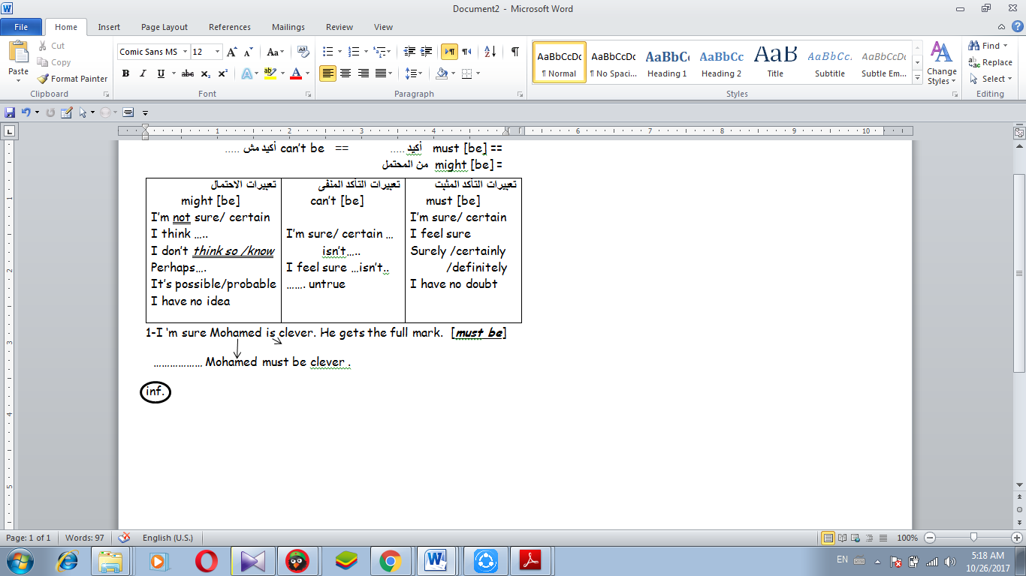
1-I ‘m sure Mohamed is clever. He gets the full mark. [must be]
تعبيرات التأكد المثبت  must [be]  I’m sure/ certain  I feel sure  Surely /certainly /definitely  I have no doubt | تعبيرات التأكد المنفى  can’t [be]  I’m sure/ certain … isn’t…..  I feel sure …isn’t..  ……. untrue | تعبيرات الاحتمال  might [be]  I’m not sure/ certain  I think …..  I don’t think so /know  Perhaps….  It’s possible/probable  I have no idea
……………… Mohamed must be clever .
2- Perhaps this coin is Egyptian. I’m not certain. [ might ]
- This coin might be Egyptian.
3- Those girls are laughing . I’m sure they are happy. [ must ]
4- I’m sure it isn’t easy to join STEM schools . [can’t]
5- Perhaps I’ll wear a jacket today, I’m not sure. (might)
6- Adel might visit us tomorrow. (I'm not sure)
7-I know that it is my pen. It is the only one that is red. (must)
8- I know that it is my pen. It is the only one that is red. (must)
9-I'm sure it isn't a British coin. (can't)
10-He looks happy he must have passed his exams. ( can’t )
11-We are sure that Maha is on time ( must )
12-I have no idea if my father will buy me a new mobile. ( might )
13– I am sure he is an engineer. (must)
14– Ahmad didn’t catch the train. (can’t)
15– I am not sure she is at home. (might)
16– Sherouq has a lot of money. (must)
17– Samah isn’t at school. (can’t)
18– He can’t be Egyptian. (French)
19- Rawda can’t have taken the money. (didn’t)
20– He must be poor. (rich)
1- Choose the correct answer from a, b, c or d:
1- Wear a coat. It ……….. rain today.
a- might b-must c- can't d- mustn't
2- There is a lot of traffic today. We .................. be late.
a- must b- should c- might d- won't
3- It …………………… be hot in the desert in summer.
a- might b- can't c- must d- mustn't
4- Ali …………… be friends with Hassan. He doesn't know his name!
a- might b- must c- will d- can't
5-I have a new text. It…… be a message from my mother, but I'm not sure.
a- must b-mustn't c-can't d- might
6-This stamp……be very old. We should ask an expert who can tell us for sure.
a- might b- must c- shouldn't d- can't
7- That book…… be good. Ahmed hasn't stopped reading it all day.
a- might b-can't c- must d- shouldn't
8-That …………….be Ali in the street. He's gone away on holiday for two weeks.
a-must b- might c- can't d- mustn't
9- In this photo, everyone is wearing warm clothes. It……very cold there.
a- might be b-can't be c- must be d- be
10- I'm not sure what the weather will be like tomorrow. It ….……hot or windy.
a-must be b- might be c- can't be d- will be

- Wear a coat. It rain today.
a might b must c can’t c mustn’t

