Date : ……./………/……… | Date : ……./………/……… | Date : ……./………/………
Class : ……………………. | Class : ……………………. | Class : ……………………………
Period : ………………….. | Period : ………………….. | Period : …………………..

Black Beauty CHAPTER 1 Lesson 1
Outcomes :
• Reading For information about the author .
# Reading to know what is good and bad in life

Warm - up:
# What does a horse eat ? In what ways is it useful ?
Viewing Key vocabulary:
Wood – field – bottom – gate – owner – healthy – races – kicked – bite [ bit ] – gentle – coat - pull a carriage- comfortable - look after – jolly

Pre-reading questions:
- Who is the narrator of the story ? 2-Who does it live with ?
- Who is its owner ? 4- Is the owner kind ? How do you know ?.
Presentation of the Lesson
……………………………………………………………………………………………………………………………………………………………………………………………………………………………………………………………………………………………………………………………………………………………………………………………………………………………………………
………………………………………………………………………………………………………………………………………………………………………………………………………………………………………………………………………………………………………………………………………………………………………………………………………………………………………….

Answer the Following :
- Who is the author ?
- What happened to her when she was young ? How did that affect her ?
- What advice did Beauty's mother give him ?

Read and match:
(A) | (B)
1- Anna had an accident which | a | Black Beauty
2- The first owner was | b | Gordon
3- The narrator was | c | In England
4- Anna Sewell was born | d | damaged her legs
1-(…..) 2-(…..) 3- (…..) 4 -(…..) | e | Farmer Grey
Preview
What is the name of Beauty's new owner ?
Self Evaluation
The steps were : ( covered – not covered )
The aims were : (achieved –not achieved )
The students were : ( all - most – not ) understood

Date : ……./………/……… | Date : ……./………/……… | Date : ……./………/………
Class : ……………………. | Class : ……………………. | Class : ……………………………
Period : ………………….. | Period : ………………….. | Period : …………………..

Chapter 1
Reviewing:

Viewing
Key vocabulary:

Pre-reading questions:

Presentation of the Lesson
………………………………………………………………………………………………………………………………………………………………………………………………………………………………………………………………………………………………………………………………………………………………………………………………………………………………
Choose the correct answer from a,b, c or d:

Answer the following questions:

Preview

Self Evaluation
The steps were : ( covered – not covered )
The aims were : (achieved –not achieved )
The students were : ( all - most – not ) understood

Date : ……./………/……… | Date : ……./………/……… | Date : ……./………/………
Class : ……………………. | Class : ……………………. | Class : ……………………………
Period : ………………….. | Period : ………………….. | Period : …………………..

The Old Man and The Sea Chapter 2
Reviewing:
- Who was Santiago?
- Why did Santiago sail far out to the sea?
- Why were Manolin's parents against his working with Santiago?
Viewing
Outcomes:
• To read the next part of the story
• To talk about a picture
• To pronounce regular past tenses correctly
Key vocabulary:
Pull – prize – sell – stay – until – held - tired. - his hand hurt. - afraid. – felt –
enough food - feel
Pre-reading Task:
I Ask the students to compare the fish and Santiago
Presentation of the Lesson
………………………………………………………………………………………………………………………………………………………………………………………………………………………………………………………………………………………………………………………………………………………………………………………………………………………………
Choose the correct answer from a,b, c or d:
1 The marlin was one of the smallest/biggest fish in the sea.
2 The fish/Santiago pulled the boat.
3 The fish was strong and it wasn’t/was afraid.
4 The fish didn’t become tired/strong.
5 It was a young/wonderful fish.
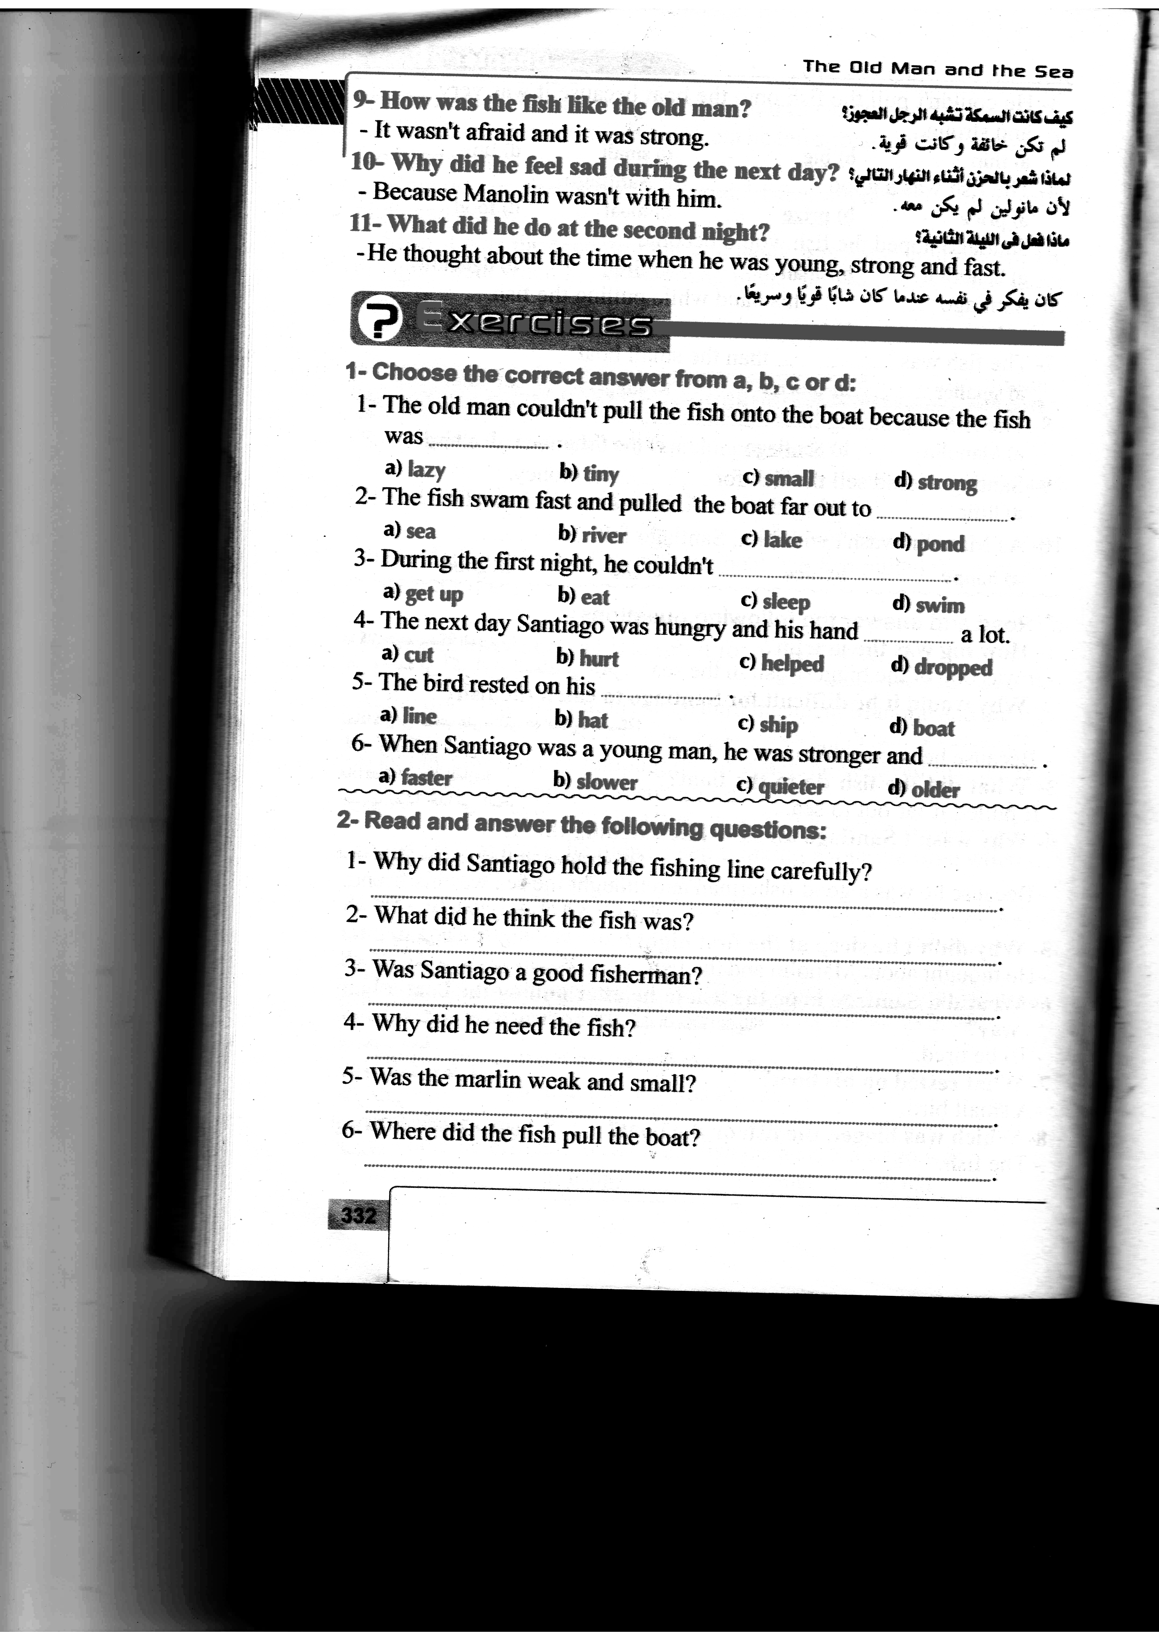
Answer the following questions:
Preview
# When did Santiago decide to sail back home?
Self Evaluation
The steps were : ( covered – not covered )
The aims were : (achieved –not achieved )
The students were : ( all - most – not ) understood
Date : ……./………/……… | Date : ……./………/……… | Date : ……./………/………
Class : ……………………. | Class : ……………………. | Class : ……………………………
Period : ………………….. | Period : ………………….. | Period : …………………..

The Old Man and The Sea Chapter 3
Pre-reading: I ask students to look at the picture and describe what they can see. What do they think is happening ? What do they think is going to happen? I let Ss discuss in pairs or small groups. I monitor as they are speaking. I ask different students for their suggestions. I write their suggestions on the board.

Viewing
Key vocabulary:
Skeleton –shark – harpoon – kill – ruin – Wait – tired – Sail - woke up

Pre-reading questions:
# Why didn't Santiago sleep on the first night ?
# Was Santiago afraid ? Why ? Why not ?

Presentation of the Lesson
I get the Students to read the first paragraph ,then I ask : What did the fishing line do to Santiago's hand ? I ask ( Why ) and I get the Ss'answers . Ss go on reading the story . I mime the events and explain what happened when necessary .Then at the end I get them to work in pairs and do the exercises . I monitor and check.
Choose the correct answer from a,b, c or d:
- The old man killed the sharks with a ………………..
- Knife b- gun c- harpoon d- pistol
- He saw the fish's …………. come out of the water.
- eye b- fin c- mouth d- tail
Answer the following questions:
- Why couldn't Santiago put the fish onto the boat ?
- What did he decide to do to the fish ?
- What do you think he meant by " I ruined us both." ?
- How many sharks did the old man kill ?
Preview
What do you think he would feel ? Why ?
Self Evaluation
The steps were : ( covered – not covered )
The aims were : (achieved –not achieved )
The students were : ( all - most – not ) understood

