MOS PowerPoint 2013 Quick Reference
Exam 77-422: MOS PowerPoint 2013 Objectives
http://www.microsoft.com/learning/en-us/exam.aspx?id=77-422
YouTube Videos: http://www.youtube.com/user/3mit1/playlists

Create and Manage Presentations

Create a Presentation

This objective may include but is not limited to:
  - Creating blank presentations
    - File tab → New → Blank Presentation
  - Creating presentations using templates
    - File tab → New → Select one, Search, or Suggested Search
  - Importing text files into presentations
    - File tab → Open → Locate file → Change type → Open
  - Importing Word document outlines into presentations
    - Insert tab → Slides group → New Slide → Slides from Outline → Open

Format a Presentation Using Slide Masters

This objective may include but is not limited to:
  - Applying a slide master
    - Insert tab → Slides group → New Slide → Reuse Slides → Reuse Slides pane → Browse → Browse File → Open → Click slide
    - Copy and paste slide from another presentation → Paste Options button → Use destination theme
  - Adding new layouts
    - View tab → Master Views group → Slide Master
    - Slide Master tab → Edit Master group → Insert Layout → Right click it → Rename Layout → Add placeholders, etc.
  - Modifying existing layouts
    - Hover mouse pointer over layout to find appropriate one → Modify placeholders, add graphics, etc.
  - Adding background images
    - Select a layout or the master → Slide Master tab → Background group → Dialog Box Launcher button → Set options in Format Background task pane
  - Controlling page numbers
    - Position placeholders for slide/page numbers
    - Insert tab → Text group → Slide Number → Check Slide Number
  - Inserting headers and footers
    - Insert tab → Text group → Header and Footer
  - Modifying presentation themes
    - Slide Master tab → Edit Theme group → Themes

Customize Presentation Options and Views

This objective may include but is not limited to:
  - Changing page setup options
    - Design tab → Customize group → Slide Size
  - Changing to view in color/grayscale
    - View tab → Color/Grayscale group → Choose one
  - Using views to navigate through presentations
    - View tab → Presentation Views group
    - Slide Show button in Status Bar
  - Modifying presentation properties
    - File tab → Info → Show All Properties OR Properties → Adv. Properties

Configure Presentations to Print or Save

This objective may include but is not limited to:
  - Printing selections from presentations
    - Select slides → File tab → Print → Change option to Print Selection
  - Setting handout print options
    - File tab → Print → Change option for desired number of handouts per page
  - Printing speaker notes
    - File tab → Print → Change option to print Notes Pages
  - Printing presentations in grayscale
    - File tab → Print → Change option for grayscale
  - Packaging presentations for CD
    - File tab → Export → Package Presentation for CD → Package for CD → Set options
    - Can also Copy to Folder
  - Maintaining backward compatibility
    - File tab → Save As → Select location → Change file type (97-2003 format)
  - Saving presentations as web pages
    - Save as web page (HTML) not available in PowerPoint 2013
    - Sign in if necessary → File tab → Share → Present Online

Configure and Present Slideshows

This objective may include but is not limited to:
  - Creating custom slideshows
    - Slide Show tab → Start Slide Show group → Custom Slide Show → Custom Shows → New → Name it → Add slides → OK → Close
  - Configuring slideshow options
    - Slide Show tab → Set Up group → Set Up Slide Show
  - Configuring slideshow resolution
    - Slide Show tab → Set Up group → Set Up Slide Show → Resolution
  - Using Presenter View
    - Slide Show tab → Set Up group → Set Up Slide Show → Multiple monitors options
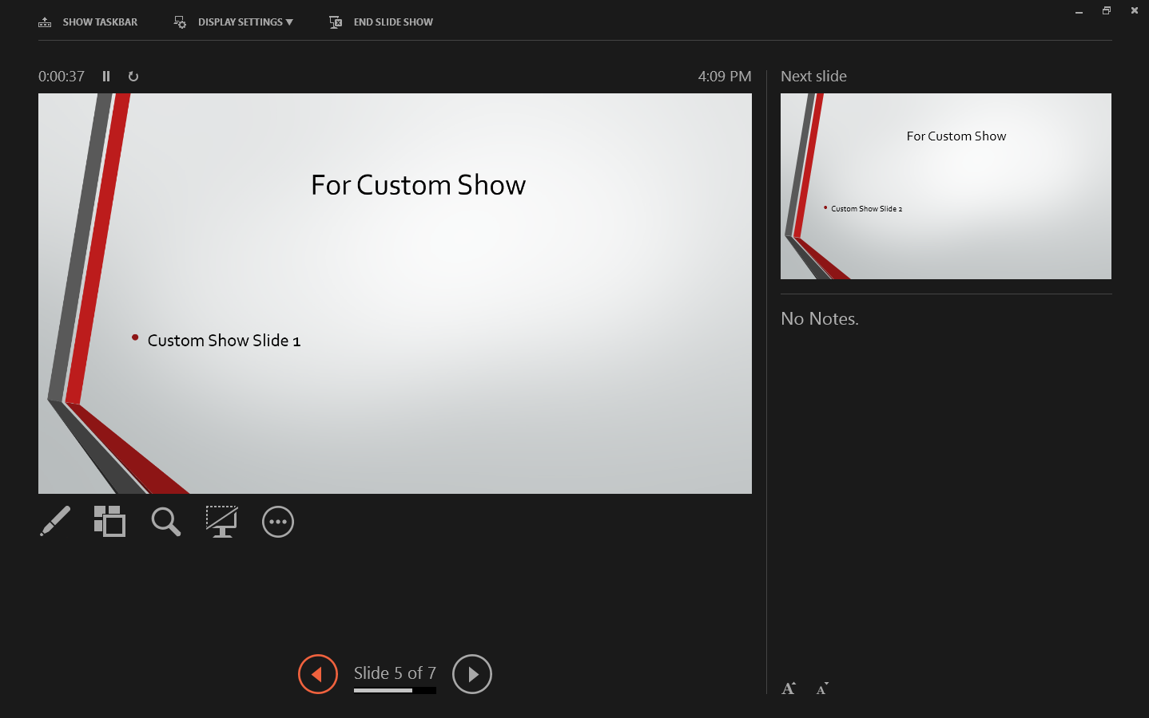
  - Rehearsing timing
    - Slide Show tab → Set Up group → Rehearse Timings → Click through the presentation pausing the appropriate number of seconds on each slide
  - Navigating within slideshows
    - Tools in lower left corner in Slide Show view
  - Annotating slideshows
    - Tools in lower left corner in Slide Show view

Insert and Format Shapes and Slides

Insert and Format Slides

This objective may include but is not limited to:
  - Adding slides layouts
    - Home tab → Slides group → New Slide → Choose appropriate layout
  - Duplicating existing slides
    - Select slide(s) → Home tab → Slides group → New Slide → Duplicate Selected Slides
  - Hiding slides
    - Select slide(s) → Slide Show tab → Set Up group → Hide Slide
  - Deleting slides
    - Select slide(s) → Right click a slide → Delete Slide
  - Modifying slide backgrounds
    - Select slide(s) → Design tab → Customize group → Format Background → Set options
  - Applying styles to slides
    - Design tab → Variants group → More button → Set options for colors, fonts, and/or background styles

Insert and Format Shapes

This objective may include but is not limited to:
  - Inserting shapes
    - Insert tab → Illustrations group → Shapes → Select shape → Draw it
  - Resizing shapes
    - Use sizing handles OR Drawing Tools: Format tab → Size group → Enter height and width
  - Applying styles to shapes
    - Drawing Tools: Format tab → Shape Styles → More button
  - Modifying shape backgrounds
    - Drawing Tools: Format tab → Shape Styles → Shape Fill
  - Applying borders to shapes
    - Drawing Tools: Format tab → Shape Styles → Shape Outline
  - Creating custom shapes
    - Insert tab → Illustrations group → Shapes → Freeform → Draw it
    - Select shape → Drawing Tools: Format tab → Insert Shapes group → Edit Shape → Edit Points

Order and Group Shapes and Slides

This objective may include but is not limited to:
  - Inserting section headers
    - Home tab → Slides group → Section → Add Section
    - Home tab → Slides group → Section → Rename Section
  - Modifying slide order
    - Slide Sorter view → Drag slides to position them
  - Aligning and grouping shapes
    - Select all shapes → Drawing Tools: Format tab → Arrange group → Align
    - Select all shapes → Drawing Tools: Format tab → Arrange group → Group
  - Displaying gridlines
    - View tab → Show group

Create Slide Content

Insert and Format Text

This objective may include but is not limited to:
  - Changing text to WordArt
    - Select text → Drawing Tools: Format tab → WordArt Styles group → More button → Select style
  - Creating multiple columns in a single shape
    - Select shape → Home tab → Paragraph group → Add or Remove Columns
  - Inserting hyperlinks
    - Select text or object → Insert tab → Links group → Hyperlink
  - Applying formatting and styles to text
    - Select text → Home tab → Font group (Dialog Box Launcher button)
  - Creating bulleted and numbered lists
    - Select text → Home tab → Font group → Bullets or Numbering

Insert and Format Tables

This objective may include but is not limited to:
  - Creating new tables
    - Insert tab → Tables group → Insert Table → Enter dimensions
  - Modifying number of rows and columns
    - Table Tools: Layout tab → Rows & Columns group
  - Applying table styles
    - Table Tools: Design tab → Table Styles group → More button
  - Importing tables from external sources
    - Copy and paste
    - Insert tab → Text group → Object

Insert and Format Charts

This objective may include but is not limited to:
  - Inserting charts
    - Insert tab → Illustrations group → Chart → Choose one
  - Modifying chart type
    - Chart Tools: Design tab → Type group → Change Chart Type
  - Creating and modifying chart styles
    - Chart Tools: Design tab → Chart Styles group → More button
  - Adding legends to charts
    - Chart Tools: Design tab → Chart Layouts group → Add Chart Element → Legend → Select one
  - Modifying chart parameters
    - Chart Tools: Format tab → Current Selection group → Select element → Format Selection
  - Importing charts from external sources
    - Copy and paste
    - Insert tab → Text group → Object

Insert and Format SmartArt

This objective may include but is not limited to:
  - Adding shapes to SmartArt
    - Select shape → SmartArt Tools Design tab → Create Graphic group → Add Shape
  - Changing color of SmartArt
    - Select shape → SmartArt Tools Design tab → SmartArt Styles group → More button
  - Moving text within SmartArt shapes
    - Select text → Drag it
    - Move text in Text Pane
  - Reversing direction
    - Select shape → SmartArt Tools Design tab → Create Graphic group → Right to Left
  - Converting lists to SmartArt
    - Select list → Right click → Convert to SmartArt

Insert and Format Images

This objective may include but is not limited to:
  - Cropping images
    - Picture Tools: Format tab → Size group → Crop button → Adjust picture
    - Picture Tools: Format tab → Size group → Bottom part of Crop button → Crop to Shape
  - Resizing images
    - Picture Tools: Format tab → Size group → Height and Width
  - Applying effects
    - Picture Tools: Format tab → Picture Styles group → Picture Effects button
  - Applying styles
    - Picture Tools: Format tab → Picture Styles group → More button → Select one

Insert and Format Media

This objective may include but is not limited to:
  - Adjusting media window size
    - Video Tools: Format tab → Size group
  - Setting start/stop times
    - Video Tools: Playback tab → Video Options group
  - Trimming timing on media clips
    - Video Tools: Playback tab → Editing group → Trim Video
  - Setting media options
    - Video Tools: Playback tab → Video Options group
  - Linking to external media
    - Sign in for additional options such as YouTube
    - Insert tab → Media group → Video → Online Video → Select video → Insert

Apply Transitions and Animations

Apply Transitions between Slides

This objective may include but is not limited to:
  - Inserting transitions between slides
    - Transitions tab → Transition to This Slide group → Select one
  - Managing multiple transitions
    - Select slides → Click on transition to apply to selected slides
    - Transitions tab → Timing group → Apply to All
  - Modifying transition effect options
    - Transitions tab → Transition to This Slide group → Effect Options

Animate Slide Content

This objective may include but is not limited to:
  - Applying animations to shapes
    - Animations tab → Animation group → More button
  - Applying animations to text strings
    - Animations tab → Animation group → More button
  - Adding paths to animations
    - Animations tab → Animation group → More button → Select Motion Path
  - Modifying animation options
    - Animations tab → Animation group → Effect Options

Set Timing for Transitions and Animations

This objective may include but is not limited to:
  - Modifying duration of effects
    - Animations tab → Timing group → Duration
  - Configuring start and finish options
    - Animations tab → Timing group → Start
    - Add an Exit animation
  - Using the Animation Pane
    - Animations tab → Advanced Animation → Animation Pane → Right click → Effect Options
  - Reordering animations
    - Drag items in Animation Pane

Manage Multiple Presentations

Merge Content from Multiple Presentations

This objective may include but is not limited to:
  - Merging multiple presentations
    - Open presentation → Review tab → Compare group → Compare → Open presentation to merge it with → Review changes → Accept → Accept all Changes to the Presentation
    - Can also select changes individually and accept those desired
  - Reusing slides from other presentations
    - Insert tab → Slides group → New Slide → Reuse Slides → Find presentation file → Select slide(s)
  - Viewing multiple presentations
    - Open presentations → View tab → Window group → Arrange All

Track Changes and Resolve Differences

This objective may include but is not limited to:
  - Setting track changes
    - No Track Changes button like Word
    - Create copy of presentation for reviewer
    - Compare and merge the files
  - Modifying options for track changes
    - File tab → Options → General → User name
  - Discarding changes from specific users
    - Review tab → Compare group → Reject (selected or all)
  - Managing comments
    - Review tab → Comments group

Protect and Share Presentations

This objective may include but is not limited to:
  - Marking as final
    - File tab → Info → Protect Presentation → Mark as Final
  - Encrypting presentations with a password
    - File tab → Info → Protect Presentation → Encrypt with Password
  - Compressing media
    - File tab → Info → Compress Media → Select quality
  - Proofing presentations
    - Review tab → Proofing group → Check spelling
  - Embedding fonts
    - File tab → Options → Save → Embed fonts in the file
  - Restricting permissions
    - Requires Windows Rights Management
    - Enter “restrict permission by people” in PowerPoint help for additional information
    - File tab → Info → Protect Presentation → Restrict Permission by People
  - Removing presentation metadata
    - File tab → Info → Check for Issues → Inspect Document
  - Checking for accessibility issues
    - File tab → Info → Check for Issues → Check Accessibility
  - Checking for compatibility issues
    - File tab → Info → Check for Issues → Check Compatibility

