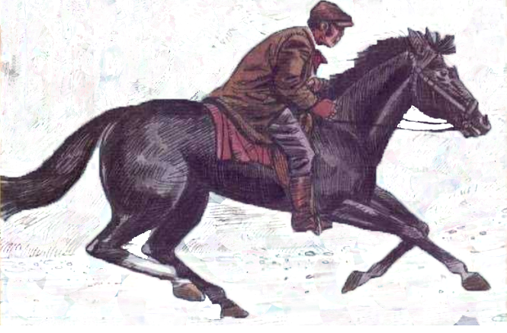
Black Beauty

Anna Sewell

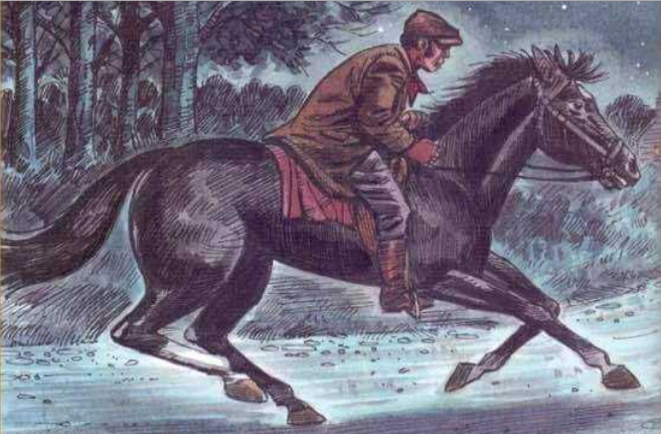

Anna Sewell (1820-1878)
Anna Sewell was born in England in 1820. When she was a child, she had an accident which badly damaged her legs. After this she couldn’t walk, but she learned to drive a horse and a carriage. She loved the horses that helped her to travel around. She also helped her mother, who wrote children’s books. Anna decided that she wanted to write, too. She wanted people to understand that looking after horses was important, so she wrote a book about the life of a working horse. In 1877, she wrote Black Beauty, and it has become one of the most popular books for Children.

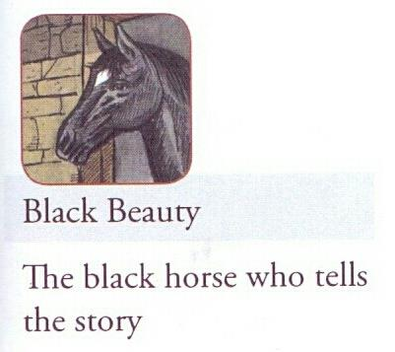
Main Characters
1 – Black Beauty
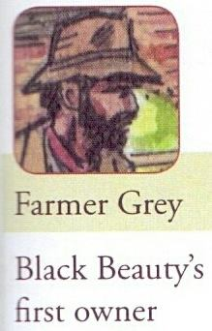
* The black horse who tells the story.
2 – Farmer Grey
* Black Beauty’s first owner.
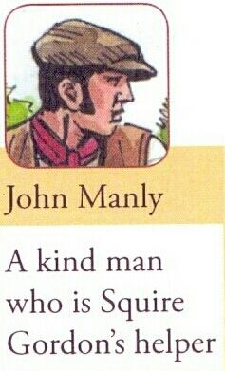
3 – John Manly
A kind man who is Squire Gordon’s helper.
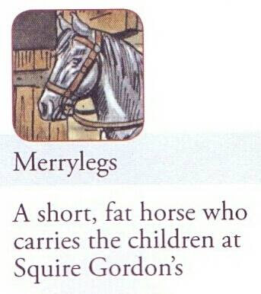
4 – Merrylegs
A short, fat horse who carries
the children at Squire Gordon’s
5 – Earl Smythe
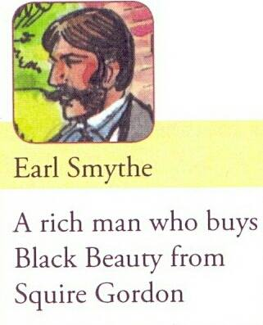
A rich man who buys Black beauty
from Squire Gordon
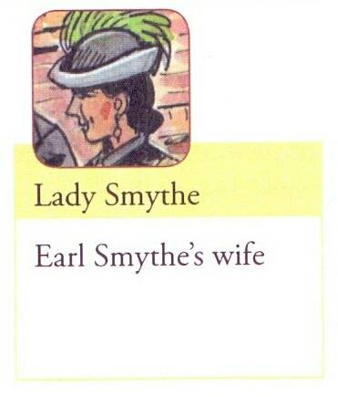
6 – Lady Smythe
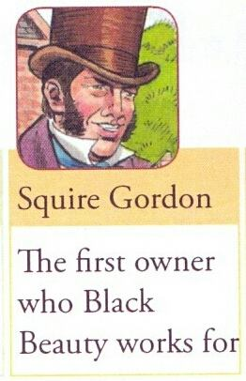
Earl Smythe’s wife
7 – Squire Gordon
The first Owner who Black Beauty works for
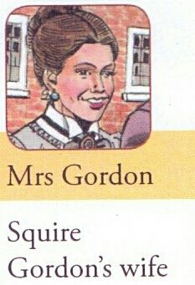
8 – Mrs Gordon
Squire Gordon’s wife
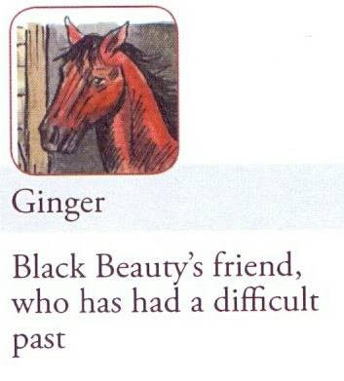
9 – Ginger
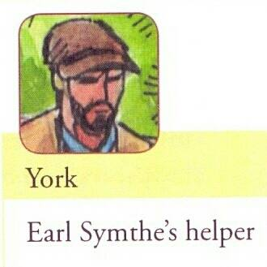
Black Beauty’s friend, who had a difficult past
10 – York
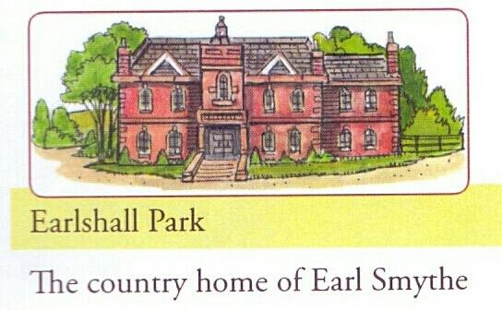
Earl Smythe’s helper
11 – Earlshall Park
The country home of Earl Smythe
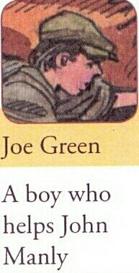
12 – Joe Green
A boy who helps John Manly

Chapter (1)

Word | Meaning | Word | Meaning
accident | حادثة | kick | يركل – يرفس
damage | يدمر | bite-bit | يعض
carriage | عربه يجرها الخيل | gentle | لطيف
horse | حصان | advice | نصيحه
travel around | يسافر حول | white foot | قدم بيضاء
decide | يقرر | coat | رقبه
look after | يعتنى بــ | explain | يشرح
important | مهم | needs | يحتاج
popular | مشهور – محبوب | true | حقيقي
remember | يتذكر | stables | اسطبل
wood | خشب | helper | مساعد
along | بطوول | jolly | مرح
owner | مالك | laugh | يضحك
farmer | فلاح | face | وجه
healthy | صحى | frightened | خائف
kindly | بطيبة – بعطف | apples | تفاح
field | حقل | handsome | وسيم
perfect | ممتاز | call | يسمى
thoughtful | مراعى لشعور الاخرين | bad-tempered | سيء المزاج
work hard | يعمل بجد | friends | أصدقاء
hurt | يؤذي | cruel | متوحش – عنيف
refuse | يرفض | machine | آلــه
different from | مختلف عن | cried | يصرخ
angry with | غاضب من | respect | يحترم
behave | يتصرف | continue | يستمر
ground | الارض | sold | باع

My early years

The first place that I can remember is a large field with a little wood at the top, where I lived with my mother and some other horses. A small river ran along the bottom of the field. If I stood at the gate to the field, I could see my owner’s house next to the road. The owner, Farmer Grey, was a good man. He gave us healthy food and he spoke to us as kindly as he spoke to his children.
There were other young horses in the field with me, but I was the youngest. I used to run with them, and have great fun. We used to have races, and when the biggest horses got too excited, they kicked and bit the horses next to them. One day, when my mother saw that was happening, she called me over to her.
“ Listen to me. The horses in this field are all good horses, but they are not like us. I don’t think you have ever seen me bite or kick anyone. I hope that you will grow up to be gentle and good, Never bite or kick, even when you are just playing a game.”
I have never forgotten my mother’s advice.
I grew into a tall, strong horse with a black coat, with one white foot and a white star on my head. I soon learned how to pull a carriage. Sometimes I pulled the carriage with my mother, and she helped me to learn what to do.
“ The harder you work, the kinder people will be to you, “ my mother explained one day. “I hope you find a good owner. However, there are many kinds of men. Some are as good as our owner, but some are bad. We never know who might buy us. Sometimes people don’t understand what a horse needs.” I found out that my mother’s words were very true.
When I was older, Farmer Grey decided to sell me to a new owner. His name was Squire Gordon and he lived in a big house in a place called Birtwick Park. It was a lovely place to live in, with large fields and comfortable stables.
Squire Gordon had a kind helper called John Manly who looked after me, and I soon became friends with the other horses in the stables. One was a small, fat horse called Merrylegs. He was a jolly, gentle horse who was always making people laugh because of the way he walked. He carried the young children of the family. Another was Ginger, a tall horse with a sad face. Merrylegs told me that Ginger often bit or kicked because people were not nice to her in the past.
Squire Gordon’s children used to bring me apples and nice things to eat,” said Merrylegs. “ But when they knew that Ginger bit people, they became frightened and now they don’t come to visit us horses any more. However, if people are kind to her she will soon learn to stop biting,” he explained.
The next day, Squire Gordon took me out around Birtwick Park. “ How is your new horse?” asked his wife when we returned.
“ He is a perfect horse!” he said. “ What shall we call him?”
“ He is very handsome,” his wife said. “ Why don’t we call him Black Beauty?”
“ Yes, l like that.” said Squire Gordon. And that is how I got my name.
On some days, I work with Ginger, pulling carriages. Although Merrylegs said that Ginger was sometimes bad-tempered, I found that she was thoughtful. She always worked hard so that I didn’t have to pull the carriage any more that she did. We soon became good friends.
One day, when I was working with Ginger, she told me about the people she worked with in the past. None of them was kind and some of them were often cruel. She decided that she didn’t like people and didn’t want to do what they asked her to. The problem was that some people hit her hard when she refused to do what they wanted. That was when she started to kick and bite people. Then they wanted to sell her, and finally she arrived at Squire Gordon’s.
However, as time passed, Ginger understood that John and Squire Gordon were different from her other owners. They were always kind and gentle with their horses and she was happy to do what they asked, most of the time.
Then one day, she saw something that showed her that some people could be good. Squire Gordon was riding her when they passed a man who worked for Squire Gordon. The man was angry with his horse and hit it hard to make it go faster. Squire Gordon didn’t like this.
“ I have never seen a man who was so unkind to a horse,” he cried. “ No horse will do what you want by hurting it! The people who work for me must understand that a horse is not a machine!”
Ginger now began to respect Squire Gordon. After this, she decided she would not bite or kick people any more.
“ She will be as good as Black Beauty soon,” said John. “ All she needed was for people to be kind to her.”
One day, I was surprised when John brought Merrylegs back to the stable and said, “ Don’t do that again, Merrylegs, or you will be in trouble.”
“ What did you do?” I asked him. I was very surprised because Merrylegs always behaved so well.
“ Oh, I didn’t do much,” said Merrylegs. “ I wanted to give the boys a lesson, so I threw them on the ground.”
“ What?” I said, very surprised. “ But you are always so careful with the children!”
“ Of course I am,” he said. “ I would never hurt the girls or the little children. But the older boys need a lesson sometimes ,” he continued.
“ they think that a horse is like a machine, which can continue for hours without a rest. They never think that I can feel tired. So I stopped. When I didn’t continue, they hit me with a stick. Then I threw them off. They need to learn how a horse feels.
“ Why didn’t you kick them?” said Ginger.
“ No, I would never do that. I threw them off because I knew it wouldn’t hurt them. If I kicked the boys, I would be sold to some unkind person who would hit me all the time. We must always remember what a good place we live in.”

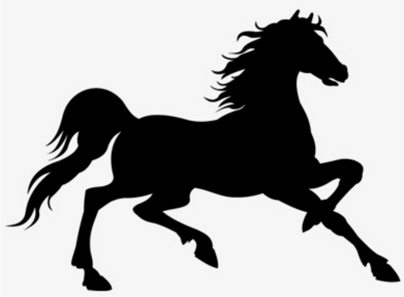
A ) Answer the following questions
1 – Who is the author of the story?
Anna Sewell.
2 – Who is the narrator of the story?
The horse (Black Beauty)
3 – With whom did Black Beauty live?
With his mother and some horses.
4 – Who was the first owner of Black Beauty?
Farmer Grey.
5 – How was farmer Grey a good man?
He gave them healthy food and spoke kindly.
6 – Who was the youngest horse ?
Black Beauty.
7 – What did Black beauty and other horses use to have?
They used to have races.
8 – What did the biggest horses do when they got excited?
They kicked and bit other horses.
9 – What did Black Beauty’s mother advise not to do?
Not to bite or kick even when just playing.
10 – Describe Black Beauty when he grew up.
He grew tall, strong with a black coat with one white foot and a white star on head.
11 – What did he learn to do?
He learnt how to pull a carriage.
12 – What advice did his mother give when he grew up?
She said the harder he worked, the kinder people will be to him.
13 – When did farmer Grey decide to sell Black Beauty?
When he got older.
14 – Who was the new or second owner of Black Beauty?
He was Squire Gordon who lived in Birtwick Park.
15 – Who looked after Black Beauty?
John Manly, Gordon’s kind helper.
16 – Who were Black Beauty’s new friends?
Merrylegs who was small, fat jolly and gentle.
Ginger who was tall with sad face.
17 – Why did ginger often kick and bite?
Because people weren’t nice to her in the past.
18 – Why did Merrylegs make children laugh?
Because of the way he walked.
19 – What did the children bring Merrylegs?
They brought him apples and nice things.
20 – Why didn’t the children visit the horses any more?
Because they knew that Ginger bit people.
21 – What did Gordon’s wife say about Black Beauty?
She said he was a perfect horse.
22 – What name did the wife suggest for the horse and why?
She suggested calling him Black Beauty as he was handsome.
23 – What did Merrylegs say about Ginger?
He said that she was sometimes bad-tempered.
24 – What did Ginger say about people she worked with in the past?
She said that they were not kind and cruel.
25 – What was Ginger’s problem with people?
Some people hit her hard when she refused to do things.
26 – Why did the people decide to sell Ginger?
Because she started to bite and kick people.
27 – For Ginger, How did she know that Gordon and John were different from other people?
They were kind and gentle with their horses.
28 – What happened that made Ginger think that some people could be good?
When Gordon was angry with a man who hit the horse and said that a horse is not a machine.
29 – When did Ginger start to respect Gordon?
When he told one of his workers that a horse was not a machine
30 – What did Ginger decide not to do?
She decided not to bite or kick people.
31 – When would Ginger be as good as Black Beauty?
When people became kind to her.
32 – What bad thing did Merrylegs do one day?
He threw children on the ground.
33 – Why did Merrylegs throw the children on the ground?
To teach them a lesson because they hit him with a stick.
34 – Why was Merrylegs angry with older children?
Because they thought it was a machine and could continue without rest.
35 – Why didn’t Merrylegs kick the children?
Because he didn’t want to hurt them and if he did so they would sell him to unkind people.

B ) Match the following:
1 – Anna Sewell was born | a – Farmer Grey
2 – Anna had an accident which | b – Gordon
3 – The narrator was | c – Black Beauty
4 – The first owner was | d - damaged her legs
 | e – In England

B ) Match the following:
1 – Black Beauty first lived with | a – Black Beauty
2 – the owner’s house was | b – badly
3 – Grey spoke to the horses | c – mother and other horses
4 – The youngest horse was | d - kindly
 | e – next to the road

B ) Match the following:
1 – Black Beauty’s mother | a – the kinder people will be
2 – Black Beauty had one | b – when he became older
3 – The harder you work, | c – white foot
4 – Grey decided to sell Beauty | d - advised him not to bite
 | e – black foot

B ) Match the following:
1 – The new owner was | a – Merrylegs and Ginger
2 – Gordon lived in | b – John Manly
3 – Gordon’s helper was | c – Farmer Grey
4 – Black Beauty became friends with | d – Birtwick Park
 | e – Squire Gordon

B ) Match the following:

1 – Merrylegs was | a – a horse was a machine
2 – Ginger was | b – a horse was not a machine
3 – Black Beauty | c – small, fat and jolly
4 – Gordon thought | d - was handsome
 | e – tall with sad face


Chapter (2)

Difficult journeys
Word | Meaning | Word | Meaning
  difficult | صعب | an inn | حانه او فندق صغير
journey | رحله | feed | يطعم
business | عمل تجاري | brush | يغسل
pull | يسحب – يجر | ready | جاهز – مستعد
light | خفيف | rider | راكب
windy | عاصف | smoke | يدخن – دخان
leaves | اوراق الشجر | cigarette | سيجارة
bridge | كوبري | woke up | يوقظ
flood | يفيض بالمياة | uncomfortable | غير مريح
rest | راحه | coughing | يكح
storm | عاصفة | frightened | خائف
the wood | الغابة | appeared | ظهر
suddenly | فجأة | beautiful | جميل
loud | عالى | softly | بنعومه – بحنية
crash | تصادم | gentle | لطيف
matter | امر – موضوع | collapsed | انهار – وقع
shouted | صاح | building | المبنى
broken | مكسور | firefighters | رجال الأطفاء
fall into | يقع في | put out | يطفىء نار
river | النهر | talk to | يتحدث إلى
saved | أنقذ | amazing | مدهش - مذهل
gates | بوابات | try | يحاول
decide to | يقرر | blow | يهب

Difficult journeys

One morning, I was put into a small carriage to take Squire Gordon and John on a long journey for the Squire’s business. I liked pulling this carriage because it was very light and easy to pull. It was raining when we left and it was also windy, with many leaves blowing across from the road.

On our journey we crossed a bridge, and I saw that the water of the river was really high. Many of the fields that we passed were flooded and sometimes I had to pull the carriage through water on the road.

When we got to the town, I had a good rest while Squire Gordon did his work. We started to go home late in the afternoon, and now there was a real storm. I heard the strong wind blowing through the big trees we passed.

“ I will be happy when we are out of the wood,” Said Squire Gordon, and as soon as he said this, a big tree suddenly fell across the road in front of us with a loud crash.
“ That was close!” Said John.
“ What can we do?” asked Gordon.
“ We can’t go forward,” said John. “ I think that we will have to go back home a different way.”

So we went back along a different road. It was longer and when we go to the bridge, it was dark. We started crossing the bridge, but I felt something was wrong, so I stopped.
“ Come on, Beauty!” said Squire Gordon, who tried to make me cross the bridge.

“ There is something wrong,” said John. “ What is the matter Beauty?”
I knew that the bridge was not safe, but I couldn’t tell him. Then we heard a man shout from the other side of the bridge.
“ Stop!” he called. “ The bridge is broken in the middle. If you continue, you will fall into the river!”
“ I see,” John replied. “ Thank you, Sir!”
“ And thank you, Black Beauty!” called Squire Gordon. “ You saved us!”

We had to take another road home, but the wind was less strong now. At last we saw the gates of Birtwick Park. I was very pleased to be home and enjoyed my evening food because I was very tired.

A few weeks later, Squire Gordon and his wife decided to visit some friends who lived about sixty kilometers from my home. They drove Ginger and me about thirty-five kilometers on the first day. We stopped often before we reached the town where we would stay for the night at an inn. Ginger and I were fed and brushed. We were ready to go to sleep when another horse arrived. His young rider smoked a cigarette while his horse brushed.

I don’t know how long I slept, or what time it was when I woke up. l felt uncomfortable although I didn’t know why. I heard Ginger coughing and I saw that the air was filled with smoke. Then knew that there was a fire.

A man appeared with a lantern and tried to take the horses outside. We could see that he was worried and this frightened us even more. None of us wanted to leave although we knew we were in danger. What would happen to us? We didn’t want to go anywhere. Then John arrived.

“ Come on, my beautiful horses, walk up please. It is time to go.”
He spoke softly and was so gentle with me that I stopped feeling frightened. I slowly followed him out of the building and away from the fire. When I saw that I was safe, I called out for the other horses to leave. Ginger later told me that I had saved her.
By now the fire was bigger and, just as John led Ginger away from the fire the building collapsed. Finally, some firefighters arrived to try to put out the fire. After many hours, the fire was no more.
When we arrived at the house of Squire Gordon’s friends the next evening, everyone was talking to John.
“ It is one of the hardest things in the world to move horses when there is a fire,” said Squire Gordon’s friend. “ What you did to help them was amazing.”
A ) Answer the following questions

1 – Where were Gordon and John going?
They were going on business.
2 – Why did Black Beauty like pulling the small carriage?
Because it was very light and easy to pull.
3. – How was the weather during the business trip?
It was raining and windy.
4 – Why were the fields flooded with water?
Because it was raining.
5 – What did Black Beauty have while Gordon was doing his work?
He had a good rest.
6 – How did Black Beauty know that there was a real storm?
Because of the strong wind.
7 – What fell across the road in front of them?
A big tree with a loud crash.
8 – How were Gordon, John and Beauty Lucky?
The big tree didn’t fall on them.
9 – Why couldn’t they go forward?
Because a tree was blocking their way.
10 – Why did they have to a different way?
Because there was a big tree on the way.
11 – Why did Black Beauty stop at the bridge?
Because he felt something was wrong.
12 – What did Beauty think about the bridge?
He thought it was not safe, but he couldn’t tell them.
13 – What did the man near the bridge say?
He shouted that the bridge was broken.
14 – What would happen if they tried to cross the bridge?
They would fall into the river.
15 – Why did John thank the man?
Because he saved them.
16 – Why did Gordon thank Black Beauty?
Because he saved them from falling into the river.
17 – Why did they have to take another road for the second time?
Because the bridge was broken.
18 – Why was Black Beauty pleased to be home?
Because he was safe and enjoyed food as he was tired.
19 – What did Gordon and his wife decide to do?
They decided to visit some friends.
20 – How far was it to Gordon friends’ home?
It was about sixty kilometers.
21 – Who were pulling the carriage?
Black Beauty and Ginger.
22 – Why did they often stop before reaching the town?
They stopped to stay for the night and to feed and brush the horses.
23 – What was the young rider doing?
He was smoking a cigarette.
24 – What cause the fire?
The Young rider’s cigarette.
25 – Why was Ginger coughing?
Because the air was filled with smoke.
26 – What frightened Beauty and the horses even more?
Because the man carrying the lantern was worried.
27 – What stopped Black Beauty from being frightened?
Because John came and spoke softly and was gentle with them.
28 – Who saved Ginger and How?
Black Beauty by calling out for her.
29 – What happened to the building when the fire became bigger?
The building collapsed.
30 – Who came to put out the fire?
Some firefighters put it out after many hours.
31 – Why do you think everyone was talking to John?
Because he was amazing and saved the horses.
32 – In Gordon friend’s opinion, What is one of the hardest things in life?
To move horses when there is a fire.
B ) Match the following:

A | B
1. Black Beauty liked | a. when Beauty heard strong wind
2. Many leaves were blowing | b. fell across the road
3. There was a real storm | c. pulling the large carriage
4. A big tree | d. because it was windy
 | e. pulling the small carriage

B ) Match the following:

A | B
1. They couldn’t go forward | a. because it was broken
2. At the bridge, Beauty | b. the bridge was broken
3. They couldn’t go on the bridge | c. the bridge was safe.
4. The man shouted and said | d. felt something was wrong and stopped
 | e. so they decided to take another way

B ) Match the following:

A | B
1. John thanked the man | a. they would fall into the river
2. Gordon thanked Beauty | b. because he told them about the bridge
3. Black beauty felt pleased | c. because he saved them
4. If they crossed the bridge | d. when he saw the gates of Birtwick Park
 | e. they would fall into the sea.
B ) Match the following:

A | B
1. Gordon and his wife | a. pulled the carriage
2. Gordon’s friends lives | b. was smoking a cigarette.
3. Beauty and Ginger | c. about 6 km from home
4. The young rider | d. about 60 km from home.
 | e. decided to visit some friends
B ) Match the following:

A | B
1. When the fire was bigger | a. softly and gently to the horses
2. John spoke | b. with a lantern
3. The man came | c. the building collapsed
4. The firefighters put out the fire | d. after many hours
 | e. After few hours

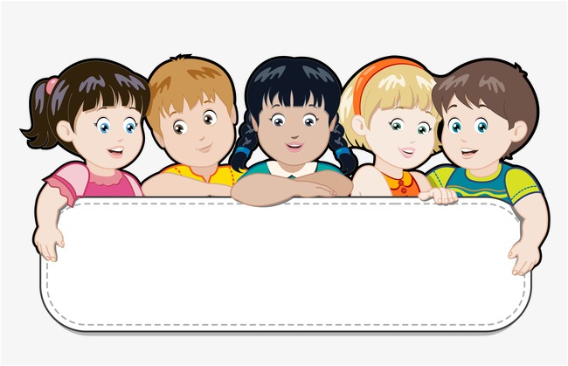

Chapter (3) Joe Green’s lesson

Word | Meaning | Word | Meaning
lesson | درس | stable | الأسطبل
new helper | مساعد جديد | ached | يؤلم
hard worker | عامل مجد | breathe | يتنفس
the same | نفس | cover with | يغطى بـــ
look after | يعتنى بــ | luckily | لحسن الحظ
as well as | بالأضافة الى | angry with | غاضب من
parents | الوالدين | message | رساله
sweep | يكنس | metal | معدن
floor | الأرضية | bars | قضبان أو أسياخ
bring food | يحضر الطعام | wheels | عجلات
wash | يغسل | factory | مصنع
practise | يمارس | hit with | يضرب بــ
dark | مظلم | whip | سوط
stand by | يقف بجوار | thick | سميك – كثيف
lantern | مصباح – فانوس | mud | طين
note | ورقة – رساله | rudely | بوقاحة
inn | حانه – فندق صغير | deal with | يتعامل مع
along | بطول | the police | الشرطة
village | قرية | manager | مدير
dark wood | غابه مظلمة | right | حق – صواب
hills | تلال | changes | تغييرات
knock on | يطرق ع الباب | pleased with | سعيد بــ
have problem | عنده مشكلة | mistakes | أخطاء
describe | يصف | climate | مناخ
almost | تقريبا | railway station | محطة قطار
wet | مبلل | leave | يغادر
warm | دافيء | the best | الأفضل
blanket | بطانية | feel sad | يشعر بالحزن
alone | بمفرده | difficulties | صعوبات


Joe Green’s lesson

When we returned to Birtwick Park, we heard that John was to have a new helper. His name was Joe Green and he was fourteen years old.
“ Are you sure you don’t need someone who is older than this?” asked Squire Gordon.
“ No, Sir,” said John. “ Joe is small, but he wants to learn and he is a hard worker. I was the same age when I started here. I had no family, but you looked after me as well as any parent. Now I live here with a good job and a good living. It is only right that I do the same to this new boy, Joe Green.”

In the next few weeks, Joe learned to sweep the floor, bring in the food and wash the carriages. He was too small to brush Ginger or me, so he practised on Merrylegs. He was a happy boy who was always singing.
However, it was not always a happy time. One day, something happened that stopped Joe singing for some time.
John woke me up one morning when it was still dark. Almost before I could open my eyes, he was riding me past the house.
“Ride as fast as you can!” called Squire Gordon, who was standing by the door with a lantern in his hand. “ Take this note to Dr. White. My wife is very ill ! when you find the doctor, Black Beauty can rest at the inn.”

“ Yes, sir!” cried John and he rode me as quickly as he could through the village and out along the river. We went through another village, through a dark wood, up and down hills, until at last we came to town. Everything was quiet and everyone was sleeping. Finally, we arrived at Dr. White’s house.
John knocked loudly on the doctor’s door.
“ Mrs. Gordon is very ill. You must come now,” said John passing the doctor the note.

I will come at once, but I have a problem. My son has taken my horse and I don’t have another. Can I ride yours?”
“ He is very hot because he has run all the way here. But I think it is the only way to save Mrs. Gordon. I will stay here and you can ride Black Beauty.”

It is hard for me to describe the journey back. The doctor was heavier than John and not such a good rider. I had almost no energy when we finally arrived at Birtwick Park. The doctor ran into the house, and young Joe took me inside. All my hair was wet and I felt so hot.

Poor Joe was young and he didn’t know what to do. A horse who has just run a long way needs to stay warm and drink warm water. It is a dangerous time for the horse, so someone should stay and watch him, too. Joe didn’t do this. He didn’t put a warm blanket on me because I was hot, and then he gave me cold water to drink, before he went away and left me alone in the stable.

I began to feel very cold. All my body ached. I lay down and tried to sleep. When I woke up, John was at my side. It was difficult for me to breathe. He covered me with blankets and gave me some hot water. He then stayed with me night and day. Squire Gordon also came to see me.
“ Poor Black Beauty! You saved my wife’s life, and now you are as ill as she was.” Although I was ill, I was happy to hear that she was well again.

Young Joe Green was very unhappy. He knew that I was ill because he did the wrong thing that night. Luckily, I became well again in a few days, but I knew that John was angry with Joe.

A few weeks later, Joe took me out to take a message to a neighbor . On the way home, we passed a carriage that was full of heavy metal bars. It was taking them to a nearby factory. The wheels of the carriage couldn’t move because the carriage was so heavy and there was thick mud on the road. Two horses were trying to pull the carriage, but they couldn’t The driver was hitting them hard with a whip.
“ stop, please,” said Joe. “ The wheels will not move in this mud.”
“ Be quiet,” said the driver rudely.
“ I can help you take some of the metal from the carriage, then it will move,” said Joe.

“ Go away,” said the driver. “ I know what I am doing.” He continued to hit the horses.
Joe quickly rode me to the factory and found the manager. Joe told him what the man was doing.
“ Thank you, Joe,” said the manager. “ I will deal with the man, will you tell the police what you saw?”
“ Yes, I will” said Joe.

The manager went to find the carriage with the metal and Joe went home. He told John what happened.
“ You did the right thing,” said John.
We heard later that the police asked Joe about what he had seen. Joe explained very well and when the police saw the poor horses. They sent the driver to prison for two or three months.
I was happy to see the change that came over Joe. He learned from his mistakes to become a very good worker. John was now very pleased with him.

“ You look taller than you did last week!” said John.
Soon Joe was singing happily again every day.
However, Mrs. Gordon became ill again in the years that followed. The doctor said that she should live in a warmer climate. We heard that Squire and Mrs. Gordon were going to leave England. Everybody was very sad.

All Squire Gordon’s horses were sold to new owners. Ginger and I were the last horses to leave Birtwick Park and one morning, We took Squire Gordon and his wife to the railway station. We never saw them again.
Ginger and I found out that we were going to live at Earlshall Park. The home of a rich Earl called Smythe John took us there the next day and told the new helper, a man called York, that we were the best horses they could have. Then John left, too. I felt very sad to see him go. I didn’t realize that my new home with Earl and lady Smythe would bring new difficulties for Ginger and me.

A) Answer the following questions:
1 – Who is Joe Green?
⇦He is John’s new helper.
2 – How old was Joe Green when he came to work?
⇦He was fourteen years old.
3 – What did Squire Gordon ask John?
⇦He asked him if he was sure he didn’t need someone older.
4 – What did John say about Joe?
⇦He said that he was small, but he wanted to learn and was a hard worker.
5 – How old was John when he started work?
⇦He was fourteen also.
6 – What was the similar thing between John and Joe?
⇦They both started work at fourteen.
7 – Why did Gordon look after John?
⇦Because he had no family.
8 – What did John want to do with Joe?
⇦He wanted to look after him as Gordon did with him.
9 – What did Joe learn in the following weeks?
⇦He learnt to sweep the floor, bring food and wash the carriages
10 – Why couldn’t Joe brush Beauty or ginger?
⇦Because he was too small.
11 – On which horse did Joe Practise working first?
⇦On Merrylegs.
12 – How did we know that Joe was a happy boy?
⇦He was always singing.
13 – What happened that stopped Joe from singing?
⇦Mrs. Gordon became ill and he didn’t look after Beauty well.
14 – Why did John ride Beauty as fast as he could?
⇦To take a note to Dr. White as Mrs. Gordon was ill.
15 – What did John say to the doctor and what did he give him?
⇦He told him that Mrs. Gordon was ill. He gave him a note.
16 – What did the doctor say?
⇦He said that he would come at once, but he didn’t have a horse.
17 – In John’s opinion, what was the only way to save Mrs. Gordon?
⇦The doctor could ride Black Beauty although he was tired.
18 – What do you think Beauty felt On the journey back?
⇦I think he felt too tired and had no energy.
19 – How was Black Beauty when Joe took him inside?
⇦All his hair was wet and he felt so hot.
20 – How did Joe lack experience?
⇦He didn’t know what a horse needed after running?
21 – What did a horse need after running for a long way?
⇦A horse needed to stay warm and drink warm water.
22 – Why it was a must to stay and watch a horse after running?
⇦Because it was a dangerous time for a horse.
23 – What should Joe have done?
⇦He should have put a warm blanket on Black Beauty and shouldn’t have left him alone.
24 – What happened to Black Beauty after Joe left him?
⇦He felt cold and his body ached and it was difficult to breathe.
25 – What did John do to Black Beauty?
⇦He covered him with blankets and gave him some hot water.
26 – Why was Joe angry?
⇦Because he knew that Beauty was ill because he did the wrong thing with him.
27 – Was John angry with Joe?
⇦Yes, because he did the wrong thing with Beauty.
28, – Why was Gordon grateful to Black beauty?
⇦Because he saved his wife.
29 – What was the carriage full of?
⇦It was full of heavy metal bars.
30 – Where were the metal bars taken?
⇦They were taken to a nearby factory.
31 – Why couldn’t the wheels move?
⇦Because the carriage was so heavy.
32 – What did the driver do with the horses?
⇦He was hitting them hard with a whip.
33 – What did Joe say to the driver?
⇦He told him to stop hitting the horses.
34 – What did Joe offer the driver?
⇦He offered to take some of the metal, but the man refused.
35 – Where did Joe go after that?
⇦He went to the factory and told the manager.
36 – What did the manager do after thanking Joe?
⇦He went to find the carriage with the metal.
37 – What was John’s opinion about what Joe did?
⇦He told him that he did the right thing.
38 – What did the police do with the driver?
⇦They sent him to prison for two or three months.
39 – What changes that happened to Joe that made Beauty happy?
⇦He learned from his mistakes and became a good worker.
40 – What happened to Mrs. Gordon in the following years?
⇦She became ill again and the doctor said that she needed a warmer climate.
41 – Why was everybody sad?
⇦Because Mr. Gordon decided to leave England.
42 – What happened to Gordon’s horses?
⇦All of them were sold to new owners.
43 – To whom were Black Beauty and Ginger sold?
⇦They were sold to Earl Smythe.
44 – Who was Black Beauty third owner?
⇦The third owner was Earl Smythe.
45 – What did John tell York the new helper?
⇦He told him that Black Beauty and Ginger were the best horses.
46 – What did Black Beauty expect about his life and Ginger with Earl Smythe?
⇦He expected new difficulties.

B ) Read and match
A | B
1. John’s new helper was | a. He wanted to learn and worked hard
2. Joe Green was | b. sweep and wash carriages.
3. Joe was small, but | c. 14 years old.
4. Joe learned to | d. Joe Green
 | e. 40 years old.
B ) Read and match
A | B
1. Joe was too small | a. and was always singing
2. Joe Practised on | b. the doctor.
3. Joe was always happy | c. Black Beauty
4. Gordon sent a note for | d. Merrylegs
 | e. to brush Beauty and Ginger

B ) Read and match
A | B
1. Dr. White said he would come, | a. needs to stay warm and has warm water
2. Although Black Beauty was tired | b. but his wife took his horse
3. Beauty’s hair was wet | c. and he felt so hot.
4. A horse who has just run | d. He took Dr. White back to Gordon’s
 | e. but his son had taken his horse

B ) Read and match
A | B
1. Joe didn’t put | a. instead of warm water
2. Joe gave Beauty cold water, | b. a warm blanket on Beauty
3. Joe should have | c. Merrylegs
4. Joe shouldn’t have | d. left beauty alone.
 | e. stayed with Beauty.

B) Read and match
A | B
1. John was | a. the horses with a whip
2. Gordon told beauty that | b. the horses with a stick
3. The carriage was full of | c. heavy metal bars
4. The driver was hitting | d. he saved his wife
 | e. angry with Joe

B) Read and match
A | B
1. Joe offered the man | a. to hospital
2. Joe went to complain the man | b. to take some metal bars
3. John told Joe that | c. he did the right thing
4. The police sent the man | d. to the owner of the factory
 | e. to prison
B) Read and match
A | B
1. Joe has changed and | a. was Earl Smythe
2. John became pleased with | b. so Mr Gordon decided to leave England
3. Mrs. Gordon was ill again, | c. Joe when he learnt from his mistakes
4. The third owner of Beauty, | d. and learnt from his mistakes.
 | e. Gordon

هذا العمل متاح للجميع لوجه الله دون استئذان وهو صدقة جارية على روح والدتى وموتى المسلمين
Mr Hamada Hashish
01287424004
وللمزيد تابعونا على

https://www.facebook.com/hamada.hashish.3

وهنا أيضا
https://www.facebook.com/groups/173244922885133/

Mr Hamada Hashish
01287424004

https://www.facebook.com/hamada.hashish.3

هذا العمل متاح للجميع لوجه الله دون استئذان وهو صدقة جارية على روح والدتى وموتى المسلمين
Mr Hamada Hashish
01287424004

https://www.facebook.com/hamada.hashish.3

وهنا أيضا
https://www.facebook.com/groups/173244922885133/

هذا العمل متاح للجميع لوجه الله دون استئذان وهو صدقة جارية على روح والدتى وموتى المسلمين
Mr Hamada Hashish
01287424004
وللمزيد تابعونا على

https://www.facebook.com/hamada.hashish.3

وهنا أيضا
https://www.facebook.com/groups/173244922885133/

