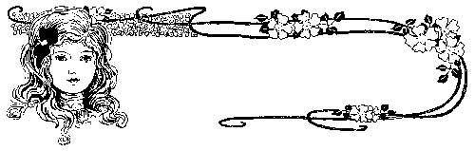
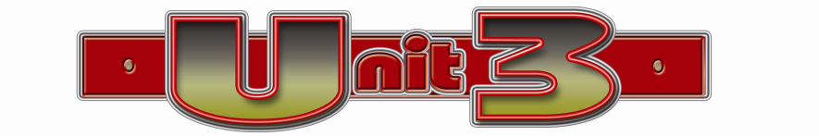
Festivals and special days

celebrate | يحتفل | subject | فاعل | midday |  | منتصف النهار | competition | منافسة
special | خاص | passive | سلبي | midnight |  | منتصف الليل | salted fish | سردين
hold | يعقد | a toy | لعبة | events |  | أحداث | good for | صالح لـ
nearly | تقريباً | fantastic | رائع | first of all |  | في البداية | onions | بصل
flowers | زهور | conclusion | خاتمة | afterwards |  | بعد ذلك | last | يستمر
appear | يظهر | pizza | بيتزا | smell |  | يشم | period | فترة
across | عبر | papyrus | ورق بردي | breeze |  | نسيم | feseekh | فسيخ
picnic | نزهة | parade | عرض | seasons |  | فصول | feast | عيد
festival | مهرجان | costume | زي | fresh |  | طازج | join | يلتحق
a pan | حلة | decorate | يزين | tradition |  | تقاليد | natural | طبيعي
for free | مجاناً | lantern | فانوس | traditional |  | تقليدي | serve | يخدم
main | أساسي | fireworks | ألعاب نارية | boiled | مسلوق |  | crafts | مشغولات يدوية
park | منتزه | envelope | مظروف | bright | مشرق |  | conclude | يستنتج
represent | يمثل | contain | يحتوي | preserve | يحفظ |  | summarise | يلخص
end | ينتهي | message | رسالة | date back | يعود الى |  | summary | ملخص

Festival | a day or time of the year when people have a holiday from work and celebrate some special event.
parade | A group of people or vehicles moving through a public place in order to celebrate an important day or event.
costumes | The clothes worn by people at a particular time
celebrate | you do something enjoyable because of a special occasion
free | Without having to pay any money
decorate | To make something nice
costume | Clothes worn by actors
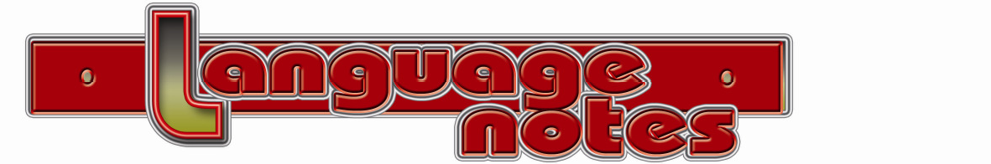
dress up get dressed يرتدى
لنعبر عن لبس الملابس كلها فى الصباح عند النهوض من النوم فنقول: get dressed نستخدم
* I get dressed after I've had a shower.
عندما نرتدى الملابس من اجل مناسبة dress up نستخدم
* I dressed up for my grandfather's funeral جنازة
Without + v + ing * Ahmed had done this without asking her.
Festival مهرجان Preparing a festival takes years.
Ceremony احتفال -a wedding/graduation ceremony
special خاص او مميز * privateملك شخص * publicعام (ملك الجميع )
customs تقاليد * costumes أزياء او ملابس تمثيل
On Mondayفي يوم الاثنين * On a Monday في أي يوم اثنين او يوافق الاثنين
parkحديقة او منتزة او يركن السيارة * bark ينبح
Language Functions
Using sequencing words استخدام الكلمات التسلسلية
- First of all, (we clean our houses). Next, (we decorate our homes).
- Afterwards, (many people go shopping).
- After / Before / At (dinner, children are given envelopes).
-At midnight / midday (there are fireworks).
- The next day / morning / afternoon (we wear our new clothes).
1- Write what would you say in each of the following situations:
1- You tell a friend what you did last Saturday at midday.
-----------------------------------------------------------------------------------------
2- A friend asks you what you do before and after dinner.
-----------------------------------------------------------------------------------------
3- You want to tell a friend what you will do first on Sham El-Nessim.
-----------------------------------------------------------------------------------------
4- A friend asks you what you do after you decorate your home .
-----------------------------------------------------------------------------------------
5- You want to conclude a writing about Sham El=Nessim.
-----------------------------------------------------------------------------------------
6- Your friend want your recommendation to spend his holiday.
-----------------------------------------------------------------------------------------
7- your younger brother is playing with matches. Advise him.
-----------------------------------------------------------------------------------------
2-Complete the following dialogue
Samir asks Hany about what he is doing
Samir : …………………………..1……………………………….? Hany : I'm colouring some eggs.
Samir : Why? Hany : Today ……………………………..2………………………………….
Samir : Sham El-Nessim is a nice day to celebrate. Where do you suggestspending the day?
Hany : …………………………………………3……………………………………..
3-Read the following, then answer the questions:
In Sweden, the longest day of the year is celebrated in June. It is the start of a five- week holiday. Most people go on a trip to the country with their families. Children put flowers in their hair and everyone eats a special cake. In the evening, a family meal is eaten. This usually includes herring: there are a lot of these in the sea around Sweden. After people have eaten, they usually go for a walk. Nobody goes to bed before twelve o'clock on this special day! There is sunshine until very late at night in Sweden at this time. In the north it does not get dark at all! It can be difficult to sleep. To help them, people should find a room that is not very light.
A: Answer the following questions:
1-What do most people do in June in Sweden?
2 What are herring?
3 Why do you think that people do not go to bed early in June in Sweden?
B- Choose the correct answer:
4 The main idea of the passage is about…………a-Swedish food b-the longest day in Sweden
c-holidays in Sweden d-Swedish flowers
5 The underlined word them refers to …………a- children b- people with out a house

Book Text

Spring Festivals
Spring is celebrated in different ways all over the world. It is a very special time of the year. In Egypt, Sham el-Nessim was first held to celebrate the start of spring nearly 4,000 years ago.
In Japan, people celebrate when small flowers first appear on thousands of trees across the country. People go outside and have picnics under the trees with their friends and family.
In rge town of Zenica in Bosnia, people have a festival of eggs in spring. Hundreds of eggs are cooked in a big pan for breakfast and these are given to all the people of the town for free.
In Australia, the start of spring is celebrated in September! In the city of Canberra, there is a month-long flower festival to celebrate spring. You can see about a million beautiful flowers in the city’s main park, and you can also listen to music.
Why do so many countries celebrate spring? The flowers and eggs all represent the new life that we can start to enjoy after the winter months have ended.

SHAM EL-NESSIM
* Sham el-Nessim means smelling the breeze and it is celebrated all over Egypt On a Monday in April or May. The festival started in about 2700 BCE. The ancient Egyptian year had three seasons and Sham el-Nessim was held to celebrate the start of spring. Sham el-Nessim isn’t celebrated in any other country.
* Today, Sham el-Nessim is a holiday and families go out to enjoy the fresh spring air. The spring air is very good for you! People often have a picnic in the country, in parks or along the Nile.
* Special food is eaten at Sham el-Nessim. Traditionally, boiled eggs are eaten for breakfast. Eggs are decorated in bright colours by children. They usually paint the eggs in the morning and leave them in the sun to dry.
* Another traditional food which is eaten on this day is FESEEKH: Fish that is dried with salt. This tradition also dates back to ancient Egyptian times. When people had more fresh fish than they could eat, they put salt on it to preserve it.
* It is important to buy FESEEKH from a clean shop so that you are sure that the fish will be good for you.

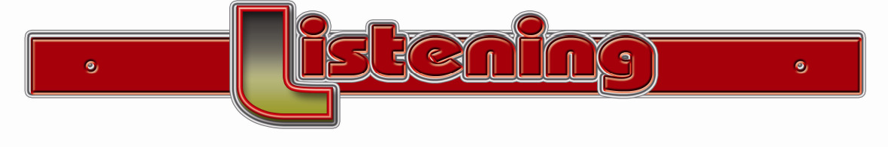

My name is Li. I am from China. My favourite festival is New Year. It lasts for about eight days. It is the most important festival for Chinese people and we start preparing for it a week before it starts. First of all, we clean our houses. We sweep and wash all the floors, doors and windows. Next, we decorate our homes with red paper lanterns. Afterwards, many people go shopping for new clothes.
There is always a special meal on the night before New Year’s Day. Relatives come from far away to join their families. Lots of special New Year food is eaten, but the most important food is usually fish. Dinner is usually eaten at home, not often in a restaurant. After dinner, children are given red envelopes with some money inside by their parents. At midnight, there are fireworks and the sky is filled with colour and noise.
The next morning, on the first day of the new year, we wear our new clothes and say congratulations to our friends and neighbours. Traditionally, young people visit older people to say Happy New Year to them. At midday, there are parades where people dress up in colourful costumes. Some people wear huge lion costumes, too.

Listening text

1 - Choose the correct answer from a, b, c or d:
1-When do people........................ new year in your country?
a- debate b- celebrate c- irrigate d- delete
2-Many countries have a ............................. when it is the start of spring.
a- festival b- ceremony c- present d- camera
3 -The teacher asks the children what " % " ................................
a- lives b- sees c- rinks d- represents
4 -Sham el-Nessim is a ............................. day for all of us.
a- special b- bad c- frightened d- sad
5 -You do not have to pay to go into the museum. It is..............................
a- busy b- not free c- free d- expensive
6-The children wore historical ………………. for the school play.
a- customers b-storms c- costumes d- bicycles
7- Many people like to freeze food to ...............................it.
a- reserve b-preserve c- serve d- deserve
8-At ..............................., there were fireworks to welcome the new year.
a- midday b-day c- noon d- midnight
9-We walked up the street in a .....................to celebrate the start of spring.
a- parade b- costumes c- festivals d- company
10-There was no electricity on the farm, so the farmer used .............. so that he could read.
a- lanterns b-pumps c- carts d- tractors
11-Salt is often used to……………fish and other food.
a- pack b- preserve c- celebrate d- decorate
14-When we ............... eggs for Sham el-Nessim, we try to use natural colours from plants.
a- see b- fill c- drink d- decorate
15-When we stood on the beach, we could feel a .......................... blowing from the sea?
a- breeze b- cloud c- storm d- wave
2-Read and correct the underlined words:
1- People often use salt to represent fish and other food. (----------------)
2- It is now eleven o'clock in the evening. In one hour, it will be midday. (----------------)
3- On Father Day, people give their mums a lot of presents. (----------------)
4- When people celebrate they use home works. (----------------)
5- A ceremony is a day or time of the year when people have a holiday from work and celebrate some special event. (----------------)
6- Costumers are the clothes worn by people at a particular time. (----------------)
3-Rewrite the following using the word(s).
1- You do not have to pay to go into the museum, (free)
------------------------------------------------------------------------------------------------------
2- People use salt on food to keep it for a long time. (preserve)
------------------------------------------------------------------------------------------------------
3- He enjoyed Sham El-Nessim on the bank of the Nile. (celebrated)
------------------------------------------------------------------------------------------------------
4- People preserve food in the fridge (Food)
------------------------------------------------------------------------------------------------------
5-I did my homework then I watched the film . (Afterwards )
------------------------------------------------------------------------------------------------------
4- Write an email to your friend Tony about a special day
® Why is this day celebrated? ® What do you usually do on this day?
® Do you eat any special food?
Your e- mail address is ali@yahoo.com
Your friend's e-mail address is tony @yahoo.com
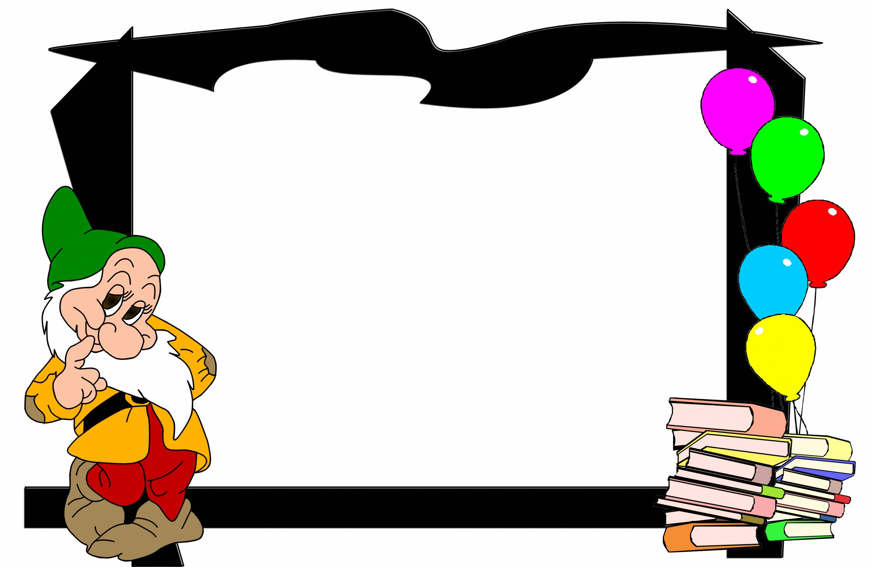
Present and past simple passive

المضارع البسيط والماضي البسيط في المبنى للمجهول
ملاحظات عامة
1 – نستخدم المبنى للمجهول عند الجهل بالفاعل او الخوف على الفاعل-شيوع الفعل- التركيز على المفعول بة- او معرفة وجملة المبنى للمعلوم هي التى تبدأ بالفاعل وجمله المبنى للمجهول تبدأ بالمفعول
عند التحويل من معلوم الى مجهول نتبع التالى
الزمن المضارع البسيط
ﻣﻔﻌﻮل بة + +sﻣﺼﺪر / ﻣﺼﺪر + ﻓﺎﻋﻞ
المجهول منه معلوم مثبت

بة ﻣﻐﻌﻮل + was /were + pp
Mr.Khaled teaches us English We are taught English
المجهول منه معلوم منفى
فاعل +don't/doesn't + بة مفعول + مصدر
بة مفعول + isn't /aren't + pp

Mr.Khaled doesn't teach the film . (The film….) ------------------------------------------------------
المجهول منه سؤال
Do /Does + مفعول +مصدر + فاعل ?

Was/ were + مفعول + pp

-What does she write? (What is……..) --------------------------------------------------
الزمن الماضى البسيط
المجهول منه معلوم مثبت
فاعل+ فعل قياسى او تصرف 2 للشاذ + مفعول

بة ﻣﻐﻌﻮل + was /were + pp
Mr.Khaled taught us English We were taught English
المجهول منه معلوم منفى
فاعل +didn't + بة مفعول + مصدر
بة مفعول + wasn't /weren't + pp

Mr.Khaled didn’t teach the film . (The film….) ------------------------------------------------------
المجهول منه سؤال
Did + فاعل +مصدر + مفعول ?

was/ were + مفعول + pp

-What did she write? (What is……..) --------------------------------------------------
1-Read and correct the underlined words:
1- Who were fireworks invent by? 2-Coats worn in winter.
3- The red envelopes that children are give contain messages.
4 -Spring is celebrate all over the world.
5- At 12 o'clock, there are fireworks and the sky is filing with colours.
6- Oranges is grown in hot countries . 7- Jam is keeping in that cupboard.
1-Rewrite the following using the word(s) in brackets .
1- Do you use lanterns to see at night? (Are lanterns…...)
----------------------------------------------------------------------------------------------
2- We give money or food to poor people. (Money…………..)
----------------------------------------------------------------------------------------------
3- We make mum a cup of tea. (A cup of tea……)
----------------------------------------------------------------------------------------------
4- The police took the thief to prison yesterday. (The thief ……...)
----------------------------------------------------------------------------------------------
5- We export cotton to other countries. (Cotton……….…)
----------------------------------------------------------------------------------------------
6- Hesham bought a new car last week. (A new car……..)
----------------------------------------------------------------------------------------------
7- He didn't send the letter to him. (The letter ..…..)
----------------------------------------------------------------------------------------------
8- The government built new schools last year. (…were…………)
----------------------------------------------------------------------------------------------
9- Where did you watch the match? (Where was..….)
----------------------------------------------------------------------------------------------
10- He doesn't drink milk. (Milk…………….)
----------------------------------------------------------------------------------------------
2-Choose the correct answer from a, b, c or d:
1- How is Sham el-Nessim ……………….. by most people these days?
a- decorate b- decorates c- decorated d- decorating
2- The museum ....................... by thousands of tourists every day.
a- was visited b- is visiting c- is visited d- visited
3- The guidebook ………………… in 1995, but it is still used today.
a- was written b- is writing c- is written d- wrote
4- His passport ………………. when he was running to catch the train.
a- was losing b- is lost c- was lost d- lost
5- Egyptian bazaars ……………………….. to be the best in Africa.
a- were thought b- is thought c- are thought d- thought
6- Costumes are ………………….. at different festivals around the world.
a- wear b- wearing c- wears d- worn
7- After the houses …………………., they are cleaned.
a- were decorated b- decorated c- are decorated d- decorating
8- What …………….. to children at New Year today?
a- give b- gave c- are given d- was given
9- The first pizza………………….. by an Italian.
a- is invented b- invented c- invents d- was invented
10- Sham el-Nessim was first ……………. to celebrate the start of spring nearly 4,000 years ago.
a- holds b- hold c- holding d- held
2-Write a paragraph of seven (7) sentences about one of the following
- a review of a book you liked - why you think Egypt is a good place for tourists to visit
2-finish the following dialogue between Ihab and Hassan :
Ihab : ………………………………………………………… ?
Hassan : I went to our farm .
Ihab : …………………………. ……………………….?
Nassau : I went with my friends
Ihab : What did you do there ?
Hassan : …………………………………………………………….

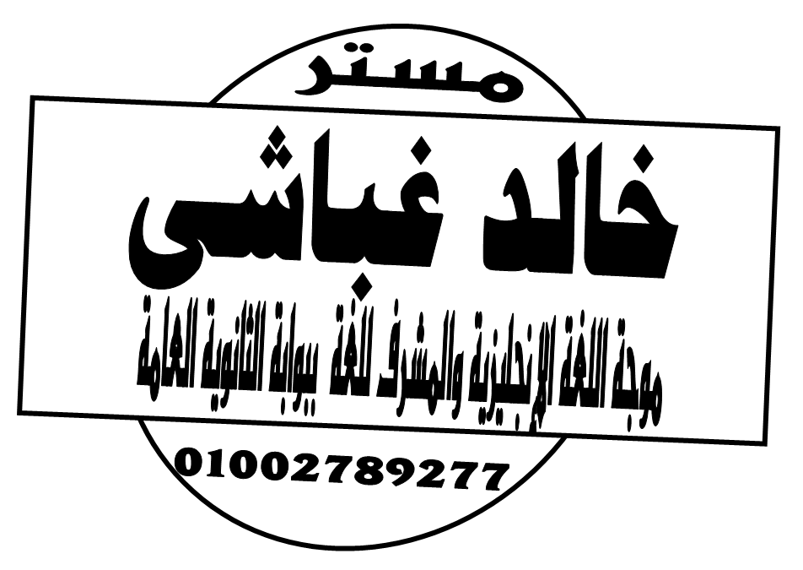

gfrmhttps://www.facebook.com/khaledghobashy

gf

