
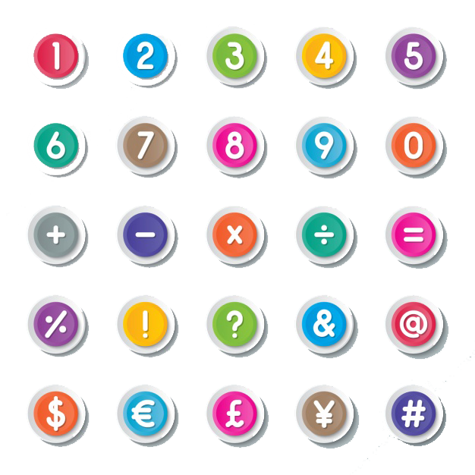
The Senses
Word | Meaning | Word | Meaning
senses | الحواس | dictionary | قاموس
invite | يدعو | adults | بالغين
invitation | دعوة | look up | يبحث عن معنى كلمة
accept | يقبل | beach | الشاطئ
refuse | يرفض | concert | حفلة موسيقية
blind | أعمى | shopping | التسوق
deaf | أصم | in Arabic | باللغة العربية
accident | حادثة | communicate with | يتواصل مع
village | قرية | take up | يتعلم
equipment | معدات | encourage | يشجع
library | مكتبة | slightly | الى حد ما
system | نظام | education | التعليم
dots | نقاط | hand out | يوصل – يسلم
instead of | بدلاً من | set up | يقيم – ينشأ
letters | حروف | shape | شكل
touch | يلمس | protect | يحمى
work out | يفهم – يحسب – يحل | orchestra | اوركسترا
meaning | المعنى | play music | يعزف موسيقي
find a way | يجد طريقة | information | معلومات
improve | يُحسن | for the blind | للمكفوفين
soldier | جندي | in Braille | بطريقة برايل
own | يملك | great | عظيم
on paper | على الورق | achievement | انجاز
message | رسالة | all over | في كل أنحاء
signs | اشارات- يفط | the world | العالم
continue | يستمر | weeks | أسابيع
adding | اضافة | sounds | يبدو
make up | يؤلف | ball | كره – حفله راقصة
take his name | يسمى على اسمة | see | يري
technology | تكنولوجيا | fingers | أصابع اليد
change into | يحول الى | toe | أصبع القدم
printer | طابعة | cost | يكلف
electronic | الكترونى | cheaper | أرخص
e-books | كتب الكترونية | money | مال
different | مختلف | hear | يسمع



Language Notes

1 – blind people= the blind
This system is for blind people.

= This system is for the blind.
2 – fingerاصبع اليد * toe اصبع القدم
They use their fingers to touch the signs.
My toe hurts me when I hit the door.
3 – make equipment for--- يصنع معدات لـــ
His father made equipment for horses.
4 – A school for -------- مدرسة خاصة بــــ
He went to a school for blind children.
5 – library مكتبة لاستعارة الكتب * bookshop مكتبه/محل بيع الكتب
I borrowed a book from the library.
6 – a system of dots--- نظام النقط
The book has a system of dots instead of letters.
7 – work out the meaningيعرف / يستنتج
You should try to work out the meaning of the word.
8 – improveيحسن / يطور * prove يبرهن أو يثبت صحه
Braille wanted to improve the system.
He wanted to prove that he was right.
9 – decide to + مصدر يقرر
He decided to buy a car.
10 – make it easy for+ مفعول
He wanted to make it easy for the blind to use.
11 – A book of signs كتاب اشارات
He wrote a book of signs.
12 – make up يؤلف
He made up signs for maths and music.
13 – change--- into ---يحول الى
Some computers can change texts into Braille.
14 – e-book= electronic booksكتب الكترونية
Some e-books can be read in Braille.
15 – Read in Braille تُقرأ بلغة برايل
The blind man can read books in Braille.
16 – look up words يبحث عن معانى الكلمات
He used a dictionary to look up words to find out their meanings.
17 – would like to + مصدر
Would you like to go to the club?
18 – play in a concertيعزف في حفلة موسيقية
They came here to play in a concert.
19 – concertحفلة موسيقية * ball حفلة رقص * party حفلة مثل عيد الميلاد
We went to the concert for the music.
20 - 1950 عام * 1950s فترة الخمسينات
The Orchestra was set up in 1950s.

Function Box Invitation

* Inviting people دعوة الناس لشيء
Would you like to ------------------------------?
I would like to invite you to----------------.
* Accepting invitationsقبول الدعوات
I would love to!
That/It sounds great.
* Refusing invitationsرفض الدعوات
I am sorry-----------------------------------------------
I am afraid I can’t-----------------------------------
I would love to, but I can’t because-----------

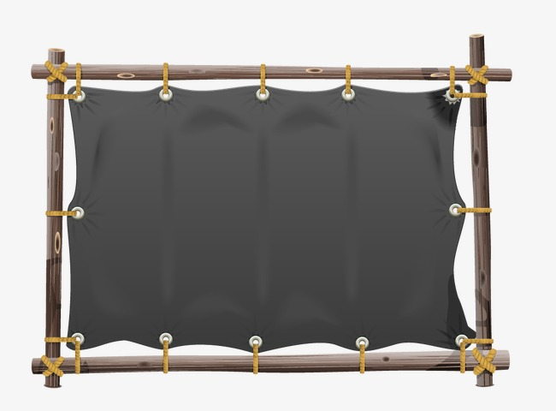
Book Text
Louis Braille

Louis Braille, who was born in 1809, became blind after an accident when he was three. At first, Louis went to school in his village, where his father made equipment for horses. When he was ten, he went to a school for blind children in Paris. In the school library, there were 14 books which had a system of dots instead of letters. When students touched the letters, they could work out the meaning of the words. Louis wanted to find a way to improve the system.
Then in 1821, a man called Charles Barbier visited the School. Barbier, who was a soldier, showed the students his own system of dots on paper. It was used by soldiers to read and write message at night. Louis decided to improve Barbier’s system to make it easier for blind people to use.
When he was 15, he wrote his first book of signs. He continued adding more signs to his system. He also made up signs for maths and music. The signs took his name : Braille.
These days, new technology has made Braille even easier to use. Some computers, which can quickly change text into Braille, now have Braille printers. Electronic books (e-books) can also be read in Braille.

You can find Braille in many different languages, all over the world. There are even Braille dictionaries, so that blind adults and children can look up words and find out their meanings.

The Deaf School in Cairo

The Deaf School in Cairo was set up in 1982 for children from all over Egypt. There are about 70 children at the school, where most of them live during the week. They go home at weekends and during the holidays.
* At the school, students learn Egyptian Sign Language. They also learn reading and writing in Arabic and English, maths, science, P.E. and computer studies.
* The teachers at the Deaf School believe that it is really important for deaf people to be able to communicate with people who can hear. They encourage the family and friends of deaf students to take up sign language themselves at special weekly classes for people who can hear. They also plan activities where both deaf people and people who can hear can learn about each other’s lives.
* More schools are now open for deaf learners all over Egypt. Moreover, slightly deaf students are now included in general education schools so that they can be with other students that hear well.

Listening text

Hassan:
Hi ! Tarek.
Tarek:
Hello! Hassan. How are you?
Hassan:
I'm fine, thanks.
Tarek:
What are you doing later this afternoon? Would you like to go to the sports club to play football?
Hassan:
I'm sorry. I'd love to but I can't because I am going shopping with my sister, Manal. She knows someone who plays in an orchestra. They are coming here to play in a concert soon so we are going to hand out information to people about the concert so I'm afraid I can't play football today.
Tarek:
Tell me more about the orchestra.
Hassan:
The orchestra which is called the Alnor wal Al Amal orchestra was set up in the 1950s for blind girls and women. They all read music in Braille.
Tarek:
That's a great achievement!
Hassan:
Yes, it is. They travel all over the world and the next concert is here in two weeks’ time. I'd like to invite you to it. Can you come?
Tarek:
Hh! I'd love to! It sounds great.

Grammar

Relative clauses

ضمائر الوصل : تُستخدم ضمائر الوصل للربط بين جملتين وتشمل

who – which – that – whose - where - when
1 – نستخدم الضمير (who/whom) ليحل محل العاقل (people)

Mr Zaki, who lives next door, is a scientist.
This is the boy who(whom) I helped yesterday.

2 – نستخدم الضمير (which) ليحل محل غير العاقل (things )

Elephants, which live for 45 years, are found in Africa.
This is the book which was written by Naguib Mahfouz.

معلومة هامة يمكن استخدام ( that ) بدلا من (who-which-whom)

A doctor is the person who/that helps sick people.
This is the e-book which/that he was reading.

ولكن لاحظ جيداً : - يجب استخدام (that) في بعض الحالات منها: -
1 – اذا جاءت الدرجة الثالثة من المقارنة

He is the tallest man that I have ever seen.

2 – اذا جاء بعض الكلمات في الجملة مثل (all – only)

I gave him all the money that I had.
3 – نستخدم الضمير( where) ليحل محل المكان (places )

Aswan is the city where he was born.
This is the school where he works.

4 – نستخدم الضمير (when) ليحل محل الوقت (time)

2015 was the year when Basant was born.
Friday is the day when we go on a holiday.

5 – نستخدم الضمير (whose) ليحل محل الملكية (possession)
والملكية ممكن أن تكون

(noun ‘s) أو صفة ملكية مثل (my-his-her-its-our-your- their)

معاومة هامة يأتى اسم دائما بعد (whose) كما في الجمل الاتية

Ali, whose factory makes clothes, is very rich.
This is the man whose daughter is a doctor.
I saw the cat whose tail is brown.
معلومات وجمل هامة
1 – عند الربط بين جملتين نتبع الأتى
- نكتب الجملة الأاولى كما هي
- نضع ضمير الوصل
- نحذف المتكرر ونكتب باقى الجمله الثانية
Ali is the pupil. He won the first prize. (who)
Ali is the pupil who won the first prize.
2 – يمكن استخدام كلمة (when) وتساوي (in-at-on Which)

Friday is the day when he arrives. (which)
Friday is the day on which he arrives.
3 – يمكن استخدام كلمة (where) وتساوي (in-at which)

Cairo is the city where he lives. (which)
Cairo is the city in which he lives.
4 – لاحظ الفرق الاتى : -
This is the flat where he lived.
This is the flat which he bought.
The post office, where he works, is big.
The post office , which is opposite the bank, is big.

Exercise Unit (9)

1 – Finish the following dialogue:
Nada and Safaa are talking about Louis Braille
Nada: (1)-----------------------------------------------------?
Safaa: He was born in 1809.
Nada: (3)------------------------------------------------------------?
Safaa: He became blind because he had an accident.
Nada: (3)--------------------------------------------------------?
Safaa : He improved Barbier’s system to help blind people.

2 – Write what you would say:
1 –You invite your friend to go to the cinema.
2 – You accept your friend’s invitation to play football.
3 – Your friend has invited you to his birthday part, but you are busy.
3 – Read the following , then answer the questions:
In the 1960s , French engineers helped to design the world's first passenger plane which could fly faster than the speed of sound. It was called Concorde. It could carry 100 passengers but was noisy and used a lot of fuel. Concordes flew from 1969 until 2003.
Now . French and Japanese engineers are designing a new passengers plane that will be able to fly more than double the speed of sound" about 1200 kilometres an hour"
Engineers predict the new plane will be ready by 2050. It will be much quieter than Concorde and it will be able to carry 250 passengers.
A) Answer the following questions :
1- What is this article about ?
2- When did Concorde stop flying ?
3- How many passengers did Concorde carry?
B) Choose the correct answer from a,b, c or d :
4- How will the new plane be better than Concorde?
a - It will be cheaper b- It will be noisier
c- It will be quieter and larger d- It will be ready soon
5- The underlined word "it" refers to --------------------
a - Sound b- the French c- Concorde d- fuel
4 – The Reader

A. Match

A | B
1. When the fire was bigger | a. softly and gently to the horses
2. John spoke | b. with a lantern
3. The man came | c. the building collapsed
4. The firefighters put out the fire | d. after many hours
 | e. After few hours

B – Answer the following questions
1 – What did Joe offer the driver?
2– Where did Joe go after that?
3 – What did the manager do after thanking Joe?
4 – What was John’s opinion about what Joe did?
5 – What did the police do with the driver?

5 – Choose the correct answer:
1. A --------------------- is a person who works to protect the country
a. soldier | b. player | c. thief | d. blind
2. ---------- are words or pictures that give information.
a. signs | b. books | c. booklets | d. news
3. --------- means not able to see.
a . deaf | b. blind | c. lane | d. dumb
4. A ---------------------- is a way of doing something.
a . diary | b. dairy | c. system | d. sense
5. You are an -------------- when you are 18 or older.
a. baby | b. kid | c. doll | d. adult
6. A square, circle an triangle are examples of --------------------------
a – share | b. shape | c. shade | d. show
7. The children, ------ enjoyed drawing in the sand, stayed on the beach.
a. which | b – who | c. whom | d. whose
8. The boy, -----------------books the tickets, is my brother
a – who | b - whose | c. when | d. where
9. I told her about all the news ------------------ I had.
a – which | b. whose | c. who | d. that
10. My brother, ------------- muscles are strong, carried the heavy bags.
a. whose | b. who | c. which | d – where
11. Reem’s family enjoyed their holiday and they want to ------- again next year.
a. go on | b. go back | c. go forward | d. go in
12. The teacher ---------------- information about the concert.
a. handed to | b. handed up | c. handed off | d. handed out
13. The school was------------- 40 years ago.
a – set to | b. set down | c. set up | d. set off
14. Ahmed usually plays the violin in a/an------------On Tuesdays.
a. orchestra | b. music | c. invention | d. spectator
15. The girl is ------------------, so she can’t hear you.
a. blind | b. intelligent | c. tired | d. deaf
16. I would like--------------------------you to the park on Saturday morning.
a. invite | b. inviting | c. to invite | d. invites
17. Maya, --------------- is slightly deaf, is learning Egyptian Sign Language.
a. who | b. where | c. whose | d. which
18. The system that blind people use to read is called -------------------------
a. Braille | b. Graham Bell | c. Benz | d. Gates
19. The blind use their------ to touch and know what is written on a page.
a. toes | b. fingers | c. ears | d. eyes
20. There are six ------------------- in each shape of Braille.
a. points | b. dots | c. full-stops | d. steps
21. Braille’s father made-------------------- for horses.
a. equipment | b. instrument | c. fireworks | d. quizzes
22. He could work-------------- the meaning of the words.
a. in | b. out | c. with | d. at
23. The book for the blind has dots ------------------ of letters.
a. instead | b. fan | c. take | d. as well
24. The word set up in the 1950s, means-----------------------------
a. started | b. closed | d. ended | d. finished
25. “ Hand out” information to people means-----------------------------
a. book | b. buy | c. give | d. sell
26. A -------------- is a part where music is played.
a. jail | b. ball | c. concrete | d. concert
27. At The Deaf School, students learn Egyptian----------------------
a. sign language | b. foreign language | c. singing | cooking
28 – It is important for the deaf to communicate--------------- other people.
a. in | b. with | c. at | d. into
29 – people who are slightly deaf-----------------------------
a. can hear well | b. can’t hear at all | c. can’t hear well | d. die
30 – I would like to -------------------- you to stay with us during the holiday.
a. invite | b. die | c. cry | d. sleep

6 – Rewrite the following sentences:
1 – Tanta is the city. He lives in Tanta. (Where)
2 – Dina is the girl. We helped her. (who/whom)
3 – January was the month. She was born in January. (when)
4 – This is the book. She wrote the book. (which)
5 – This is the city where we work. (which)
6 – Ahmed’s cousin is a doctor. He lives in Assyut. (who)
7- Squash keeps me fit. It is my favourite sport. (which)
8 – The bank is near the school. My brother works there. (where)
9 – Ali broke the window. (who)
10 – Do you know the girl?-Her father is a doctor. (whose)
7 – Read and correct:
1 – If you take up sign language, you forget it.
2 – Sign language is a language that is communicated by the mouth.
3 – The charity was set up ten years ago. “ set up” means ended.
4 – I used my dictionary to look after the new word.
5- The Orchestra was set up in the 1950.
6- They all read music with Braille.
7 – That is a great achieve.
8 – Ayman is the man whose books the tickets.
9 – Luxor, who thousands of tourists stay, is near the Nile
10 – English which all students study at school is very important.
8 – Write an e-mail of (7) sentences about one of the following:
- Inviting your friend to your birthday party.
- The senses.

هذا العمل متاح للجميع لوجه الله دون استئذان وهو صدقة جارية على روح والدتى وموتى المسلمين
Mr Hamada Hashish
01287424004
وللمزيد تابعونا على

https://www.facebook.com/hamada.hashish.3

وهنا أيضا
https://www.facebook.com/groups/173244922885133/

