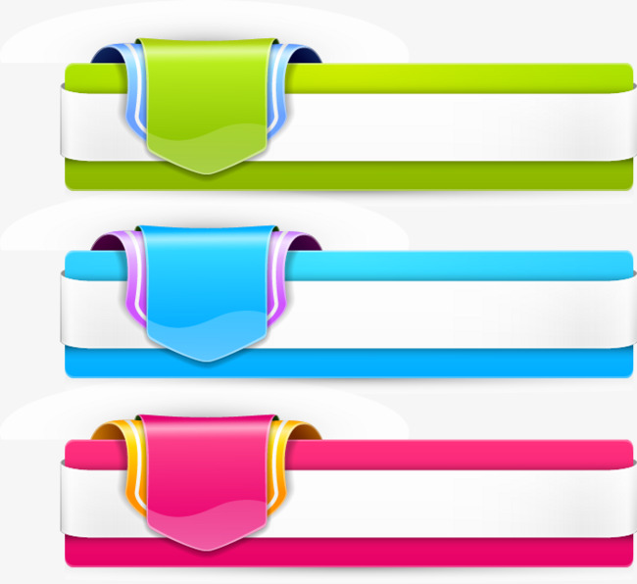
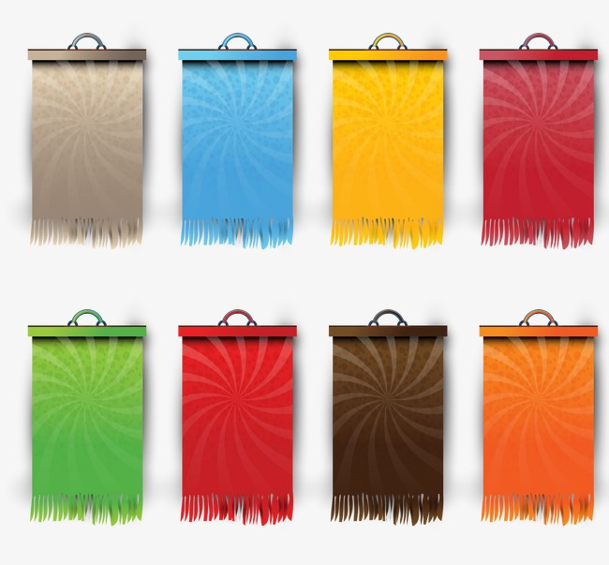
Books and reading
2

Word | Meaning | Word | Meaning
lesson | حصة أو درس | road | طريق
choose | يختار | go down | يغرب
history | تاريخ | rise | يشرق
historical | تاريخى | warm | دافيء
stories | قصص | cold | بارد
novels | روايات | suddenly | فجأة
detective | محقق – مخبر سري | a light | كشاف – مصباح
popular | مشهور | towards | نحو – باتجاه
try | يحاول – يجرب | finally | في النهاية
solve | يحل | help | مساعدة
problems | مشاكل | the end | النهاية
interest | اهتمام | excited | مثار – فرحان
pages | صفحات | frightened | مرعوب
amount | كمية | feel | يشعر
travelling | السفر | alone | بمفردة
title | لقب – اسم كتاب | lonely | وحيدا
address | عنوان سكن | quiet | هاديء
review | مقاله نقدية | quite | الى حد ما
living thing | كائن حى | adventure | مغامرة
wind | الرياح | adventurous | مليء بالمغامرة
blow | يهب | secret | سر
leaves | اوراق الشجر | mystery | لغز غامض
tremble | يرتعش | reading | القراءة
tired | متعب | discussion | مناقشة
weak | ضعيف | comparison | مقارنه
die | يموت | spend time | يقضى وقت
death | الموت | dry | جاف
food | الطعام | shaking | يهتز
desert | الصحراء | safe | آمن
last | يدوم | summary | ملخص
How far ? | كم المسافة ؟ | view | منظر طبيعى
nearest | اقرب | library | مكتبه
care | يهتم – يرعى | careful | حريص
carer | راع – مهتم | carefully | بحرص
Language Notes

1 – Let’s + مصدر ------- = How about + v + ing-----------?
Let’s choose a book to read.
How about choosing a book to read?
2 – historyالتاريخ * historianمؤرخ
My favourite subject is history.
He writes about history, he is a historian.
3 – historicتاريخى او مهم في التاريخ * historical يحكى عن التاريخ مثل كتاب او قصة
There are a lot of historical stories.
4 – like + v+ ing --------- *would like to + مصد
I like watching TV.
I would like to watch TV.
5 – take + وقت + to + مصدر يستغرق وقت = spend + وقت + V+ing
I will take 2 hours to do homework.
I will spend 2 hours doing homework.
6 – titleعنوان كتاب او لقب شخص * address عنوان سكن
The title of the book is Black Beauty.
My address is 30 Orabi Street, Cairo.
7 – review مقاله نقدية عن * view منظر طبيعى
I have read a review of that book.
I like natural views.
8 – like يحب – مثل
l like football.
He is walking like a lion.
9 – desert صحراء * dessertحلو – حلوى
He was lost in the desert.
We have dessert after lunch.
10 – the last الأخير * last يدوم – يستمر
The last time he visited Aswan was in 2010.
His water won’t last for long.
11 – lightضوء – خفيف * a light مصباح – كشاف
It is not heavy, it is light.
He is carrying a light.
12 – finally في النهاية * final نهائي
Finally, help has arrived.
The final match will be tomorrow.
13 – realize يدرك او يفهم * recognize يتعرفف على شكل شخص او مكان
When I went home, I realized that I lost my money.
I didn’t recognize Al, because he was abroad for long.
14 – gone to ذهب ومازال هناك * been to ذهب لمكان وعاد
She has gone to the market. مازالت في السوق
She has been to the market. عادت من السوق
15 – make + مفعول feel يجعله يشعر بـــ
It makes me feel excited.
16 – alone بمفرده * lonely يشعر بالوحدة
He was alone in the desert.
He feel lonely although he has a big family.
17 – very + صفة * very + حال
He is very good.
He plays very well.
18 – quite الى حد ما * quietهاديء * quitخروج – هروب
It is quite hot today.
The place is quiet not noisy.

Expressing feelings

I feel/felt + صفة
Did the story make you feel+ صفة ?
How did you feel when------------------?
It made me feel---------------------------?
How do you feel about---------------?
I don’t feel ----------------------------- .
Book Text

Tarek:
I have some time before my next lesson. Let’s choose a book to read.
Omar:
There are lots of historical stories here, but there are few detective stories.
Tarek:
That is because detective stories are more popular, aren’t they? People like trying to solve the problems before the detective. People have less interest in historical stories.
Omar:
Detective stories are too long. I have little time to read this year because I have more schoolwork. So I want a book with fewer pages than a detective story.
Tarek:
This book has the fewest number of pages and will take you the least amount of time to read.
Omar:
Tarek , that book is about travelling, isn’t it?
Tarek:
True! This is good. Its title is Ten Facts about the World.
Omar:
I read a review of that book. It said it was very good. I will read that!

Text book 2

The trees are the first living things that Hassan has seen in five days. The Wind is blowing and the leaves on the trees are trembling, like him. He is tired and weak.
A few hours before he arrived here, Hassan thought he was going to die. There was no food in the desert and he knew that the little water he had would not last another day. Now he knows that he will find water, because if there are trees, there must be water somewhere. But he still doesn’t know where he is. How far is it to the nearest road, where he might find help?
The sun is going down quickly and he knows it will be cold for the next eight hours. How can he stay warm for another night in the desert?
Suddenly, he sees something. Someone is carrying a light towards him. He realizes that it is a man. Finally, help has arrived. He is safe.

Listening text
Nadia:
Did you like the end of the story?
Salma:
I am not sure I understand it. Who is the man with the light? And why does it say that the leaves are trembling? people usually tremble when they feel excited or frightened, not leaves.
Nadia:
Hassan is trembling because he is tired and week. He has been in the desert for five days. I don’t think the writer is saying that the leaves feel frightened when the wind comes, but they are moving in the same way as Hassan because he is so tired.
Salma:
How did you feel when Hassan finally saw the trees?
Nadia:
It made me feel excited! You know that he will find some water because there are trees there, and they need water. We know that he won’t die.
Salma:
I think it is clever because we think that he will be alone in the desert for another night, but then he sees the light.
Nadia:
Why do you think there is a man with a light?
Salma:
I think that it is his friend Ahmed . Ahmed knew that Hassan was going in the desert and we know that Ahmed knows the desert very well. So Hassan is safe now.
Nadia:
Yes, I think you are right.
Salma:
How do you feel about the story now?
Nadia:
I feel quite happy! I like adventure stories like this.

Grammar
Comparatives and superlatives

few-fewer- fewest
little- less- least
 | as --------- as | than | the
قليل للعدد | few | fewer | fewest | يأتى بعدها اسم جمع
قليل للكمية | little | less | least | يأتى بعدها اسم لا يعد
كثير للعدد | many | more | most | يأتى بعدها اسم جمع
كثير للكمية | much | more | most | يأتى بعدها اسم لايعد
I have fewer books than Ali.
I have less money than Dina.
Class four has the fewest students.
That bottle has the least water.
I want a book with fewer pages than this.
He has as much money as me.
She has as many books as her sister.

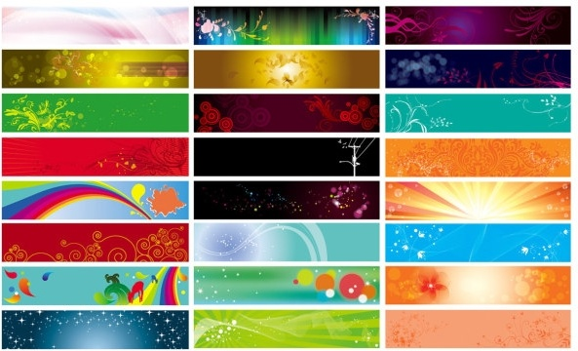
Exercise Unit (2)

1 – Finish the following dialogue:
Eman is going to the library
Tamer: Where are you going?
Eman: (1) -------------------
Tamer : (2) ------------------?
Eman: I prefer historical books.
Tamer: (3)-------------------?
Eman: I go there three times a week.
2 – Write what you would say:
1 – How did you feel when you read the story?
2 – What is your opinion of the film?
3 –You suggest going to the library.
3 – Read the following , then answer the questions:
Samira is a clever girl. She is going to be a nurse. She is having classes at a nursing school near her home. She has to study hard. She is already helpful to other nurses because she can feed and wash a sick child. She can also change its clothes.
One day her little brother Ahmed, .was sick. He had a bad cold and couldn't go to school.
Samira advised him to stay at home or other children would catch his cold. She gave him a glass of orange juice and opened the window wide to let fresh air in. Her mother smiled. "A sick child in the family is good practice for a nurse, isn't it Samira ?" she said .
A)Answer the following questions :

1 - What is Samira going to be?
2 - How is Samira already helpful to other nurses?
3 - Why couldn't Ahmed go to school?
B ) Choose the correct answer:
4 - Samira advised Ahmed to-----------------------------------
a - go to school b - go to the park.
c -stay at home d - eat ice cream.
5 - Samira opened the window to ----------------------------
a - let fresh air in b.- help Ahmed to sleep.
c - clean the room d - catch cold.

4 – The Reader
a. Match

1 – The new owner was | a – Merrylegs and Ginger
2 – Gordon lived in | b – John Manly
3 – Gordon’s helper was | c – Farmer Grey
4 – Black Beauty became friends with | d – Birtwick Park
 | e – Squire Gordon
B – Answer the following questions
1 – When would Ginger be as good as Black Beauty?
2 – What bad thing did Merrylegs do one day?
3 – Why did Merrylegs throw the children on the ground?
4 – Why was Merrylegs angry with older children?
5 – Why didn’t Merrylegs kick the children?
5 – Choose the correct answer:
1. If someone is ------------- , he is shaking very hard.
a. laughing | b. trembling | c. templing | d. resembling
2. He is not strong, he is --------------------------------------.
a. week | b. weak | c. leak | d. peak
3.A ------------------------- is the name given to a book or a person..
a . title | b. address | c. dress | d. site
4. A ------------------------- is a long story that is written.
a . novel | b. tale | c. poem | d. poet
5. ------------- is writing which gives your opinion about a book or a film.
a. view | b. return | c. review | d. interview
6. A ------------- gives the main information about something.
a – summer | b. hammer | c. title | d. summary
7. The story is horrible, it makes me feel------------------------
a. happy | b – hopeful | c. frightened | d. jobless
8. He cares a lot about his country, he is -----------------------
a – care | b - careful | c. careless | d. car
9. This is a ------------- story about the Pharoahs.
a - historic | b. historical | c. modern | d. new
10.A ------------helps the police in their work.
a. porter | b. farmer | c. detective | d – engineer
11.The ------------- of the book you are using New Hello!
a. reader | b. titles | c. dress | d. address
12. I want to see that film because the ---------- says that it is very exciting.
a. view | b. review | c. interview | d. new
13. There are ------------ English cars than Korean cars in Egypt.
a - few | b. little | c. less | d. fewer
14. Something that is unusual, exciting and may be dangerous,--------------
a. adventure | b. habit | c. custom | d. old
15. The main ---------------- in the story is The Horse.
a. title | b. theme | c. character | d. end
16. Mazin’s mother is a -------------------. She helps old people.
a. car | b. carer | c. careless | d. ought to
17. Let’s -------------------- the new book.
a. buying | b. buys | c. bought | d. buy
18.He spent 3 hours ----------------------------for the exam.
a. revise | b. revising | c. to revise | d. revised
19. The camel is called the sip of the -----------------------------------
a. desert | b. dessert | c. spaceship | d. river
20. The -------------- match was between Ahly and Zamalek.
a. finally | b. final | c. funny | d. find
21.He has --------------------------to France. He is still there.
a. been | b. gone | c. went | d. goes
22. I did my homework ---------------------------. No one helped me.
a. lonely | b. alone | c. loneliness | d. me self
23. The street is not noisy, it is -----------------------------------
a. quit | b. quiet | c. quite | d. queue
24.This is a difficult problem I can’t ----------------------- it.
a. see | b. solve | d. read | d. eat
25. There are too ----------- people on the boat, it is going to sink.
a. many | b. few | c. much | d. little
26.How---------------- information do you have?
a. many | b. few | c. fewer | d. much
27. How many ------------------- are there on the table?
a. apples | b. juice | c. water | apple juice
28 – We don’t know the reason for the accident, it is a ----------------
a. secret | b. mystery | c. clear | d. clean to
29 – A story has a ----------------,characters and themes.
a. title | b. tool | c. top | d. tyre
30 – He has been ------------------ the club, he is there now.
a. to | b. in | c. by | d. from
6 – Rewrite the following sentences:
1 – Ali has fewer books than Mona. (more)
2 – I have got many friends. (few)
3 – Not many people like films. ( few)
4 –I don’t have much time to read. (little)
5 – Rodayna has fewer book than Malak. (more)
6 – I don’t have as much interest in films as I do in matches. (less)
7- How much money do you have? (many)
8 – I don’t have much information. (little)
9 – No boy is taller than Ali. (tallest)
10 – I want a book with fewer pages. (many)
7 – Read and correct:
1 – The old library has less books than the modern one.
2 – This bottle has the fewest juice in it.
3 –Do you know the animal with the least teeth?
4 – A address is the name given to a book or a play.
5- A long story that is written is a tale.
6- There are lots of history stories here.
7 – We usually have desert on Friday.
8 – He plays football very good.
9 –He lives lonely at his own flat.
10 – This street is quit.
8 – Write a paragraph about one of the following:
- The importance of reading
- Your favourie hobby.

هذا العمل متاح للجميع لوجه الله دون استئذان وهو صدقة جارية على روح والدتى وموتى المسلمين
Mr Hamada Hashish
01287424004
وللمزيد تابعونا على

https://www.facebook.com/hamada.hashish.3

وهنا أيضا
https://www.facebook.com/groups/173244922885133/

