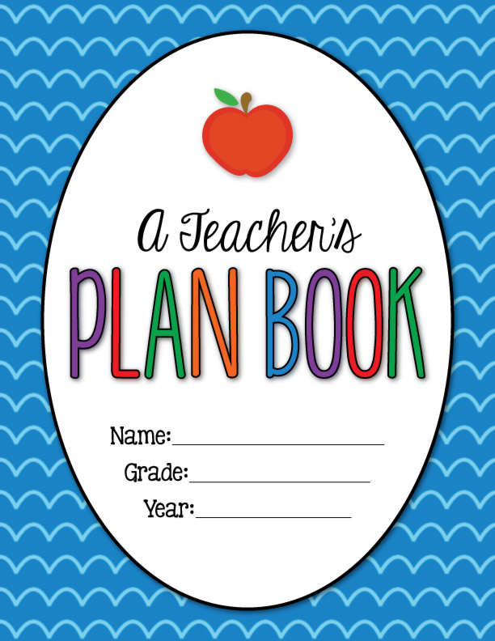

Lessons ( 1 -2 ) SB page 60
Time | Resources | Procedures | Strategies | Contact | Teaching Aids | Objectives
5 M.  15 M.  15 M. | The Reader  Teacher’s  preparation  book  Students’  note  books  Student’s'  activity  books | Worm up and revision:  What can you see in these pictures?  Presentation:  Reading the story  1 Complete the sentences with these words from the story  1 Ask the students to read the words in the box and elicit the meanings.  2 They then work in pairs to complete the  exercise, as in the example.  3 Check answers as a whole class.  2 Put the events into the correct order  1 Choose students to read the sentences aloud. Make sure that they understand them.  2 Explain that they have to put the sentences into the correct order so that they make a summary of this part of the story.  3 Choose students to read the sentences aloud in the correct order. Check answers as a class. | Discussion-  -Brainstorming  - Co- operative  -Role playing  Peer learning  -  -Work groups  -Pair work | New vocabulary:  Mutineers  Happily  sail  ship’s captain  captured  wife  decide  experience  married | -Data show  Internet-  Board-  Cassette- | By the end of the chapter students will be able to:  • To predict the ending of the story  • To read the final installment of the story  • To answer comprehension questions about  Chapter 4  - To discuss a typical day on the island
Assessment: How do you think Crusoe felt when he saw the English ship?
5 M.
Home Assignment : Answer question on chapter 4 and read the second part of chapter 4.
Self-Evaluation:
1- I've achieved all the lessons objectives . ( )
2- I haven't achieved all the objectives for some reasons. I'll try hard to achieve them. ( )

Lessons ( 3 ) SB page 60
Time | Resources | Procedures | Strategies | Contact | Teaching Aids | Objectives
5 M.  15 M.  15 M. | The Reader  Teacher’s  preparation  book  Students’  note  books  Student’s'  activity  Books | Worm up and revision:  Why did Crusoe feel sad when he left the island at the end?  Presentation:  Critical thinking  1 Elicit adjectives to describe feelings and write them on the board.  2 Then ask the students to read the questions and discuss their ideas in small groups.  3 Invite a student from each group to explain the ideas that they talked about, and hold a short class discussion.  4 Ask What advice do you think Crusoe gave to other sailors about travelling by sea?  Writing activity  Give the students the following questions and ask them to write a report about the whole story: What is the story about? [Students should write four or five sentences.]  What is your favourite part  Are you going to tell your friends to read it? [Students should write one or two sentences] | Discussion-  -Brainstorming  - Co- operative  -Role playing  Peer learning  -Work groups  -Pair work | New vocabulary:  Experience  Sadly  Dangerous  Returned  sailed back  special meal  Difficult  trader.  ship’s captain. | -Data show  Internet-  Board-  Cassette- | By the end of the lesson students will be able to:  • To discuss the story ending in more detail  • To write a review of the story
Assessment: Do you think Friday enjoyed living in England? Why / Why not?
5 M.
Home Assignment : Answer question on chapter 4 on page 59 and read chapter 60.
Self-Evaluation:
1- I've achieved all the lessons objectives . ( )
2- I haven't achieved all the objectives for some reasons. I'll try hard to achieve them. ( )

