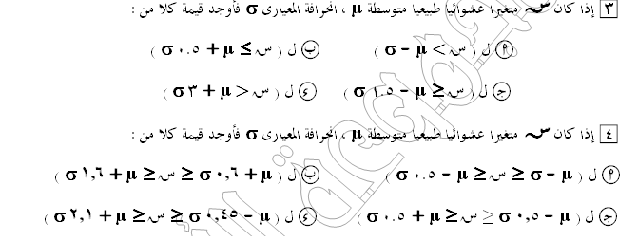
ج(ا)= ل(ص<-1)=
0.5+ ل(0>ص>1)=0.5+0.3413=0.8413
ج (ب)=ل(ص<0.5)=
0.5- ل(0>ص>0.5)=0.5-0.1915=0.3085
ج(ج)=ل(ص>-1.5)=
0.5-ل(0>ص>1.5)=0.5-0.4332=0.0668
ج(ء)=ل(ص>3)=
0.5+ل(0>ص>3)=0.5+0.4987=0.9987

4- ج(ا)=ل(-1>ص>-0.5)=
ل(0>ص>1)-ل(0>ص>0.5)=03431-0.1915=0.1516
ج(ب)=ل(0.6>ص>1.6)=
ل(0>ص>1.6)-ل(0>ص>06)=0.4452-.2259=0.2193
ج(ج)=ل(-0.5>ص>0.5)=
2 ل(0>ص>0.5)=2.(0.1915)=0.383
ج(ء)=ل(-0.45>ص>2.1)=
ل(0>ص>0.45)+ل(0>ص>2.1)=0.1736+0.4821=0.6557

